An Online Based Non-Exam Evaluation System.

*by* Ahmed Saif Sobraj

**Submission date:** 03-Jan-2023 11:45AM (UTC+0600)

**Submission ID:** 1988128505

**File name:** Eloy_Project_Report_Defense.pdf (2.45M)

**Word count:** 5773

**Character count:** 30006

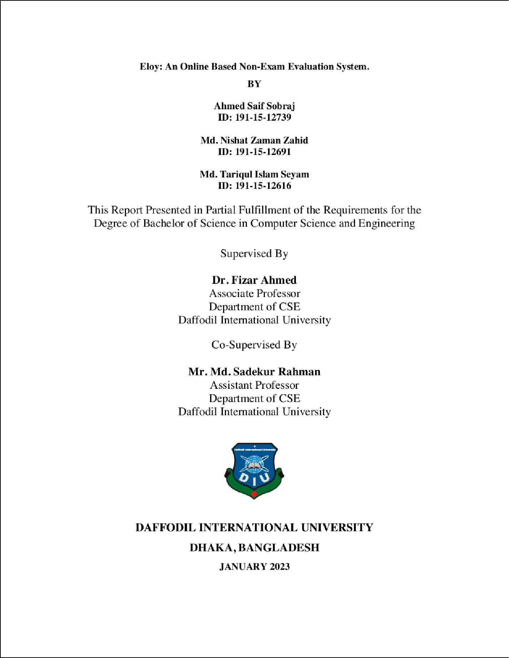

1

|  |  |  |  |  |  |
| --- | --- | --- | --- | --- | --- |
|  | |  | |  | |
|  |  | |  |
|  |  | | | |
|  | | | | | |

|  |  |  |  |
| --- | --- | --- | --- |
|  |  |  | |
|  | |  |
|  |  | |  |
|  | | | |

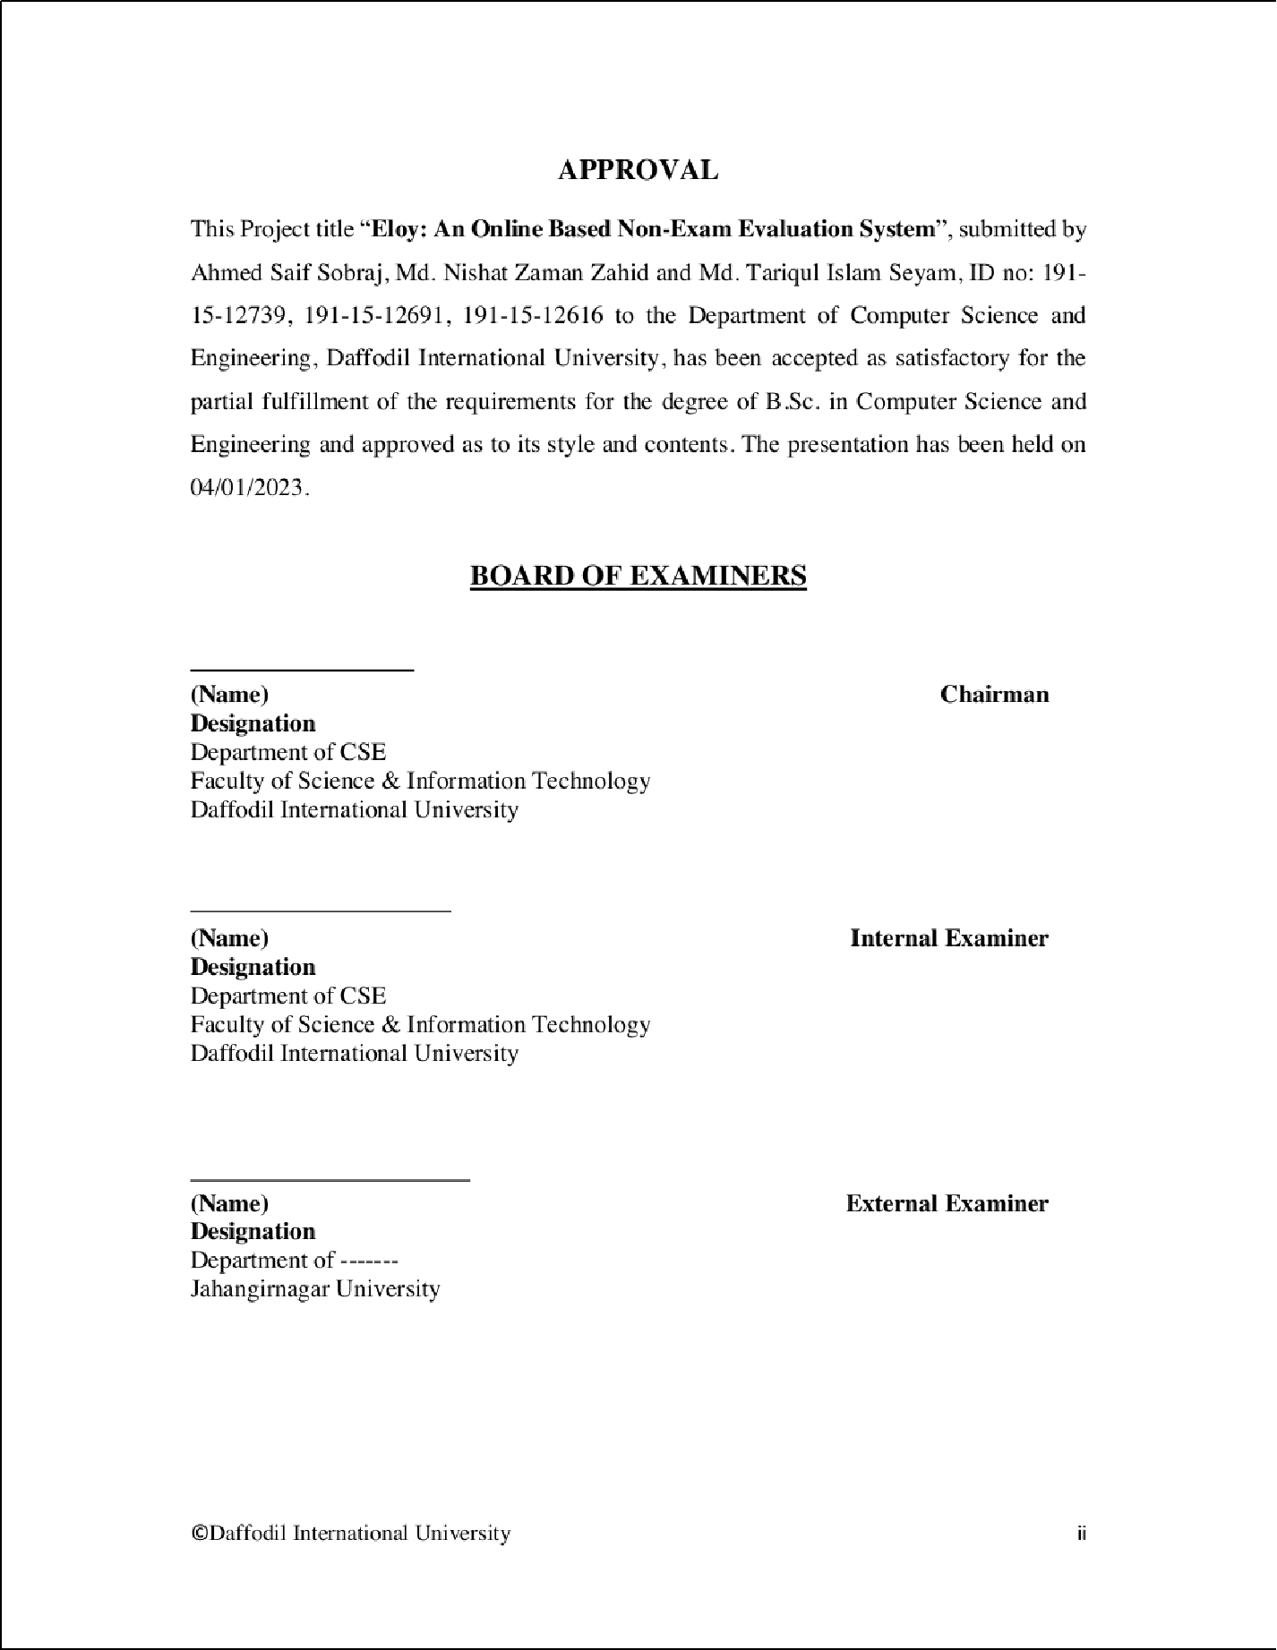

1

|  |  |  |  |  |
| --- | --- | --- | --- | --- |
|  |  | | | |
|  | |  | | |
|  | | |  | |
|  | | | | |
|  | | | |  |

|  |  |  |  |
| --- | --- | --- | --- |
|  |  | | |
|  | |  | |
|  | | |  |
|  | | | |

1

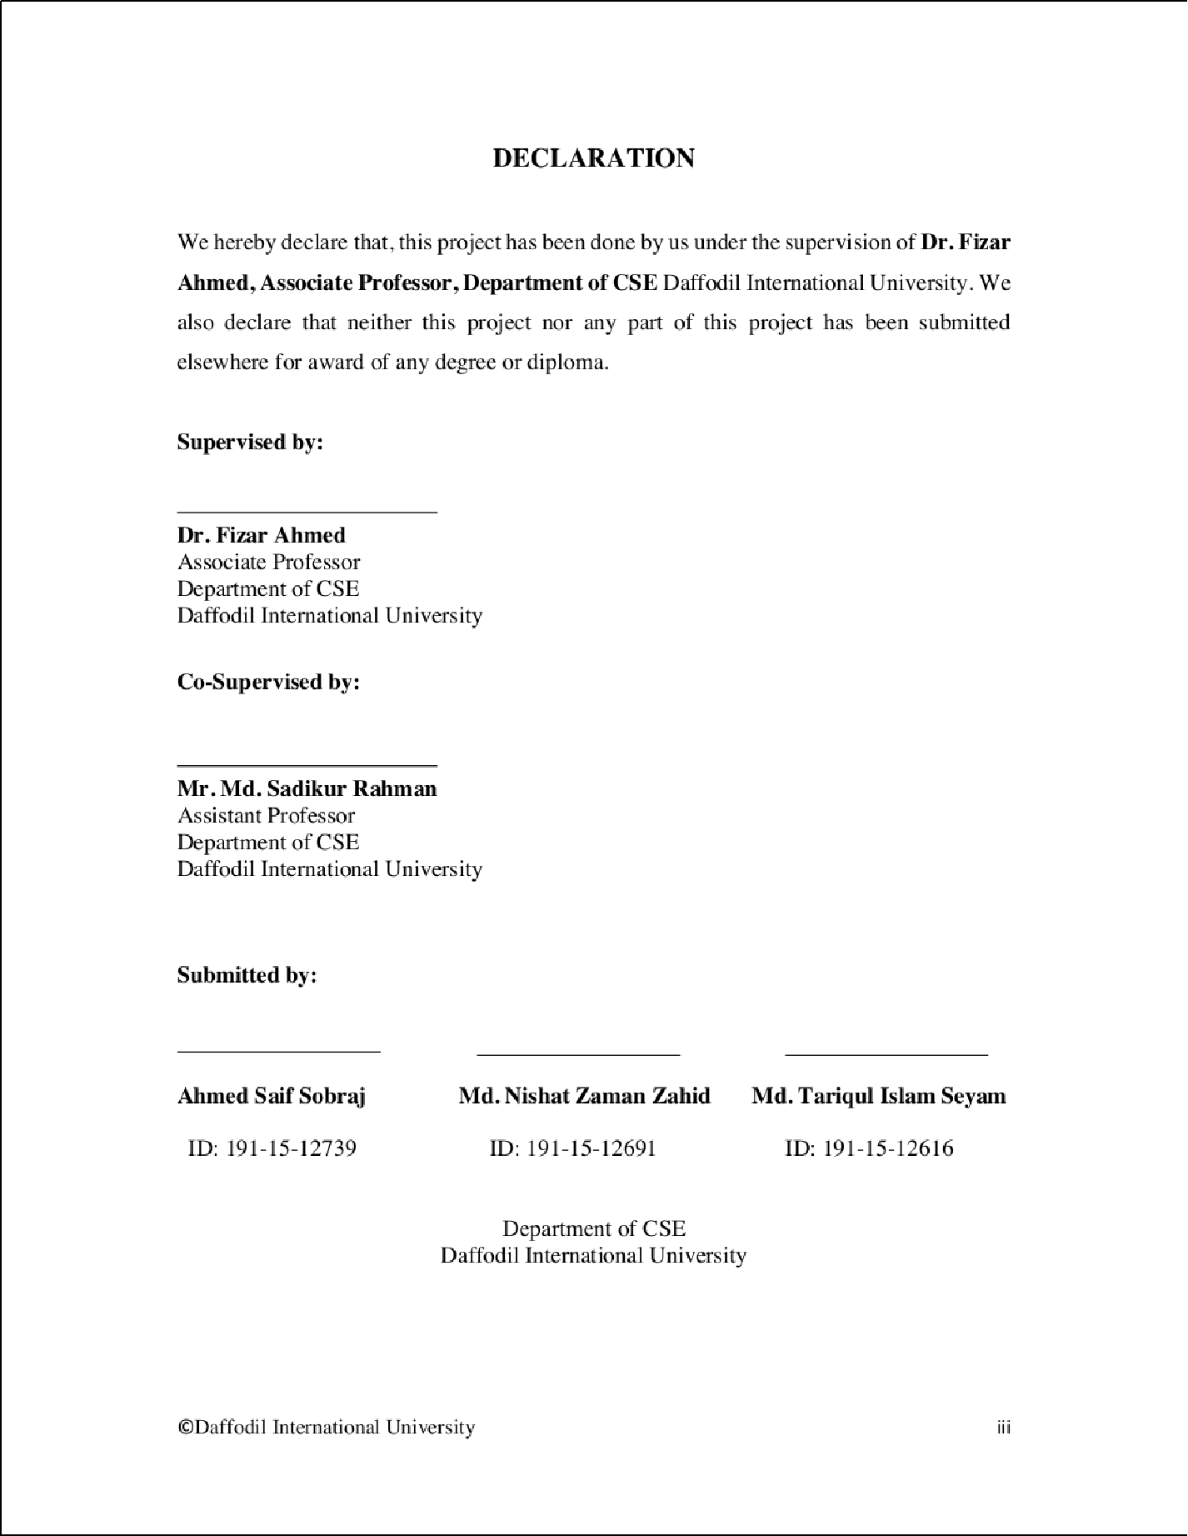

2

1

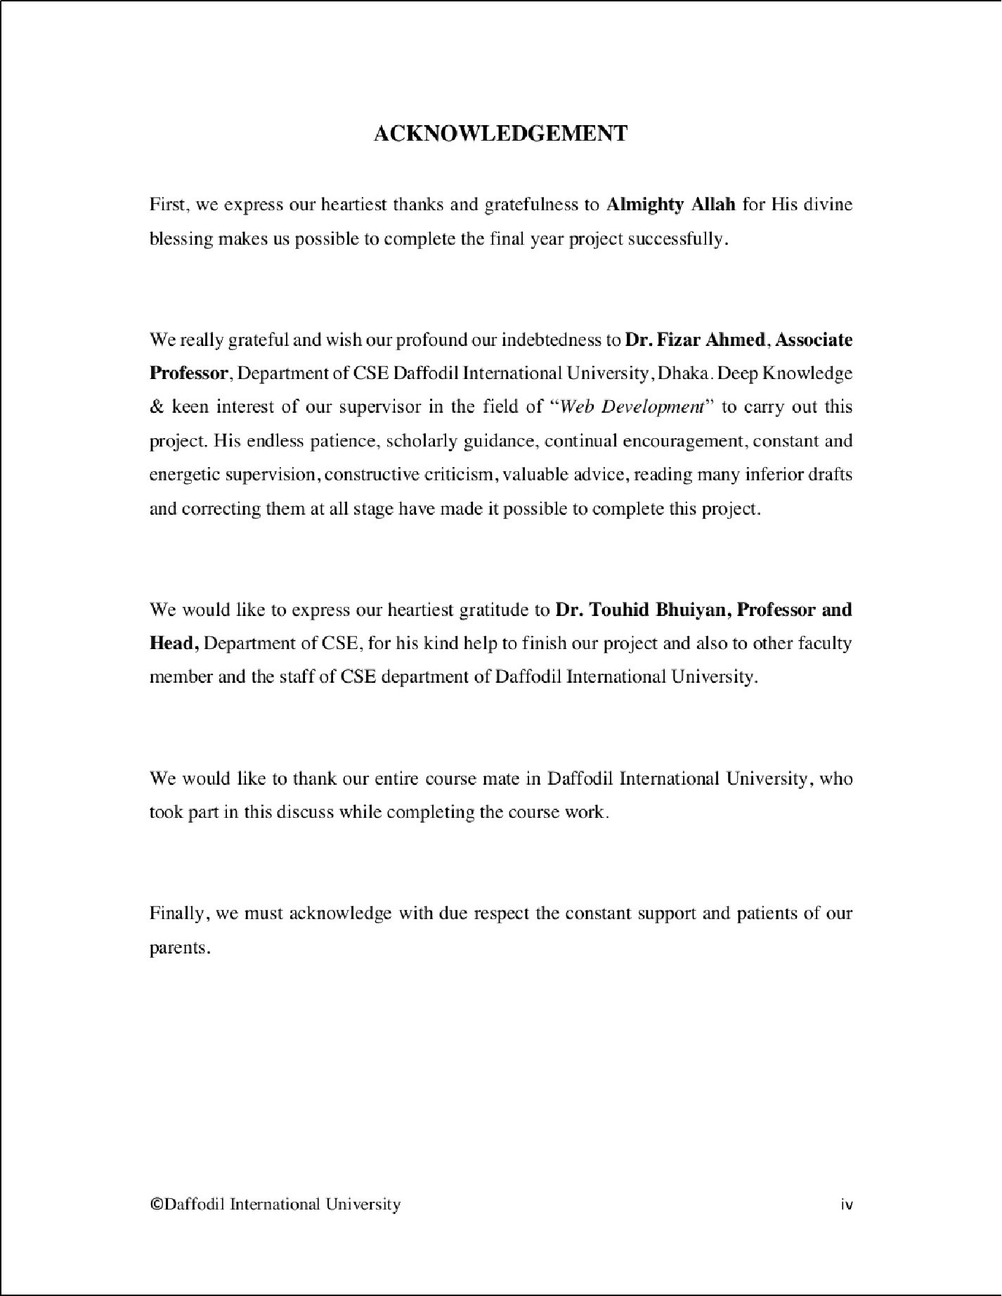

|  |  |  |  |
| --- | --- | --- | --- |
|  | | |  |
|  | | | |
|  |  |  | |
|  | | | |
|  | | | |
|  | | |  |

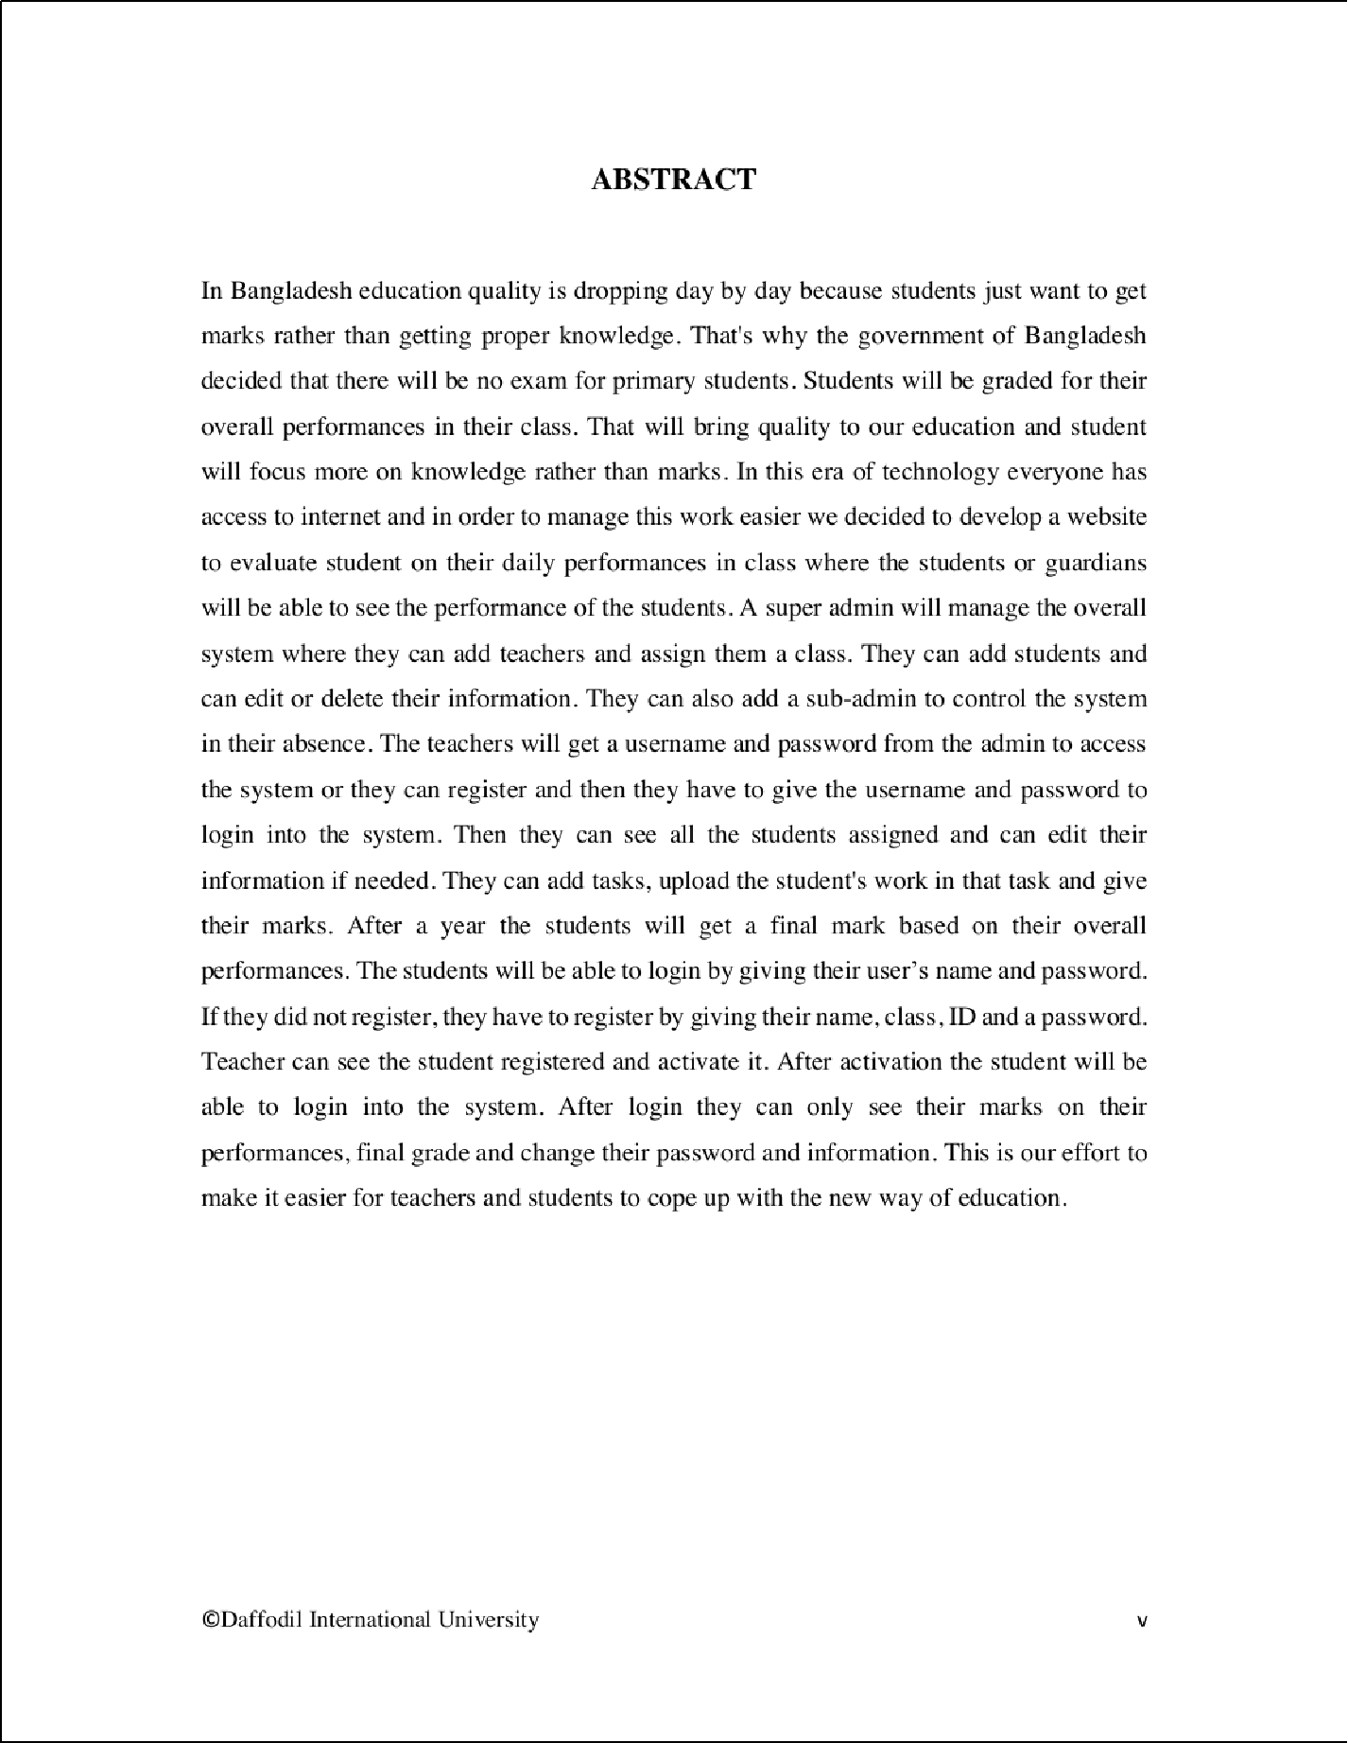

3

5

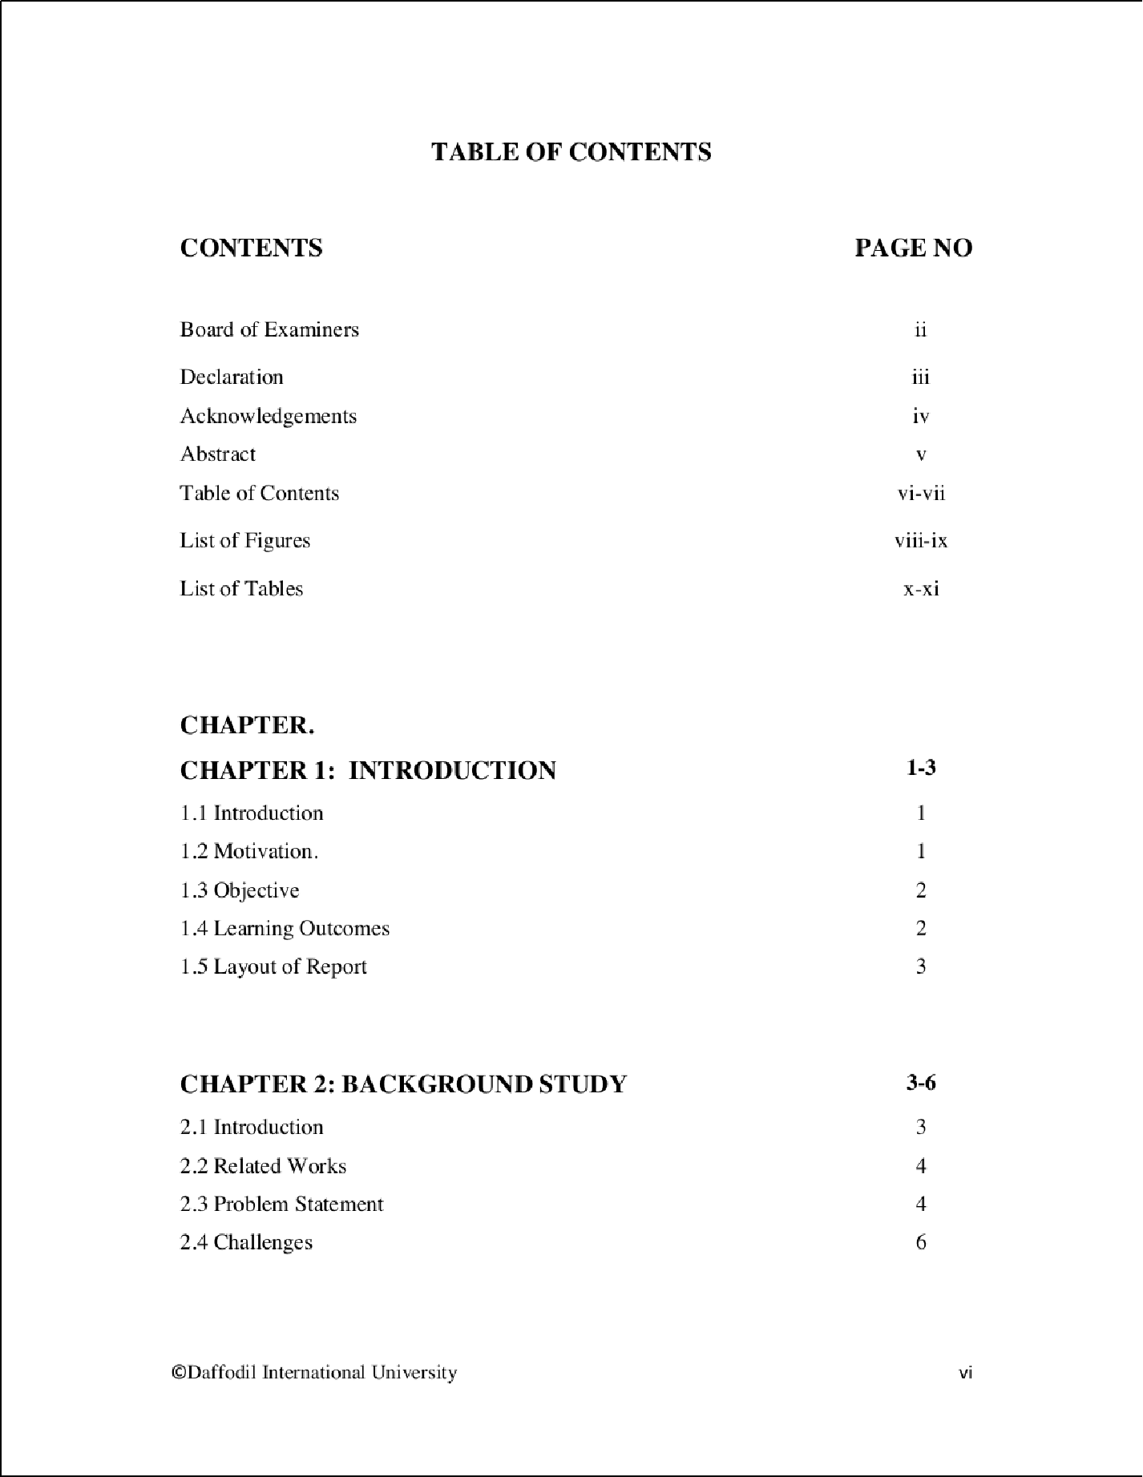

2

2

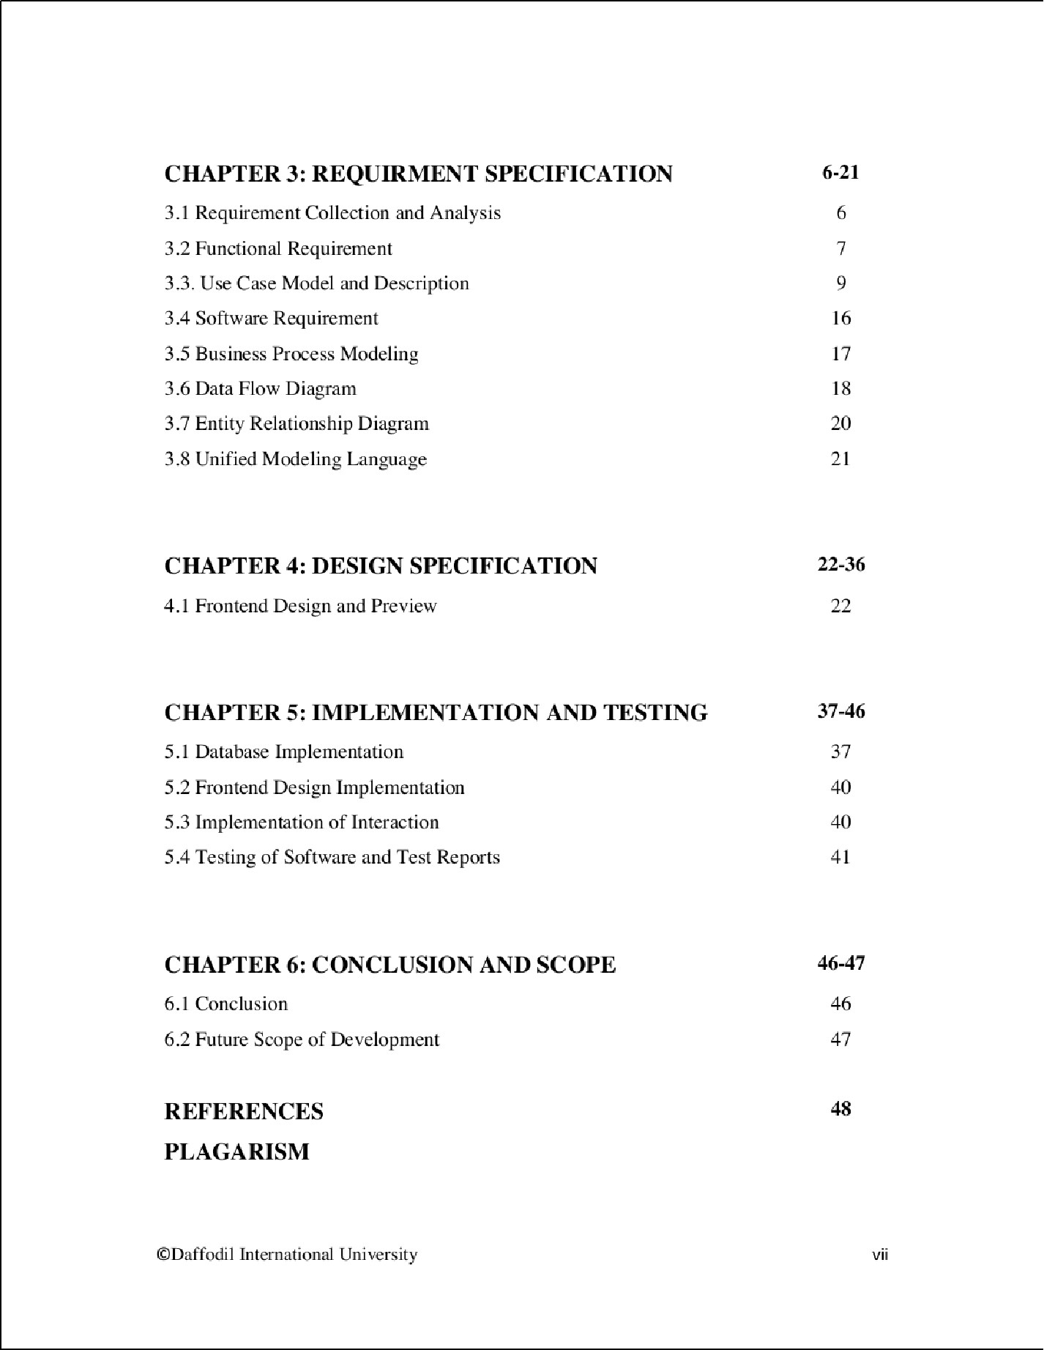

7

14

2

2

1 1

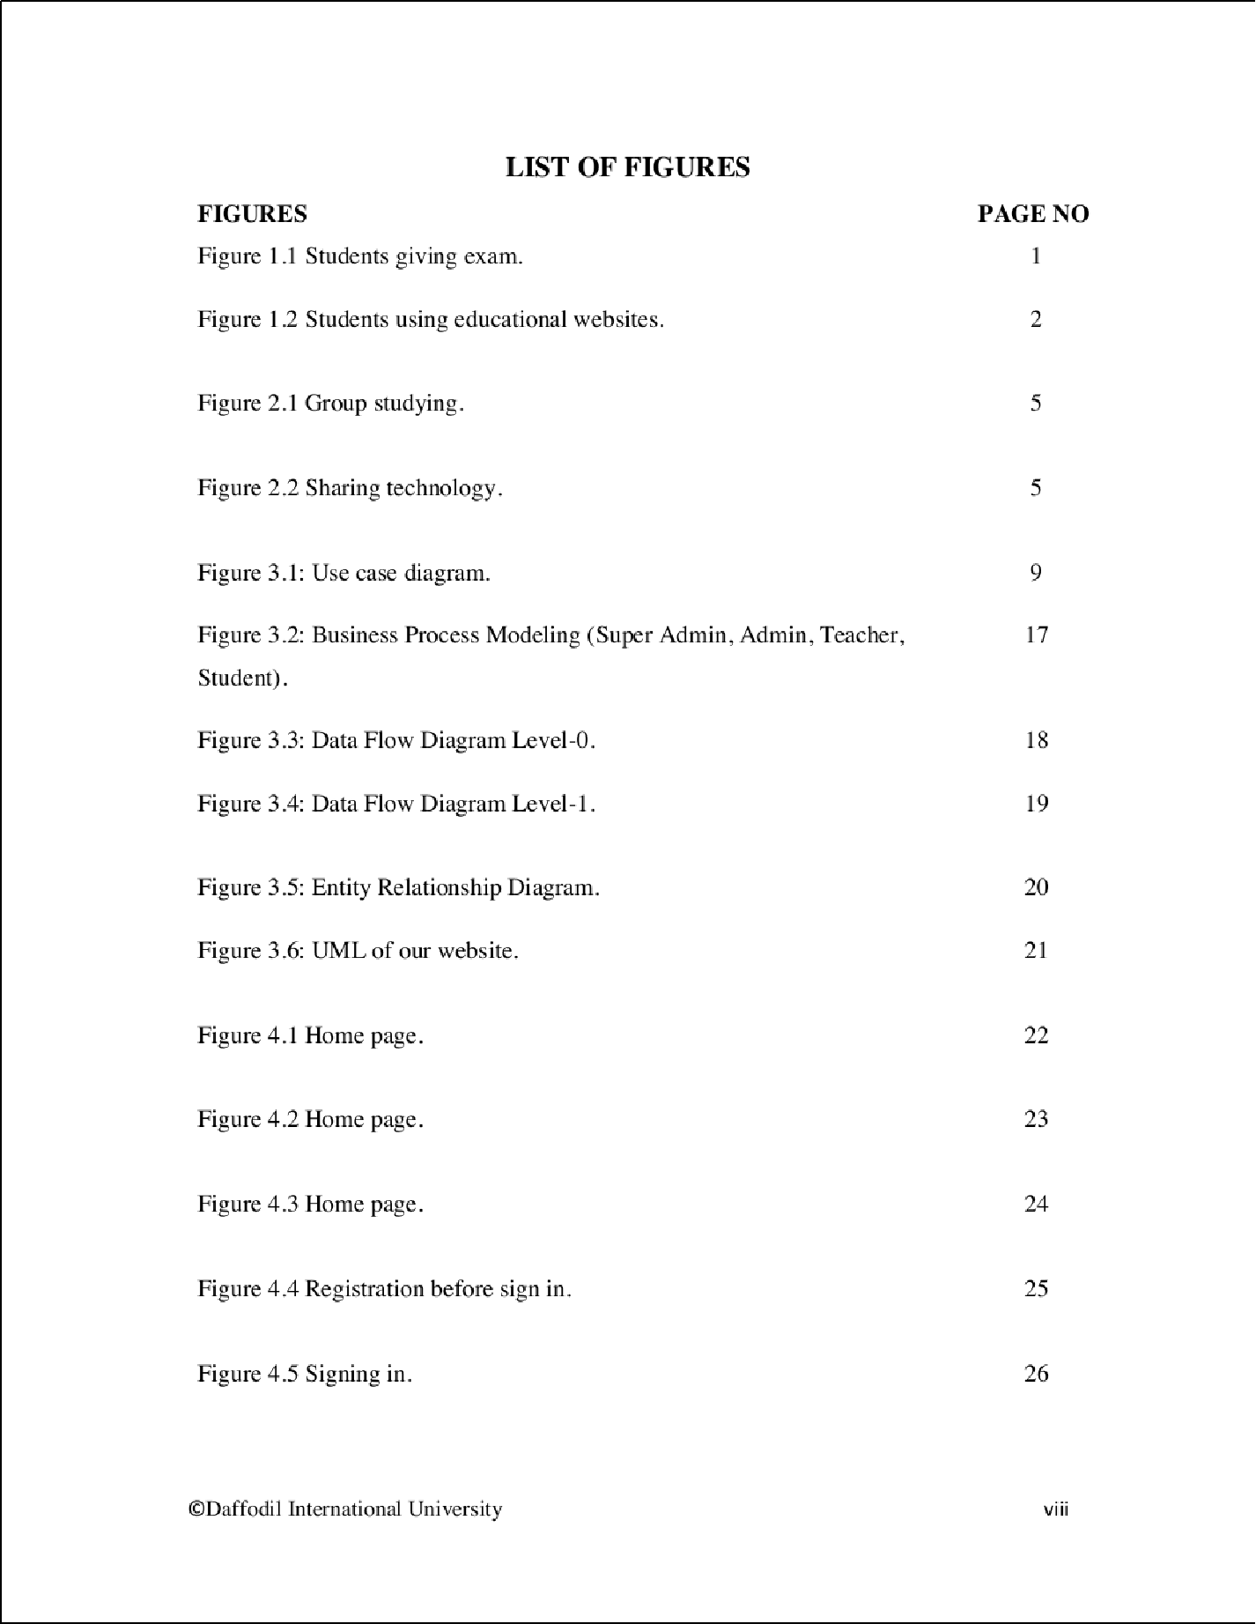

1

3

1

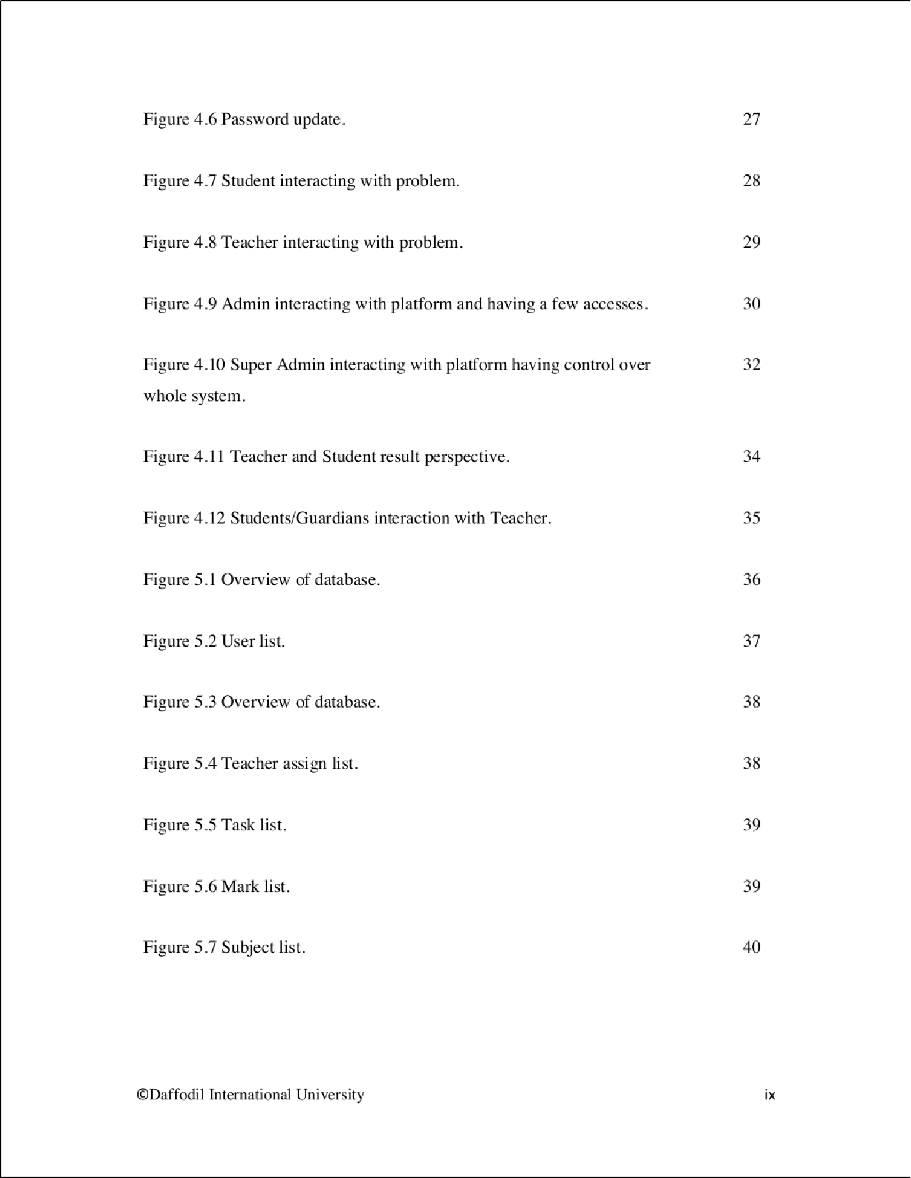

9

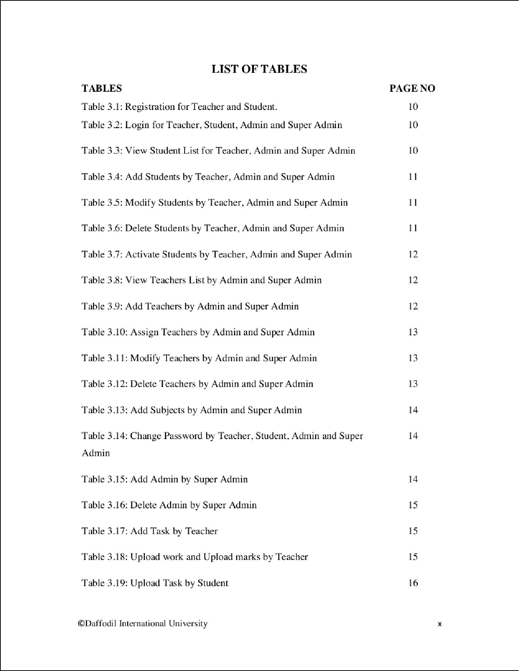

2

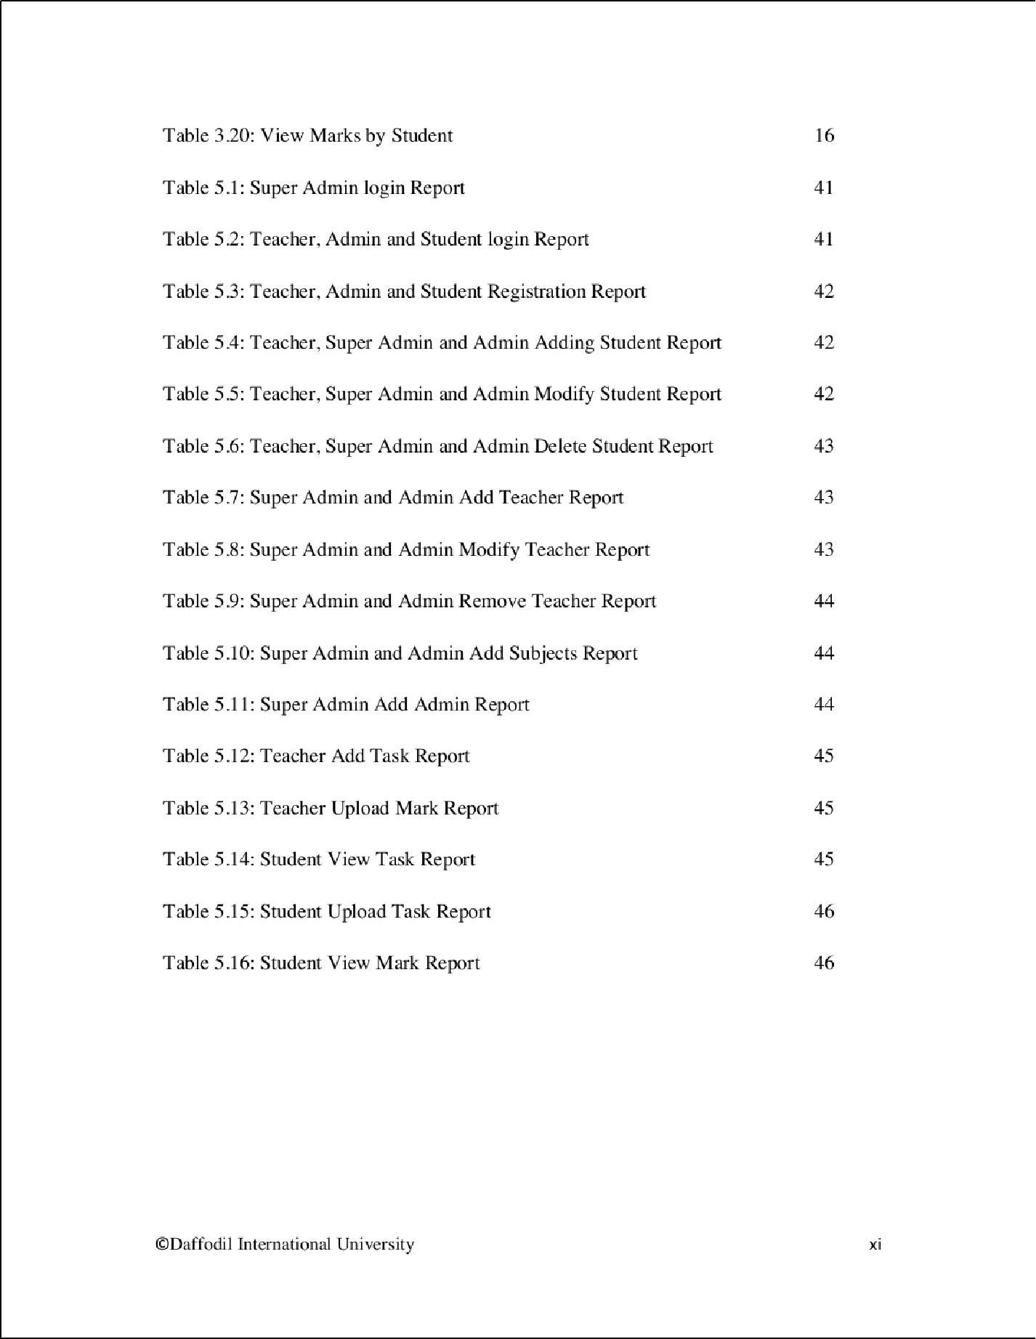

3

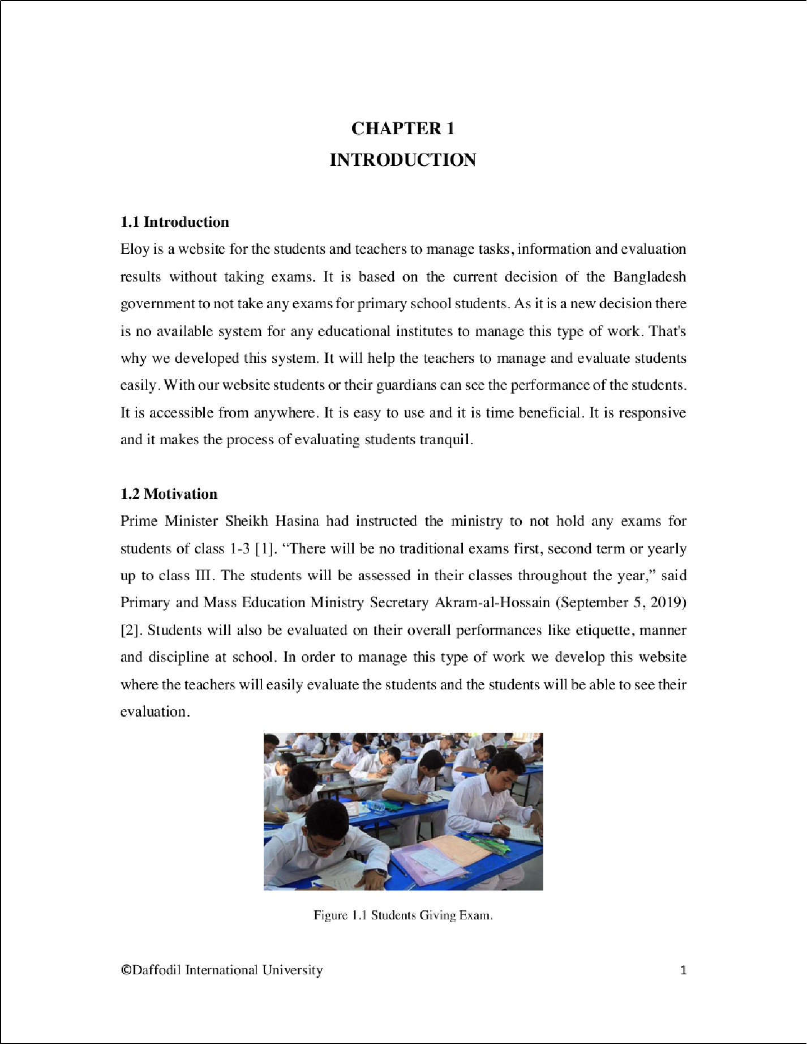

20

6

4

4

4

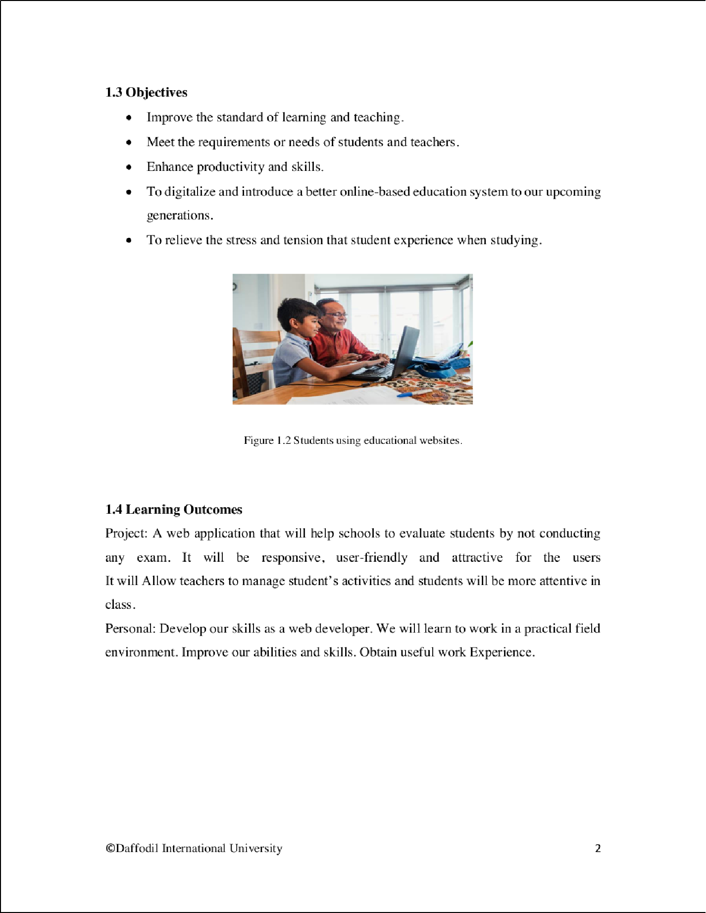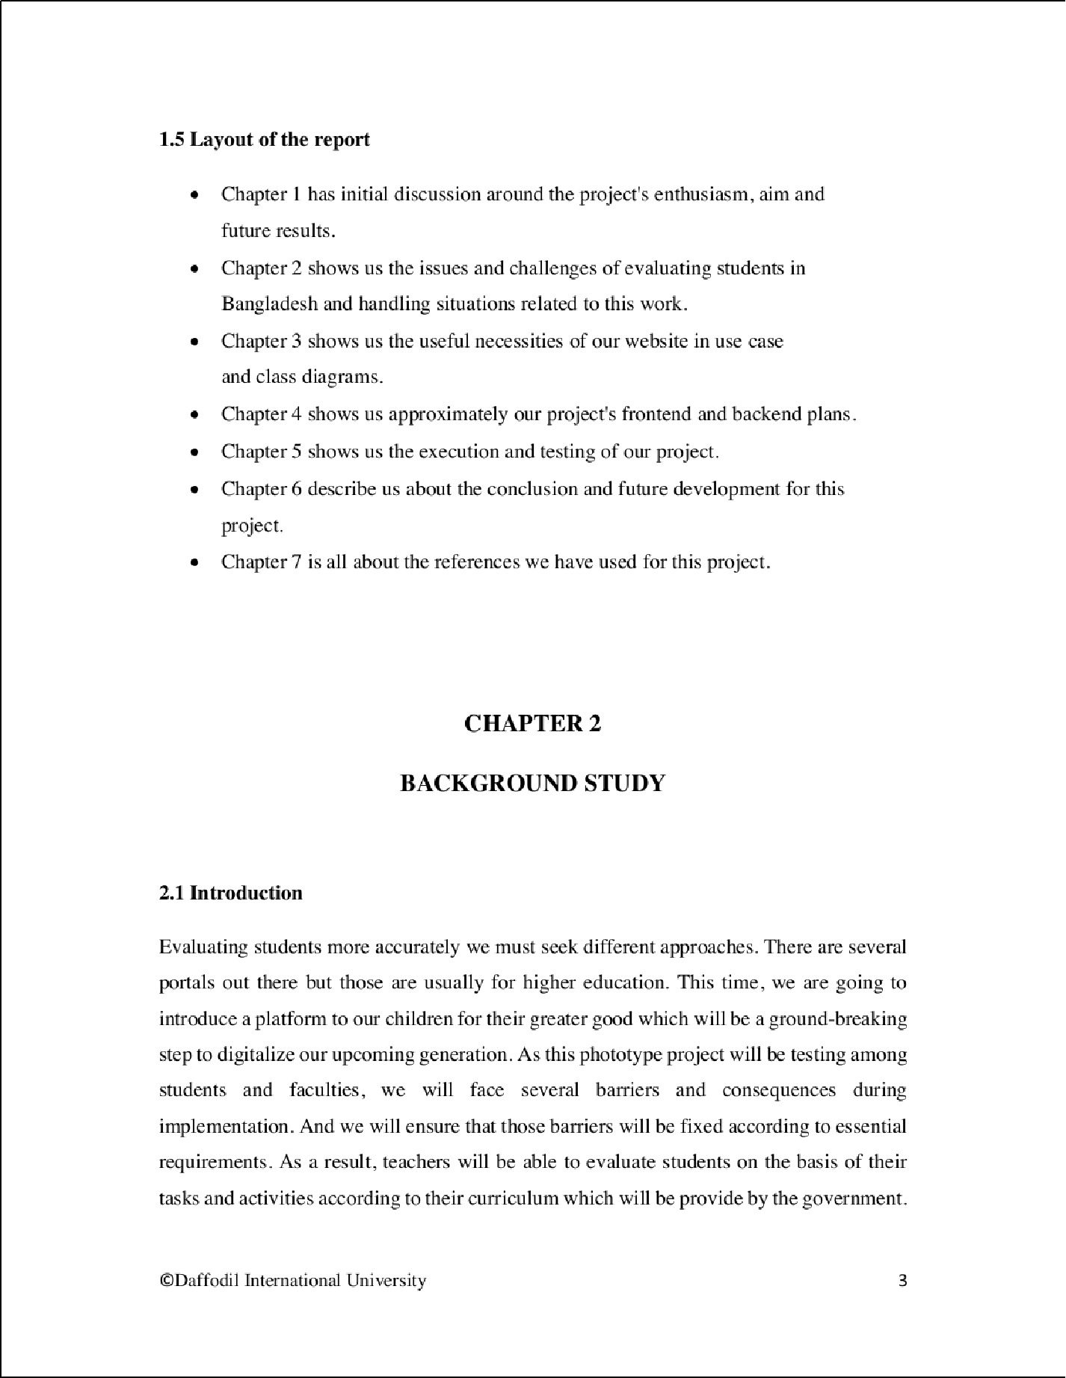

2

2

2

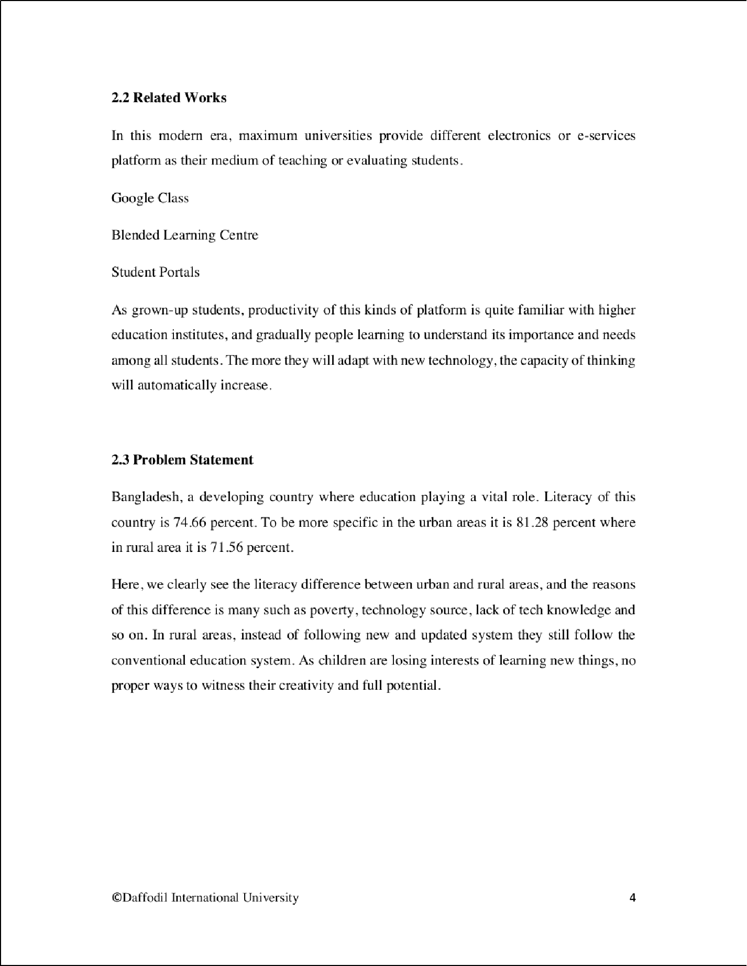

11

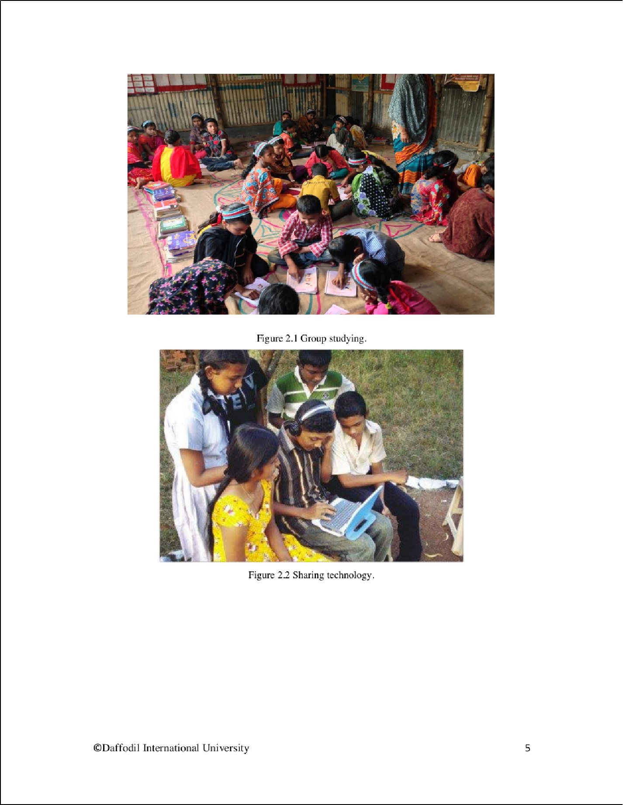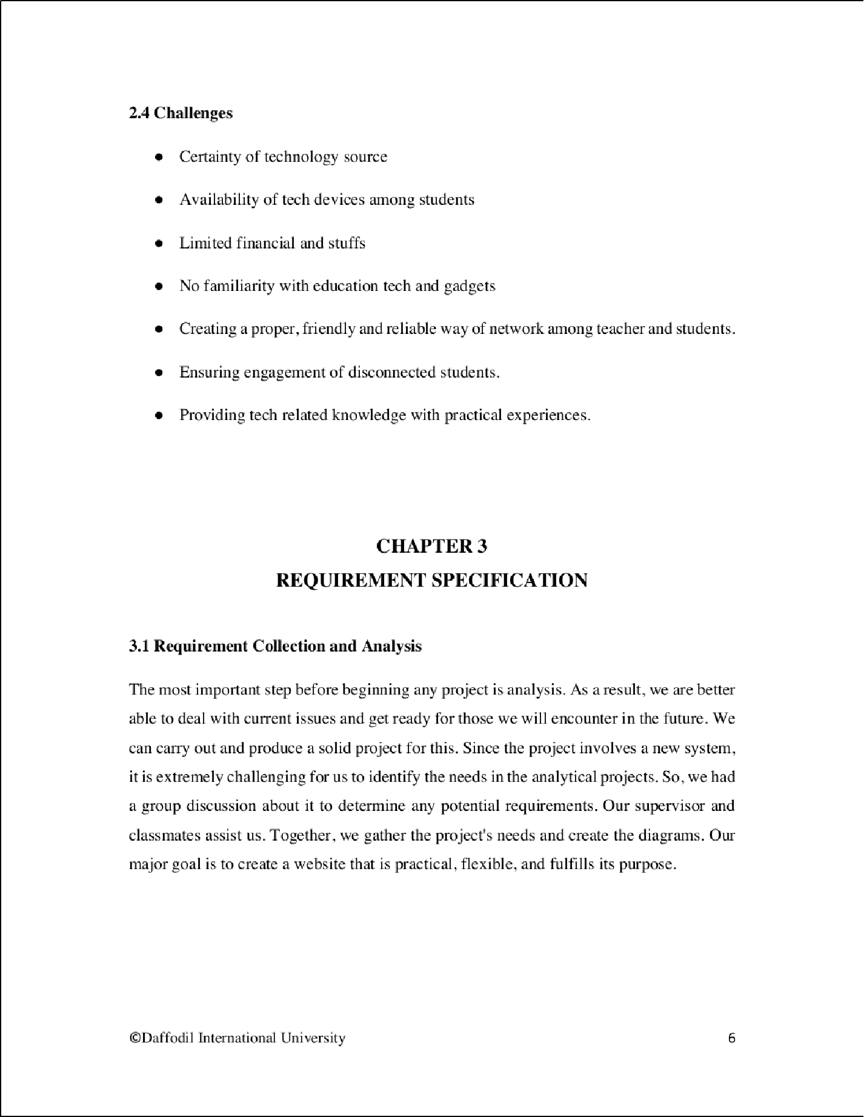

2

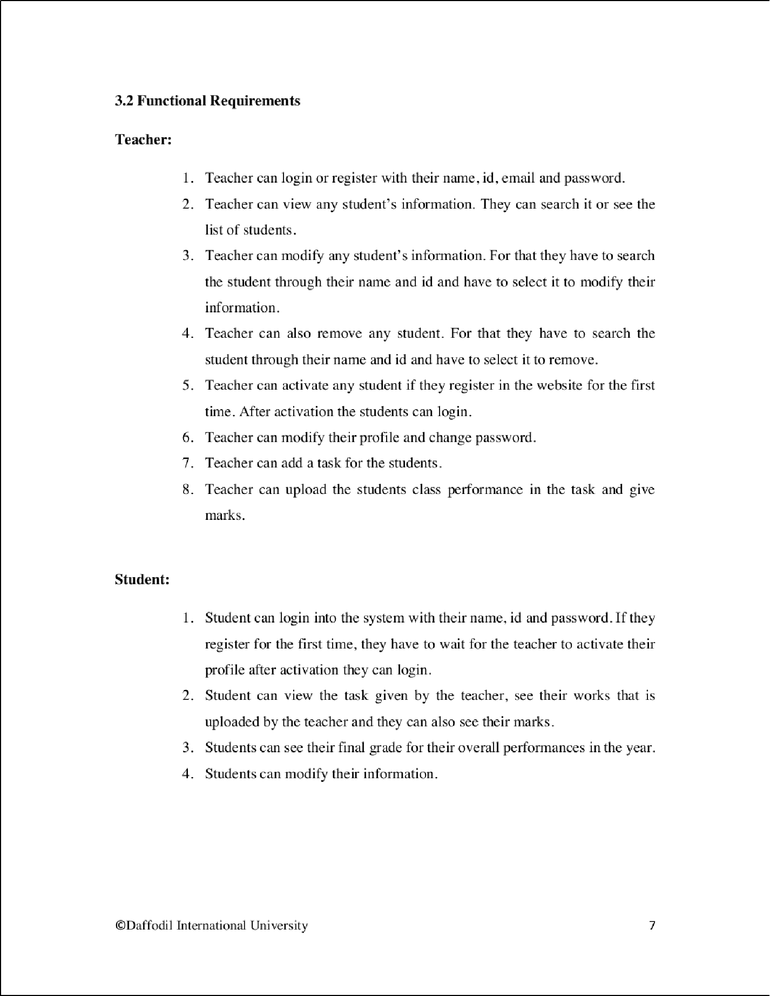

2

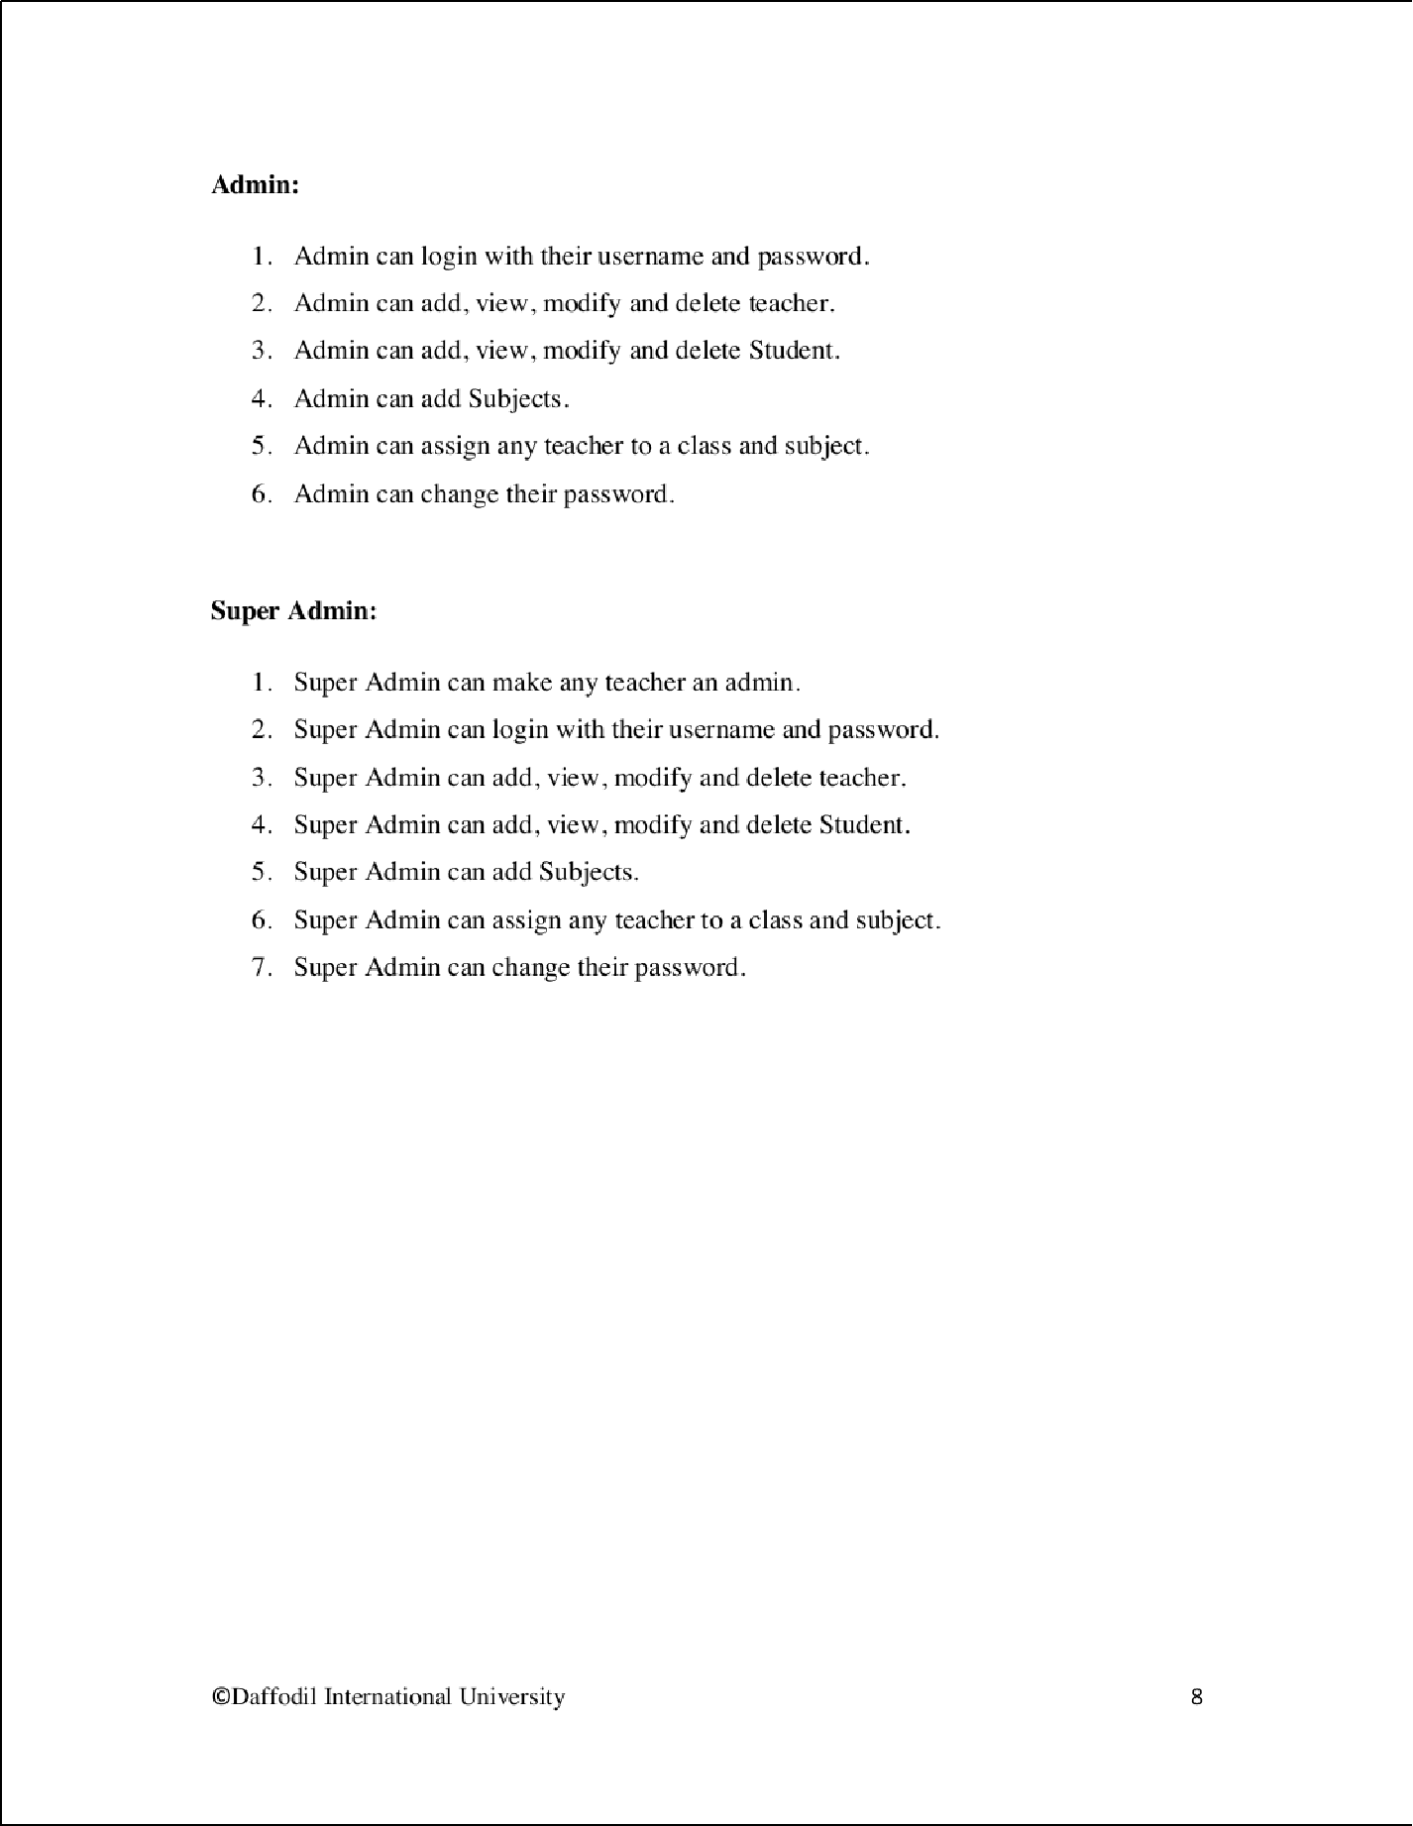

2

12

2

12

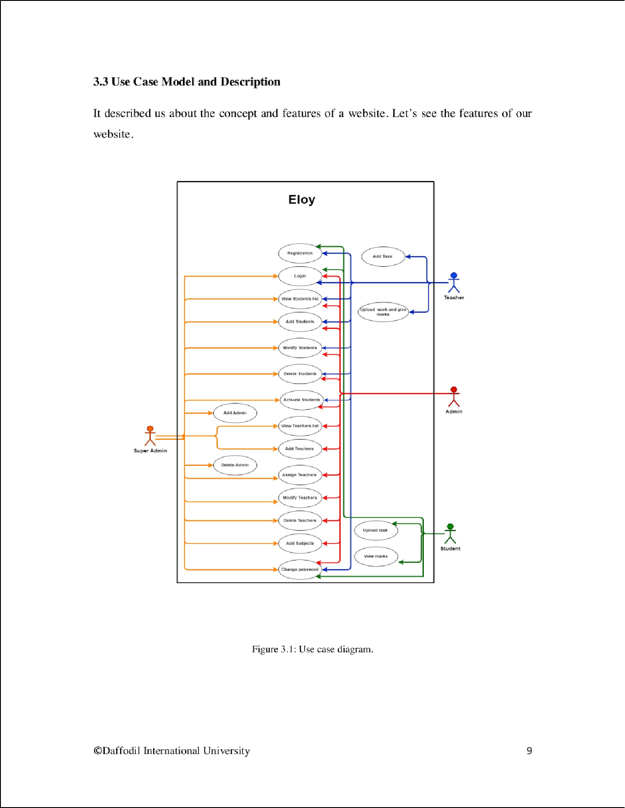

15

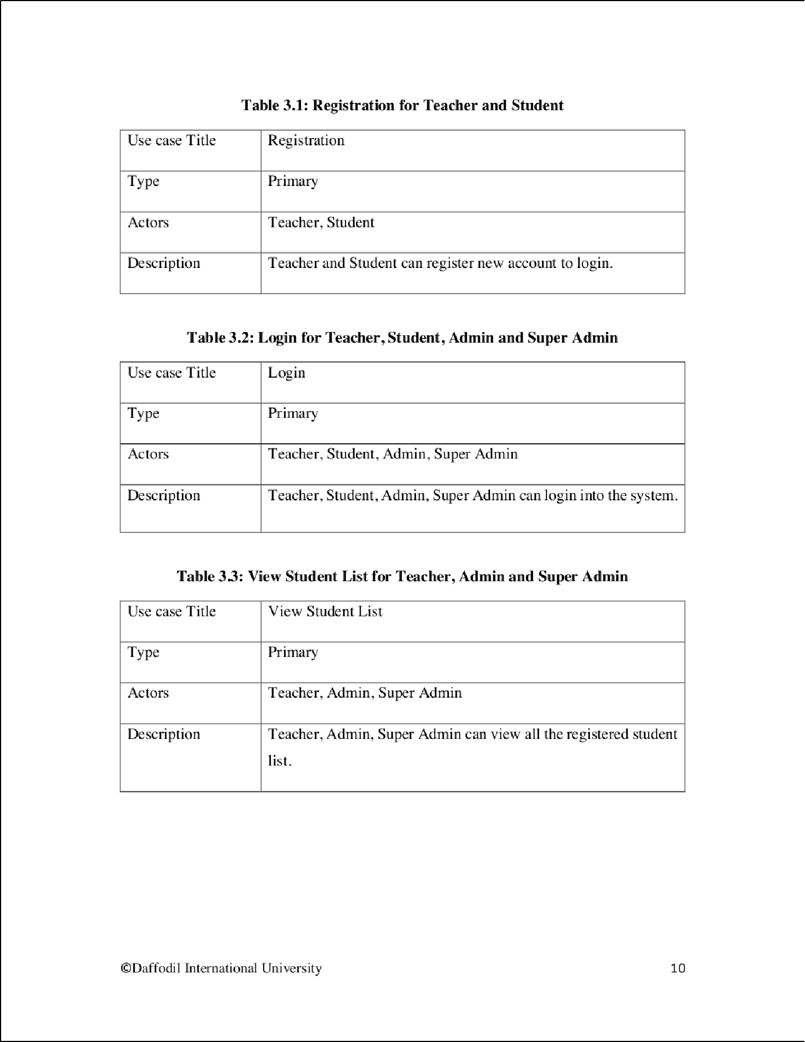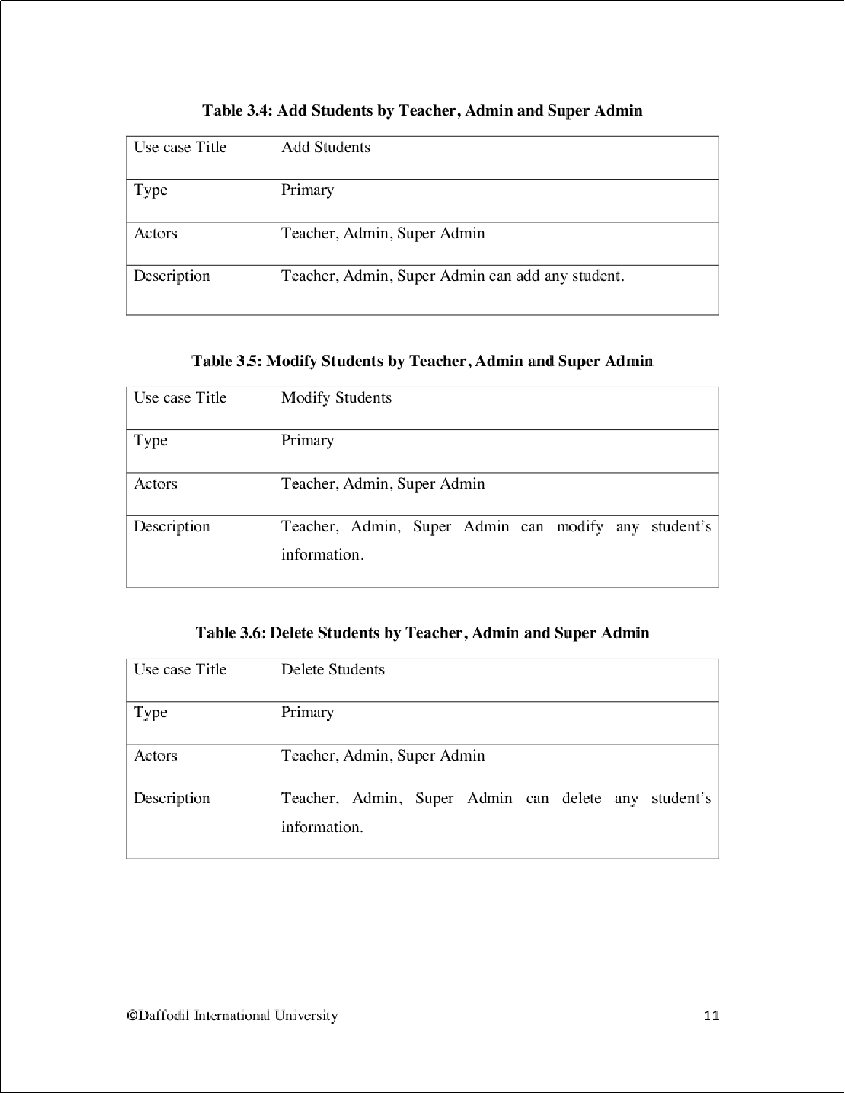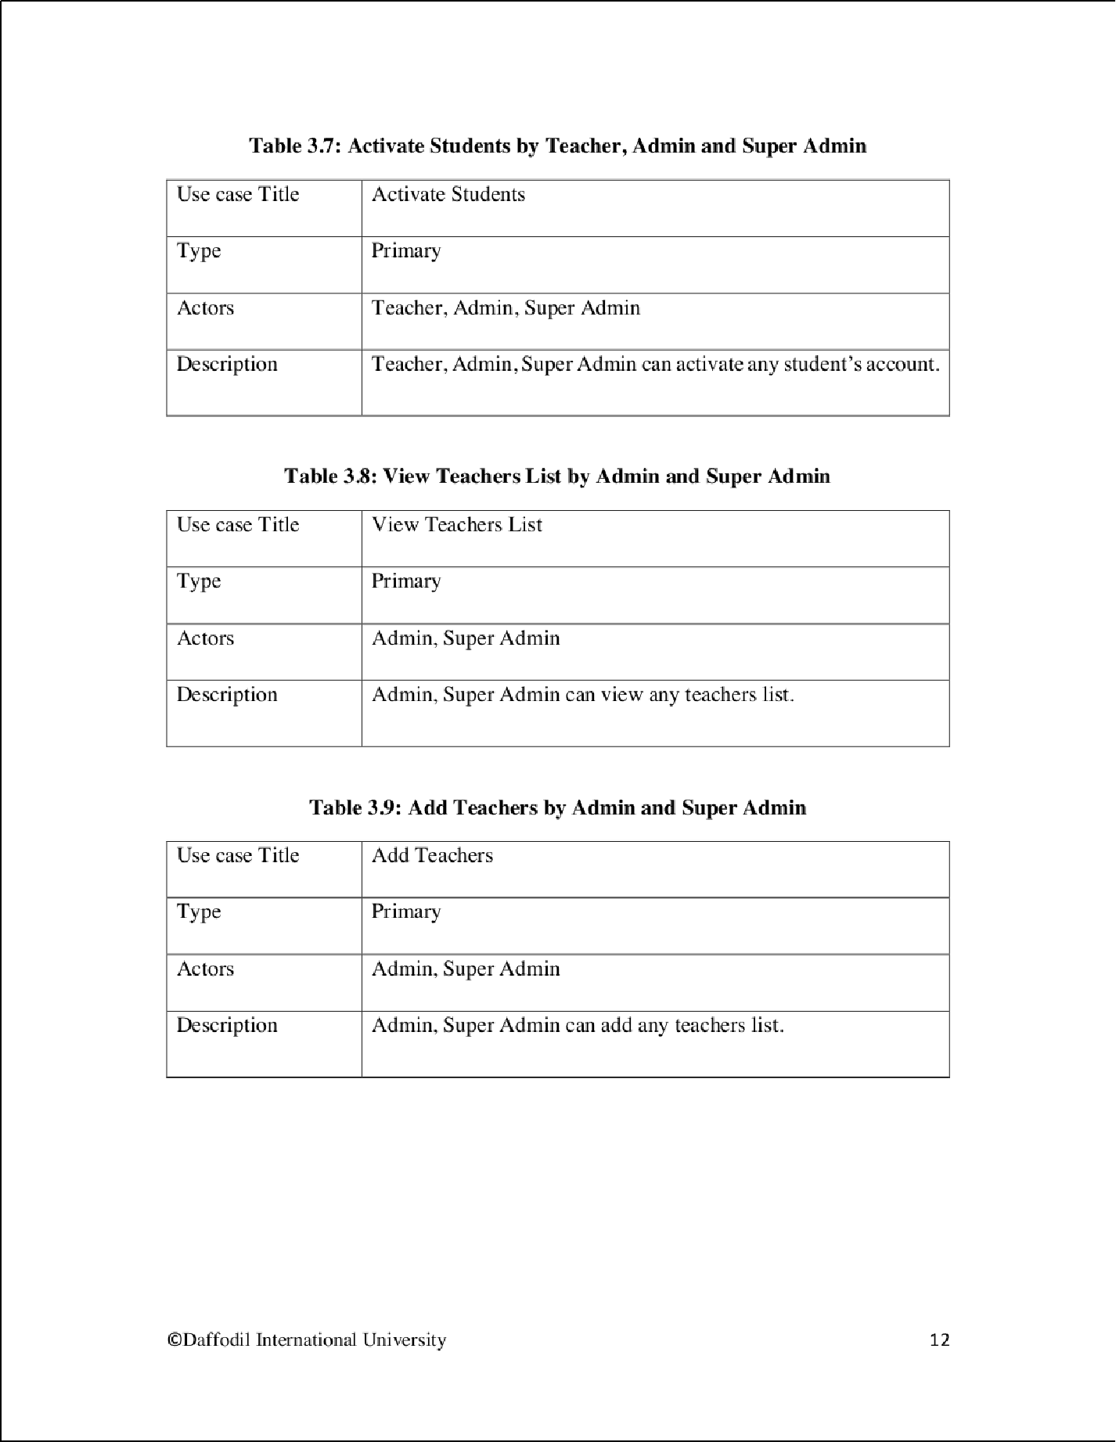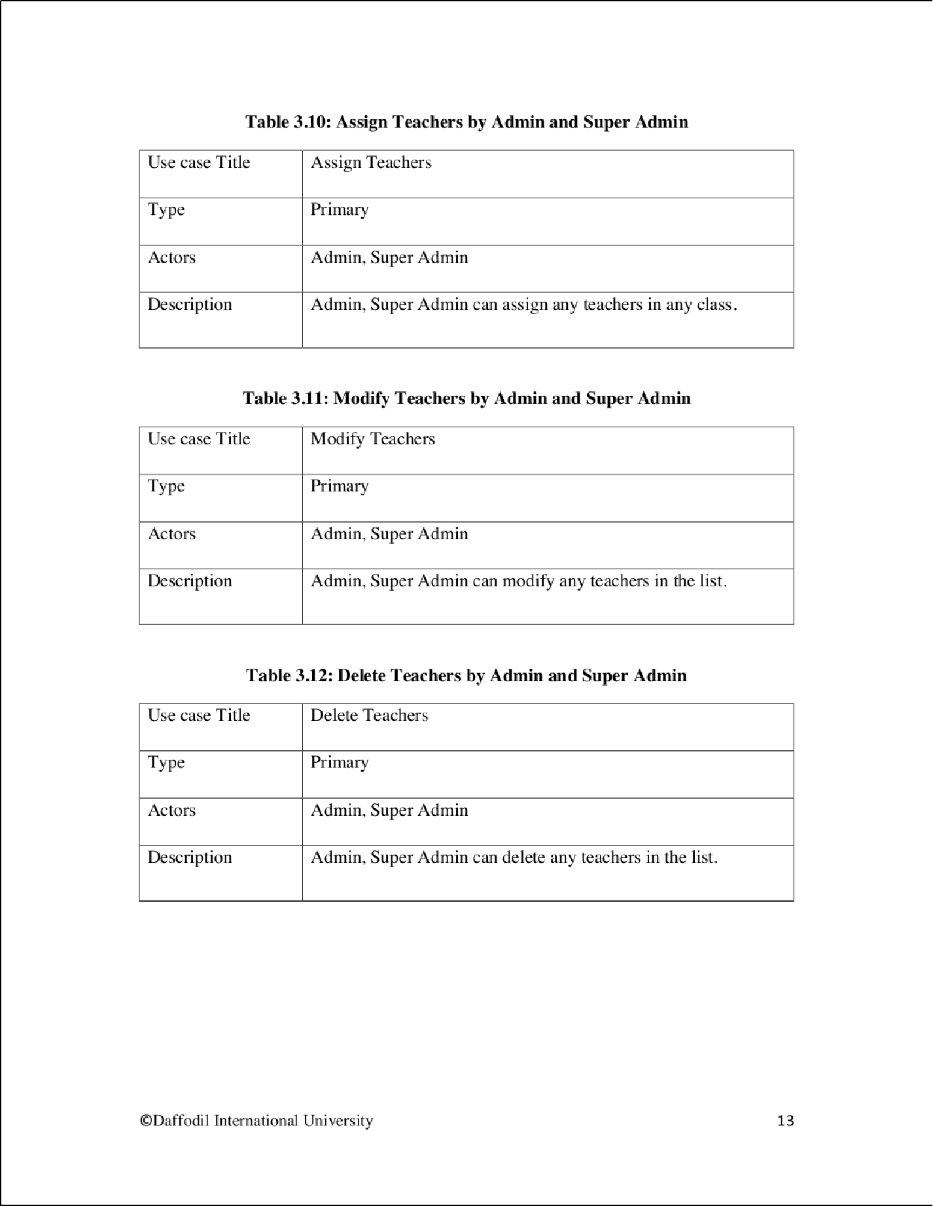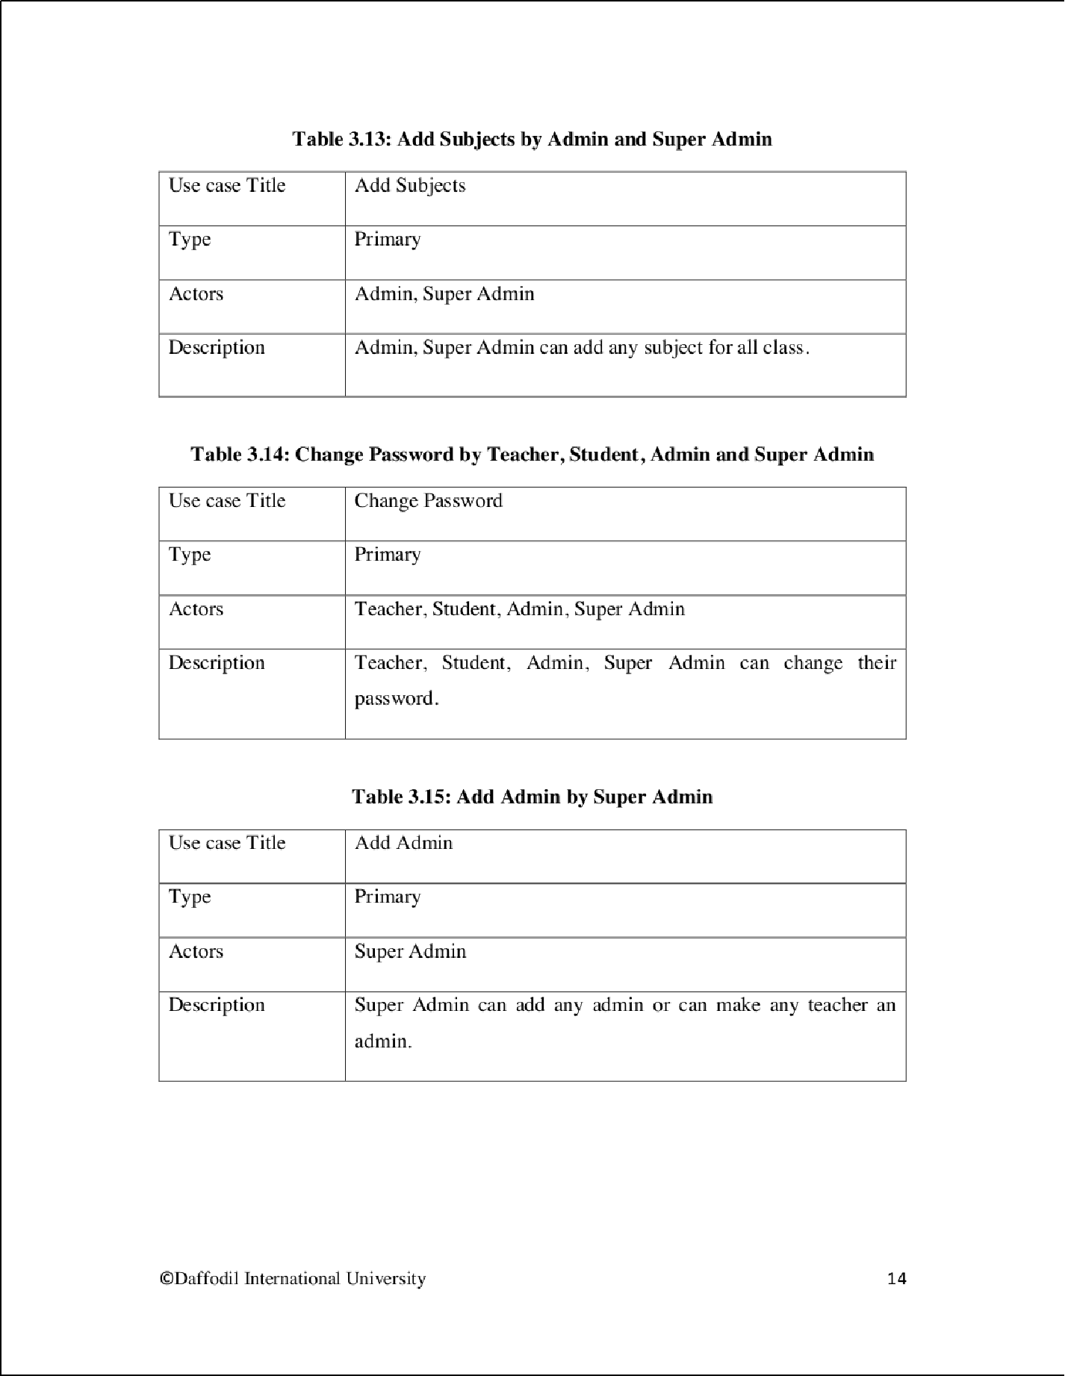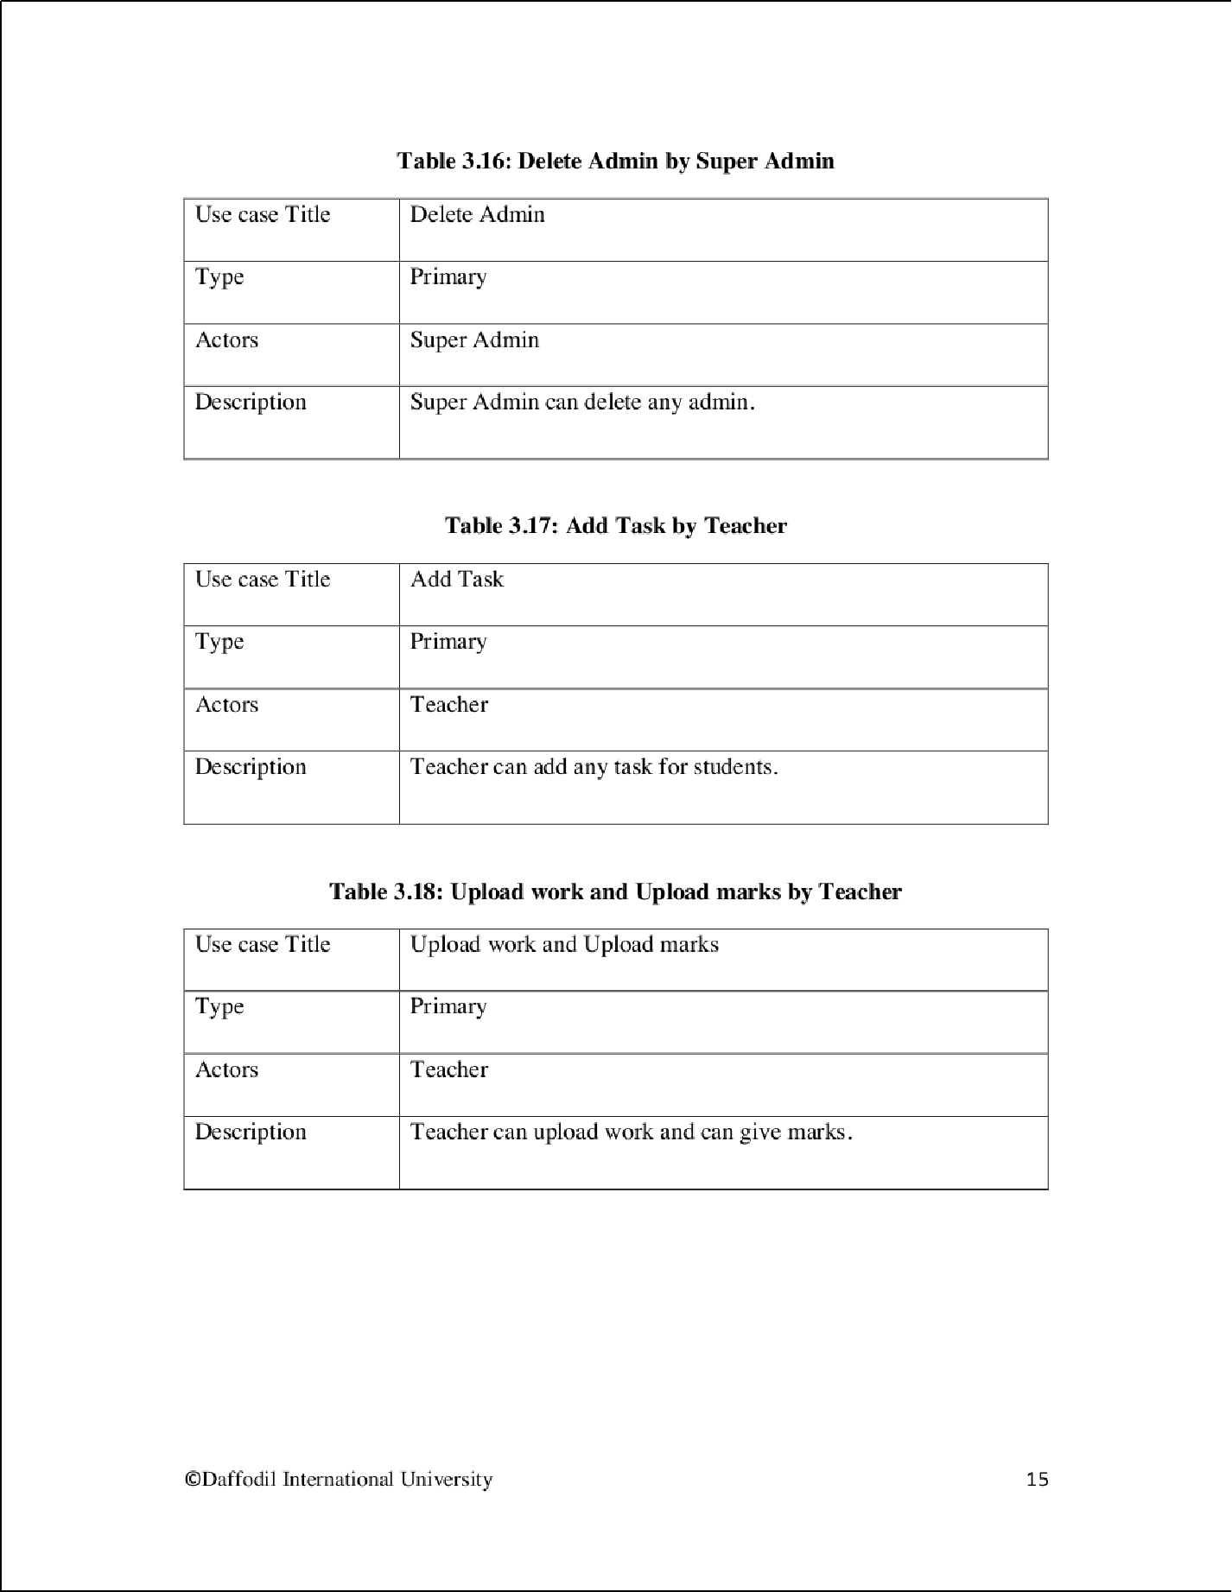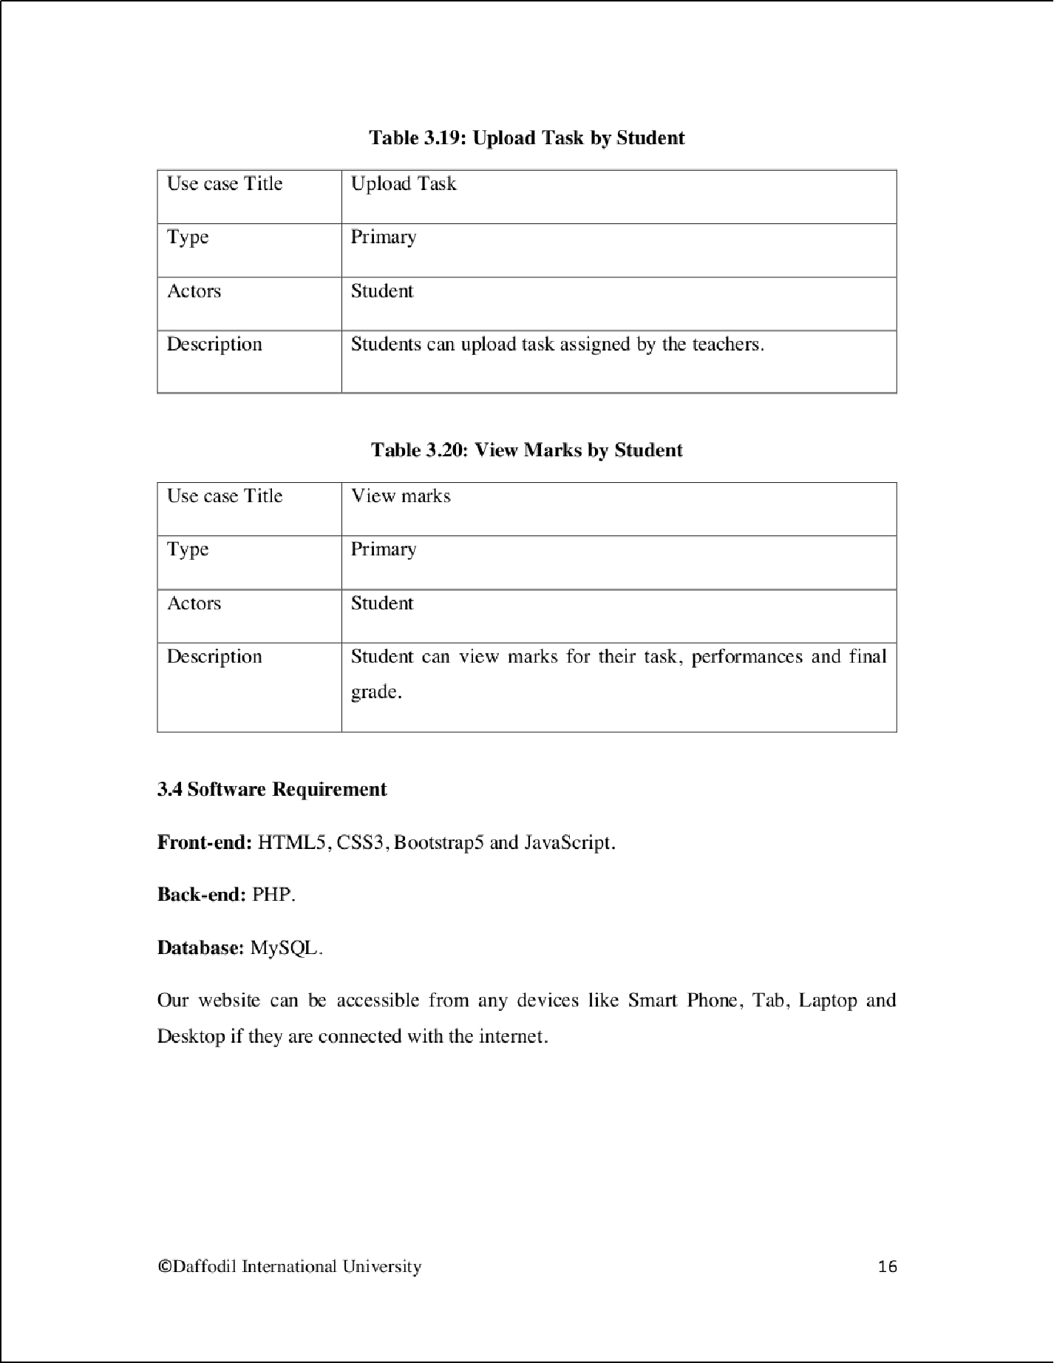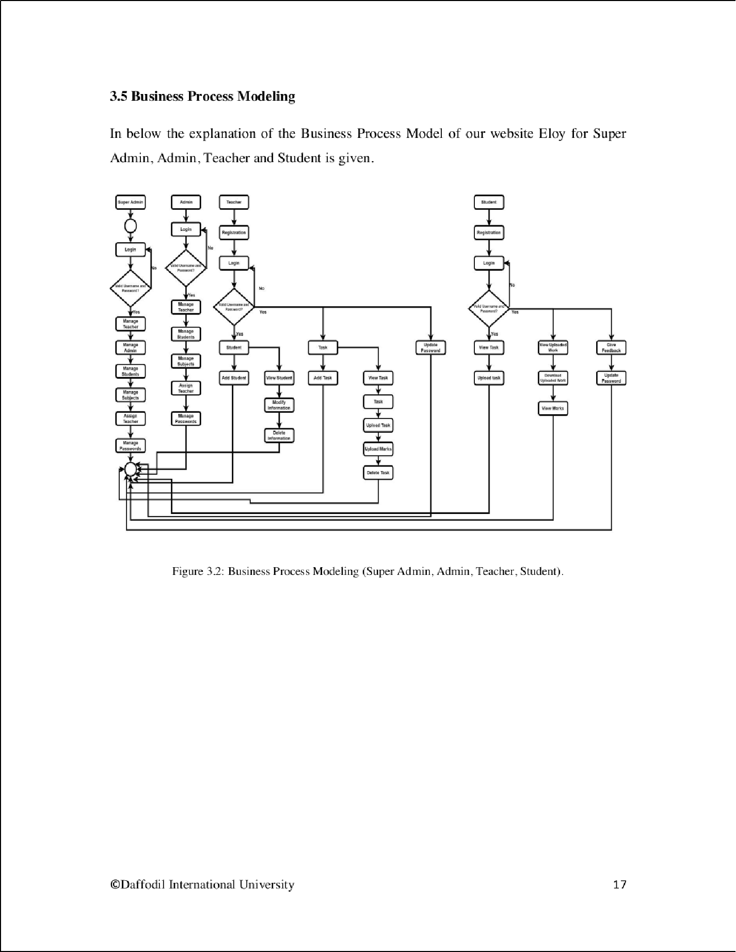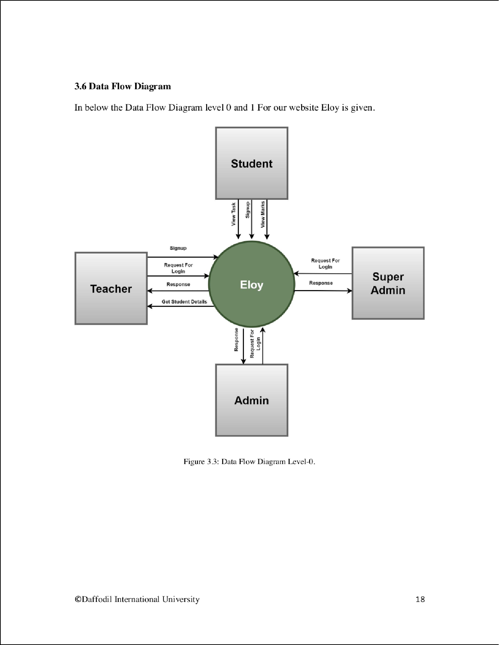

17

3

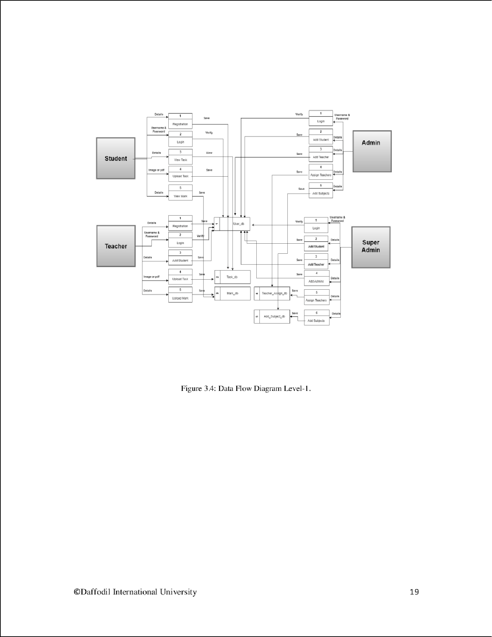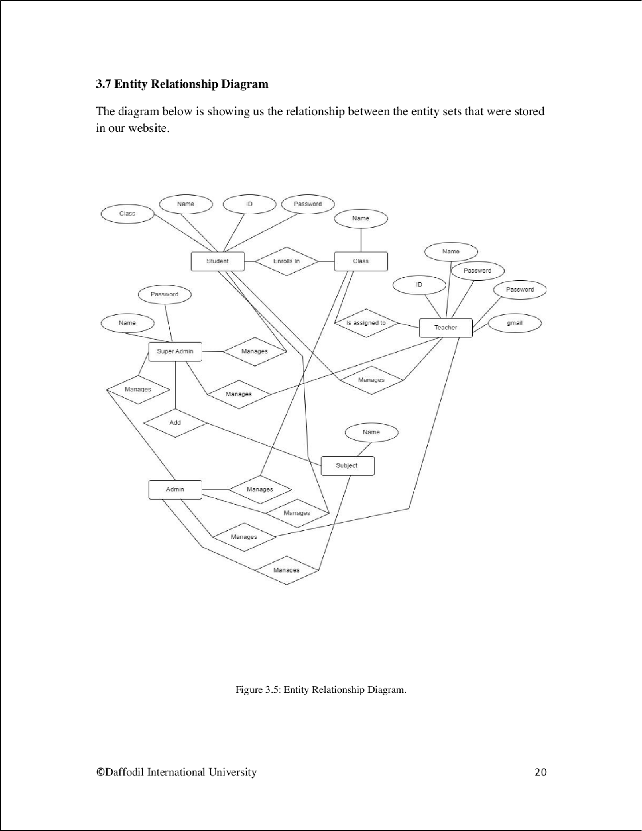

19

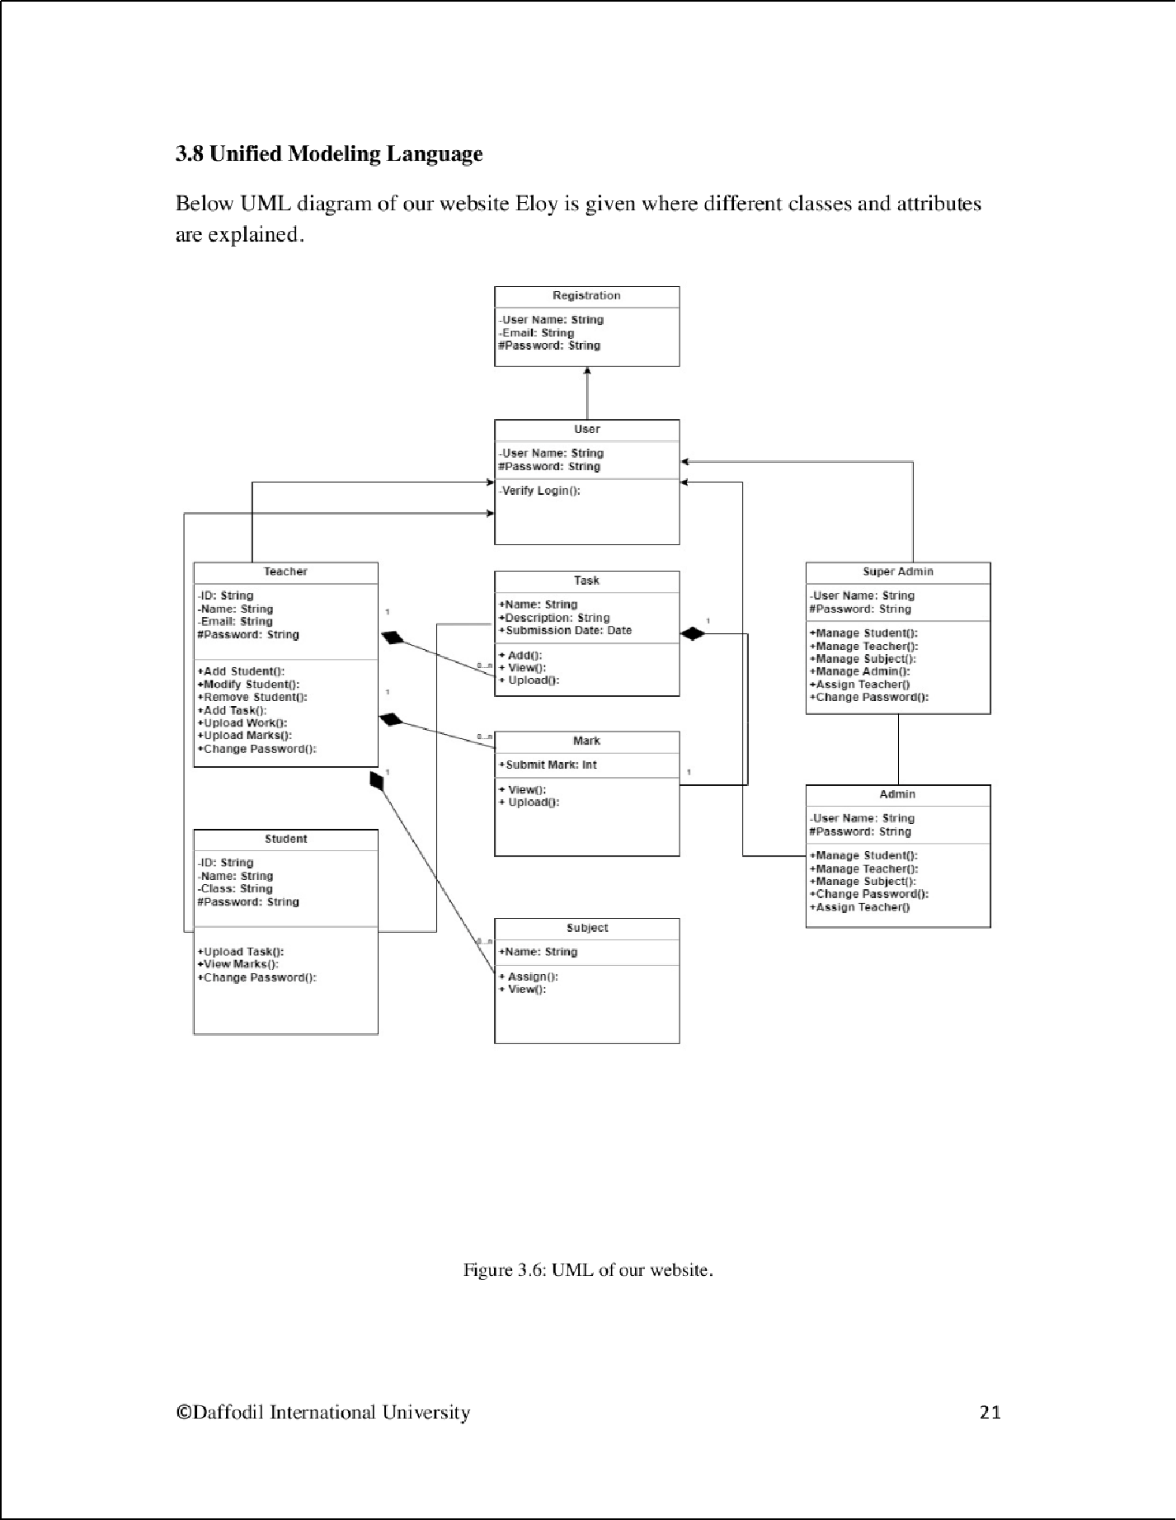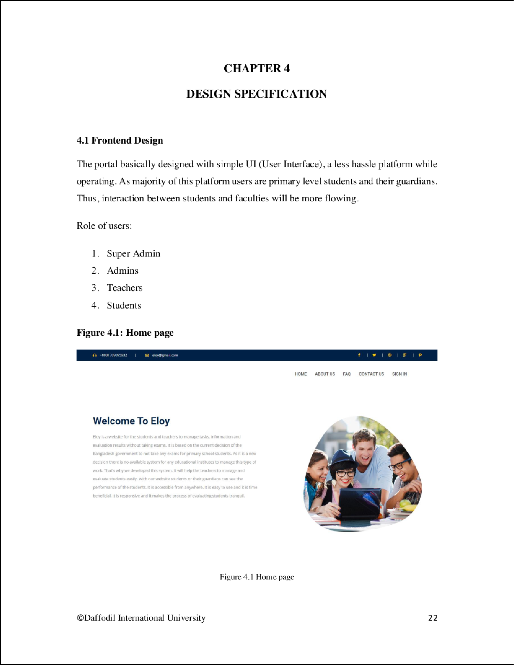

2

1

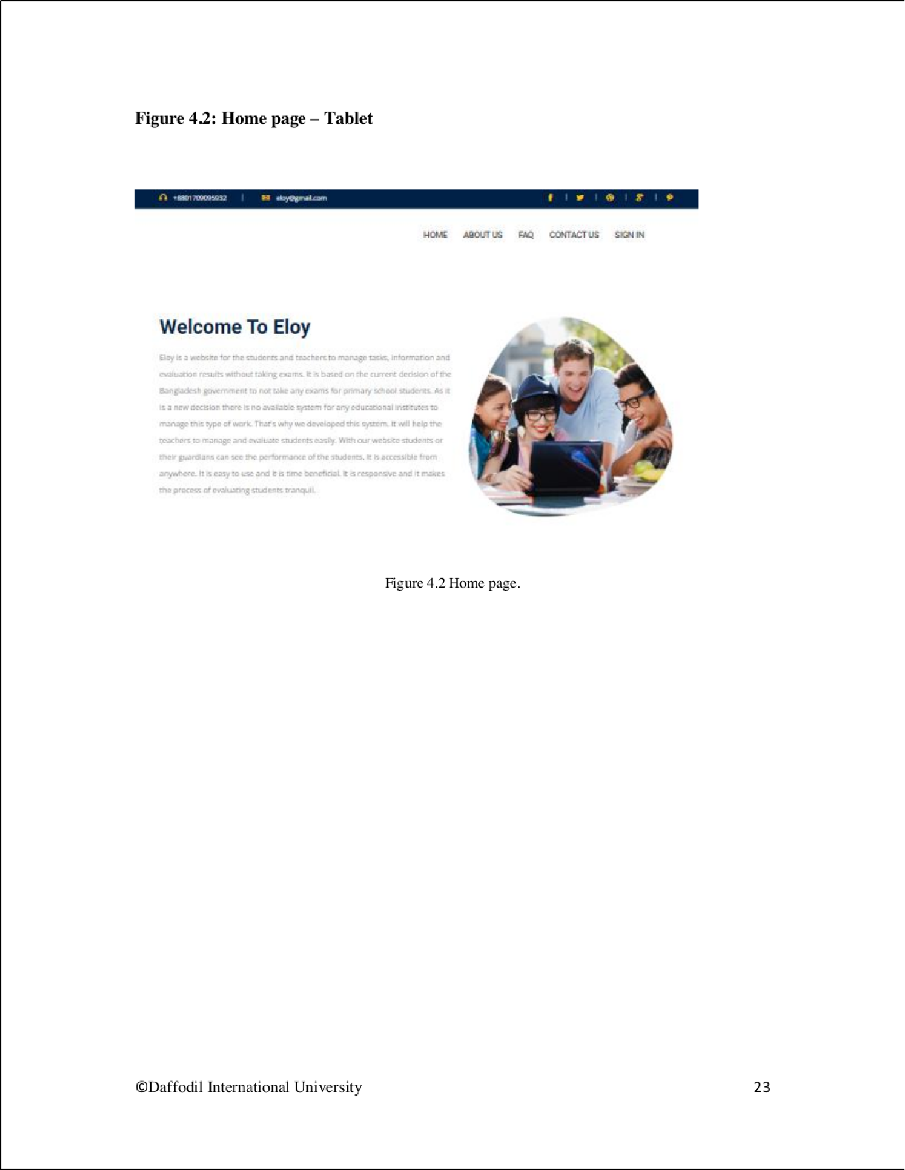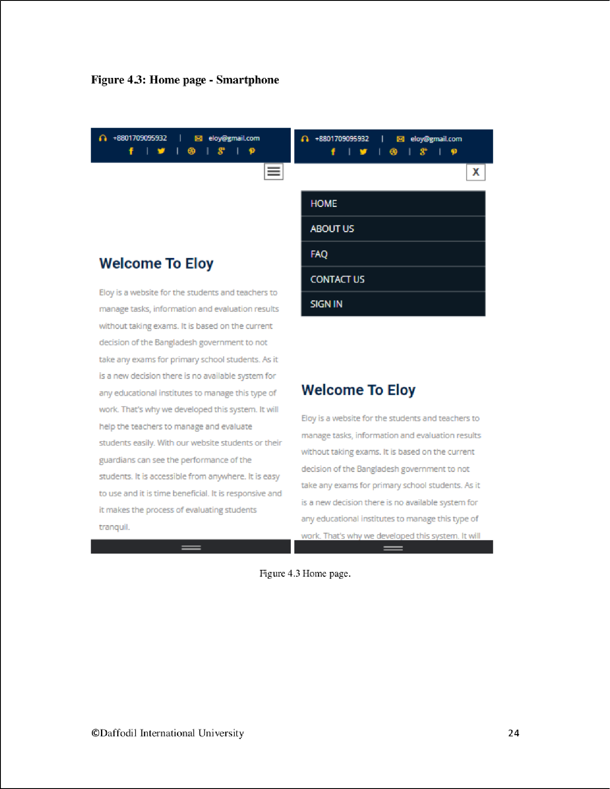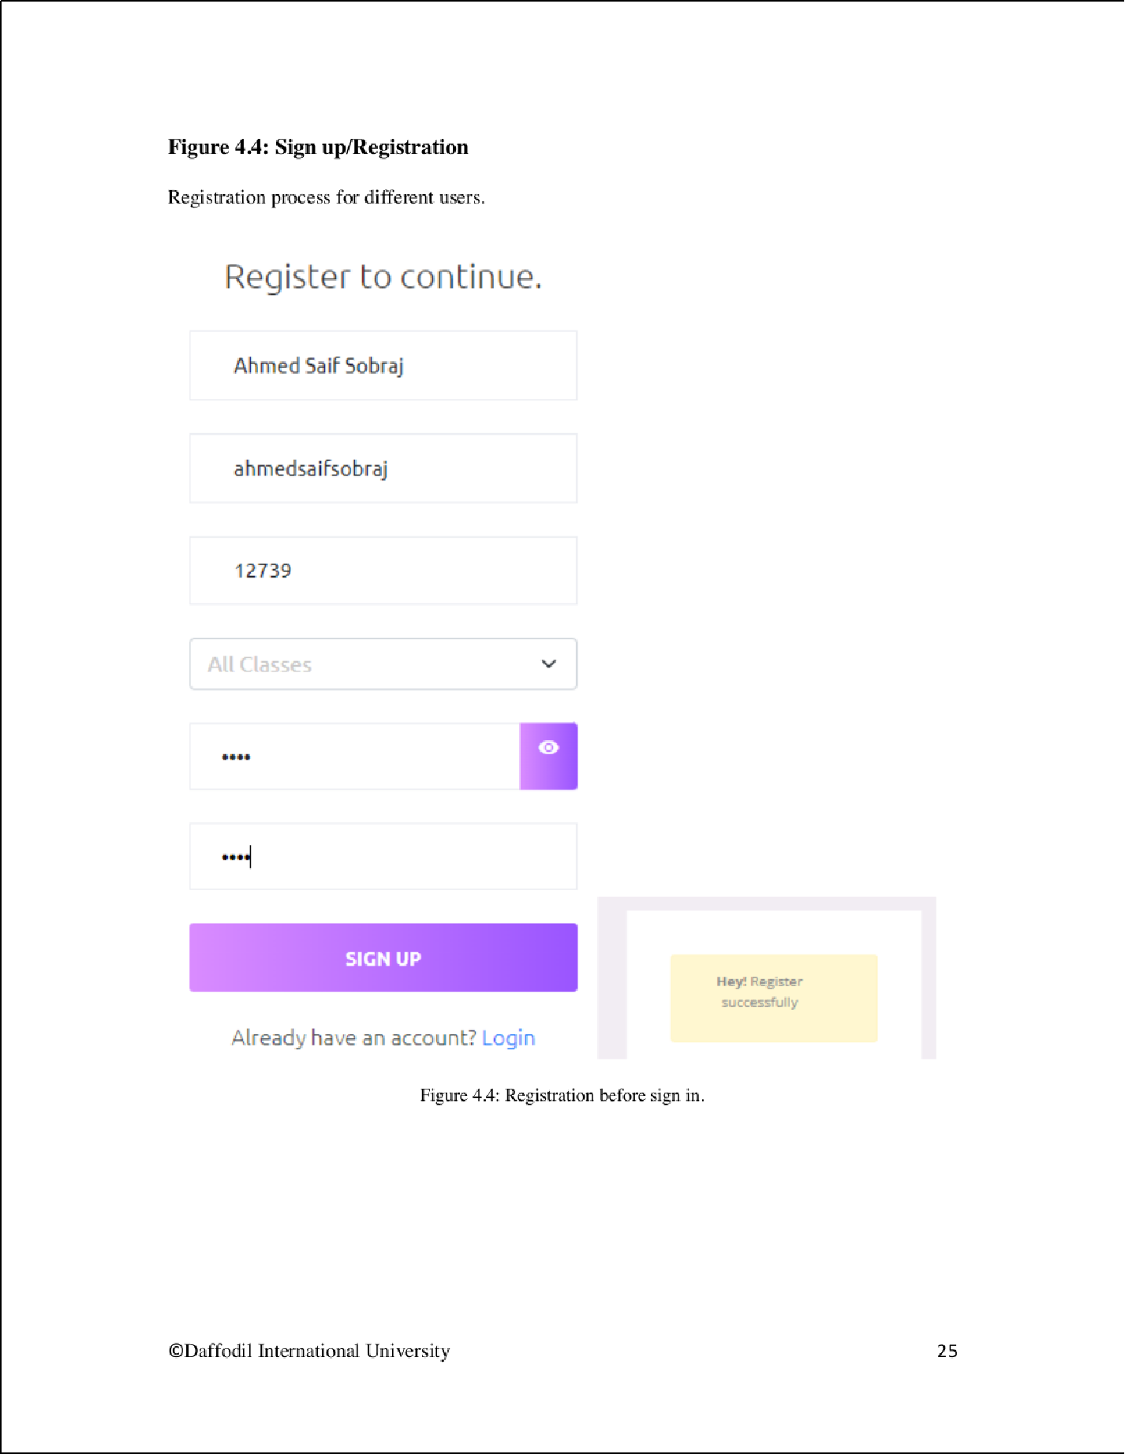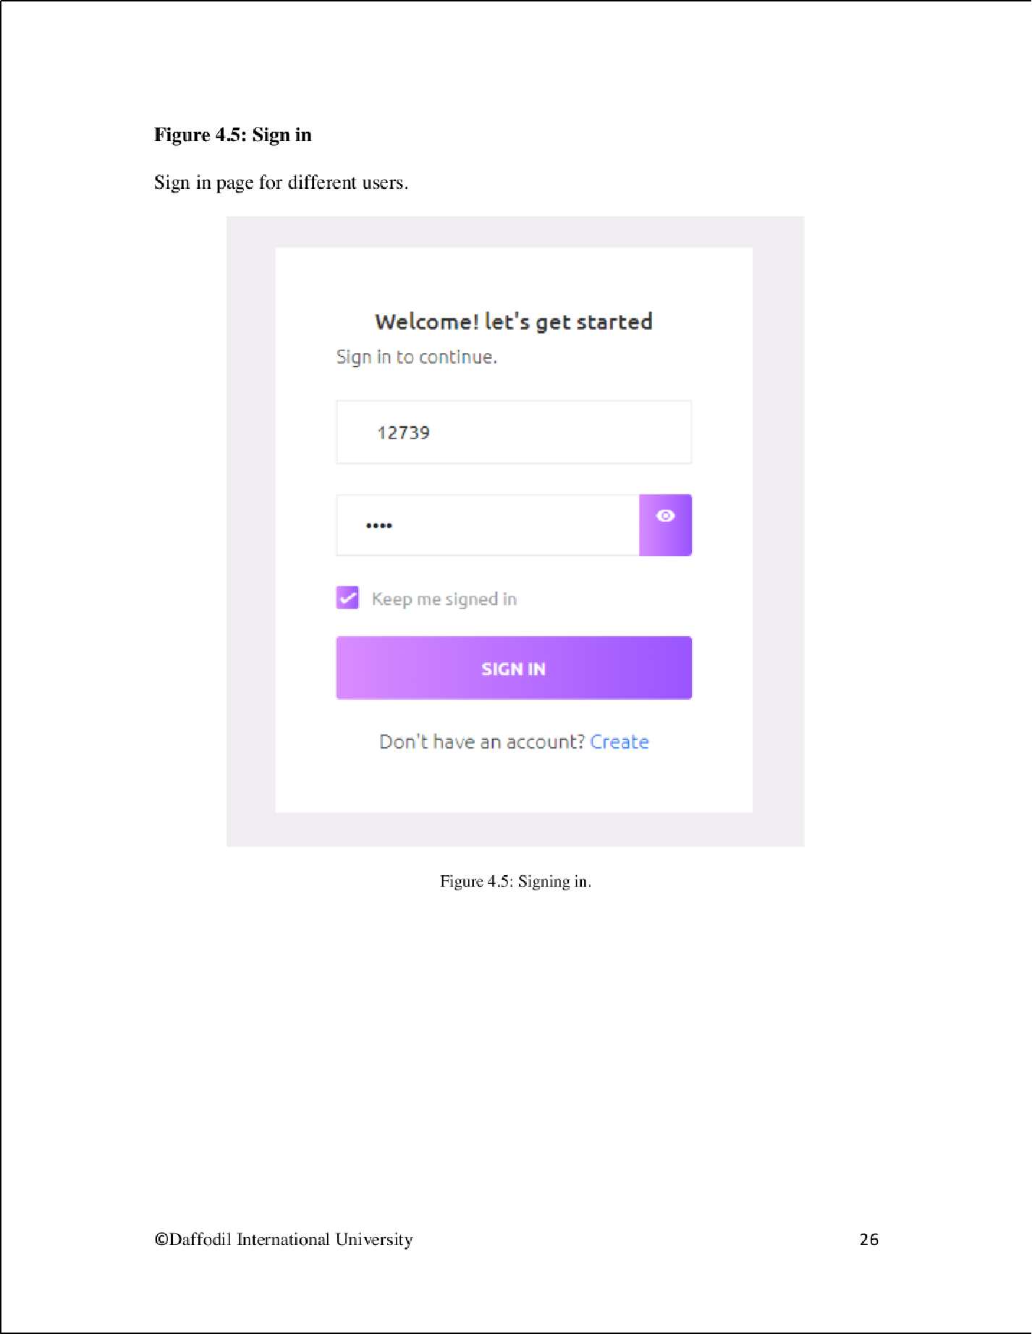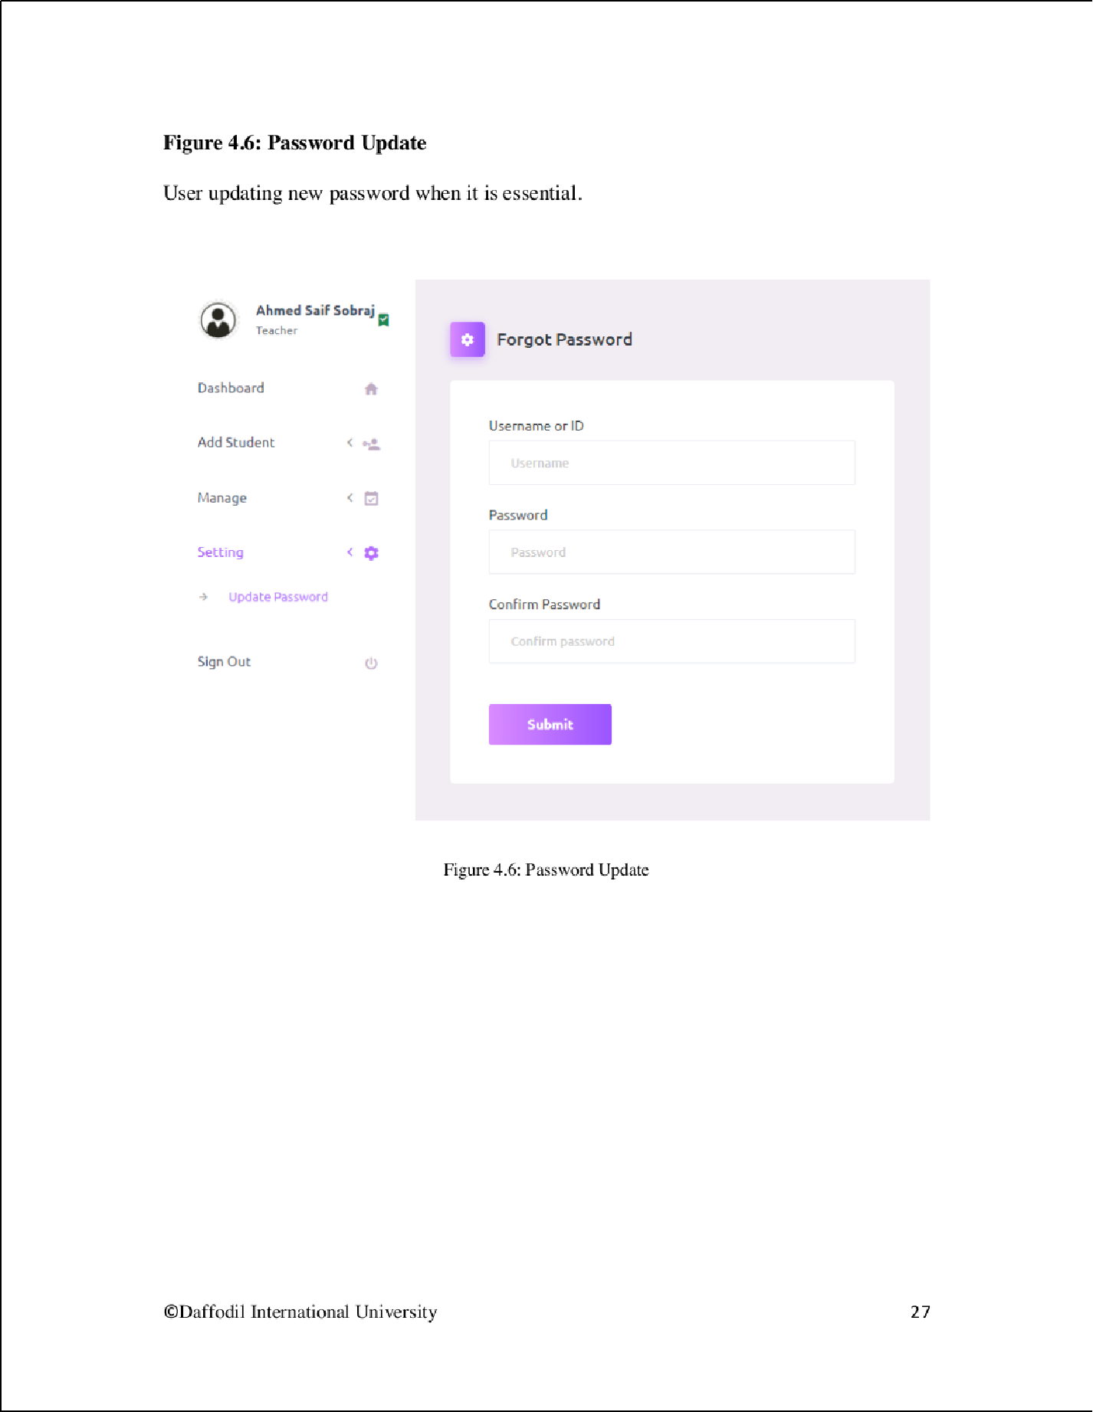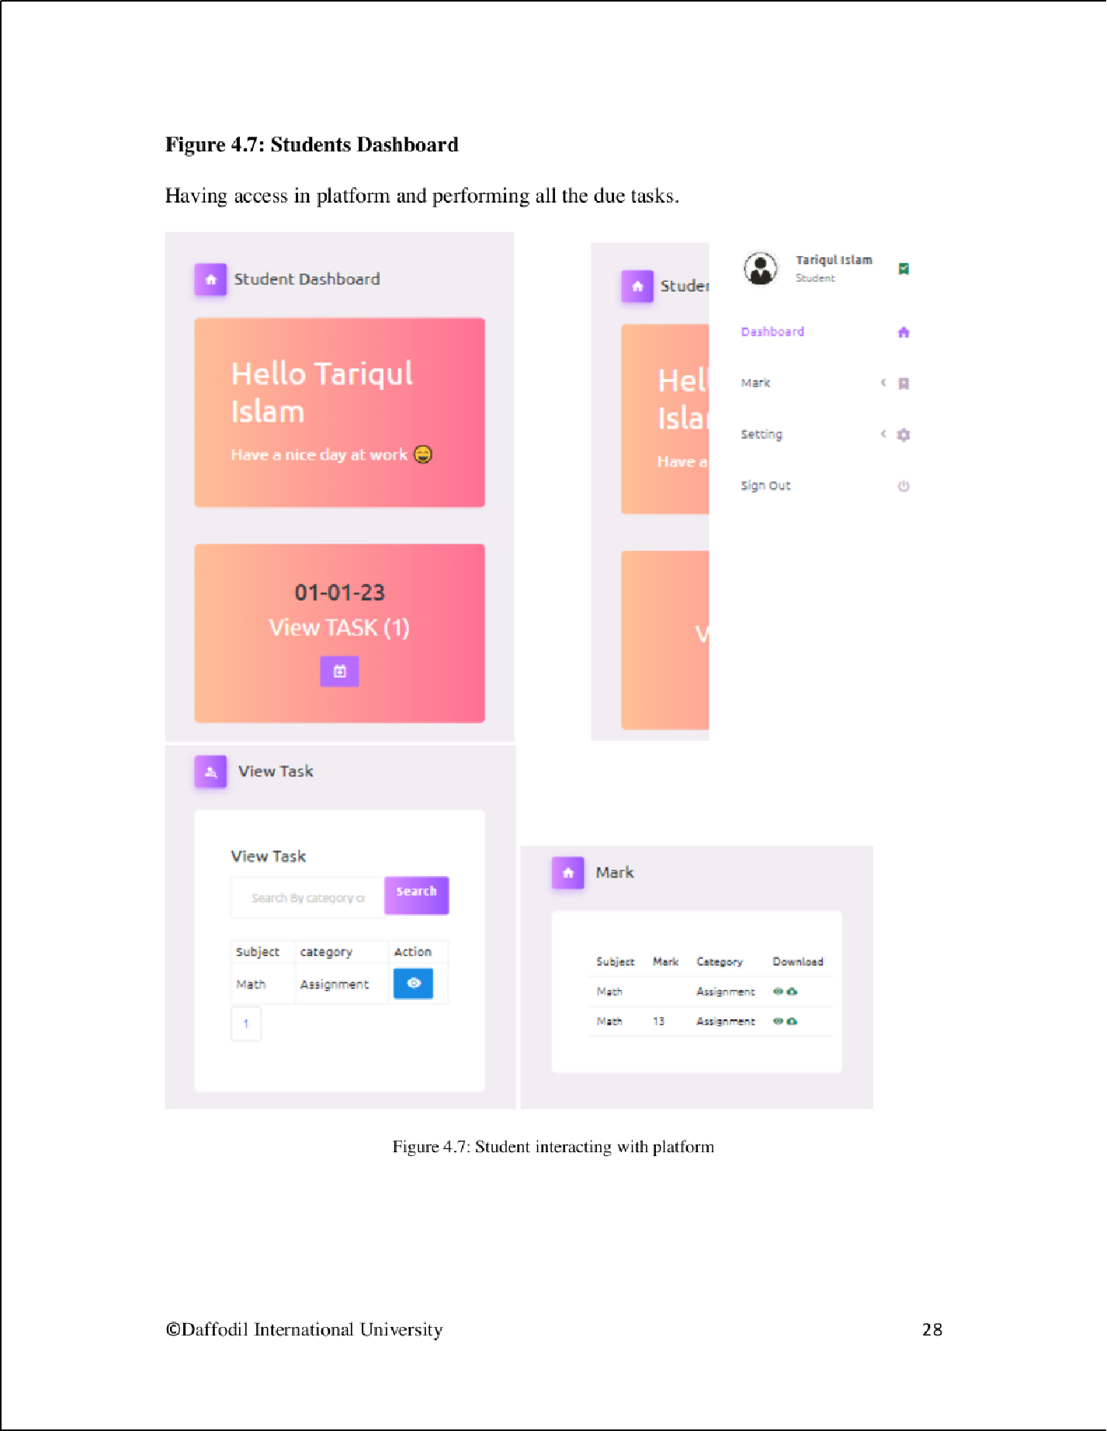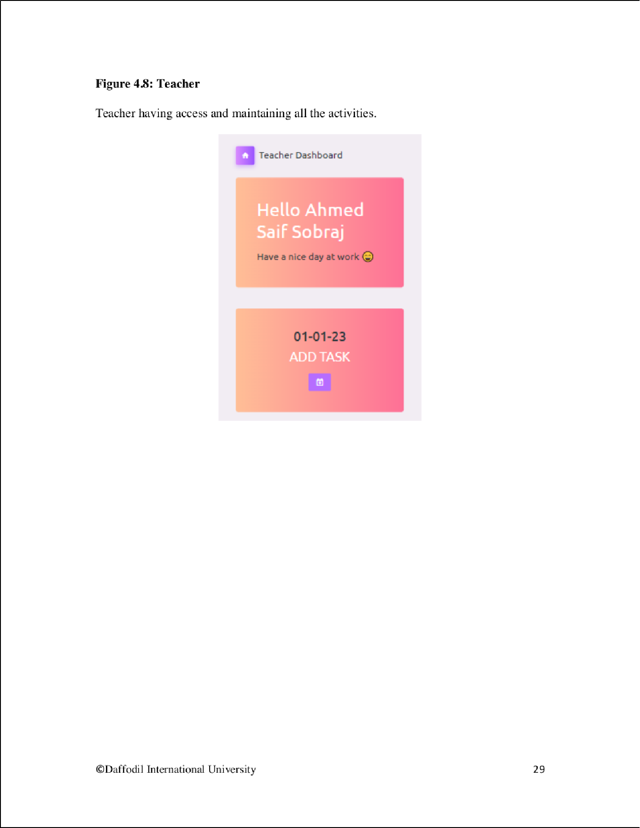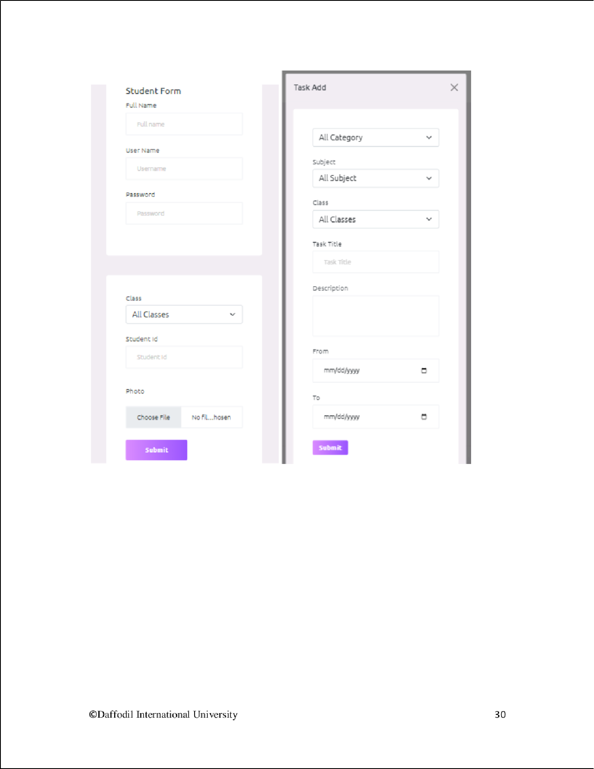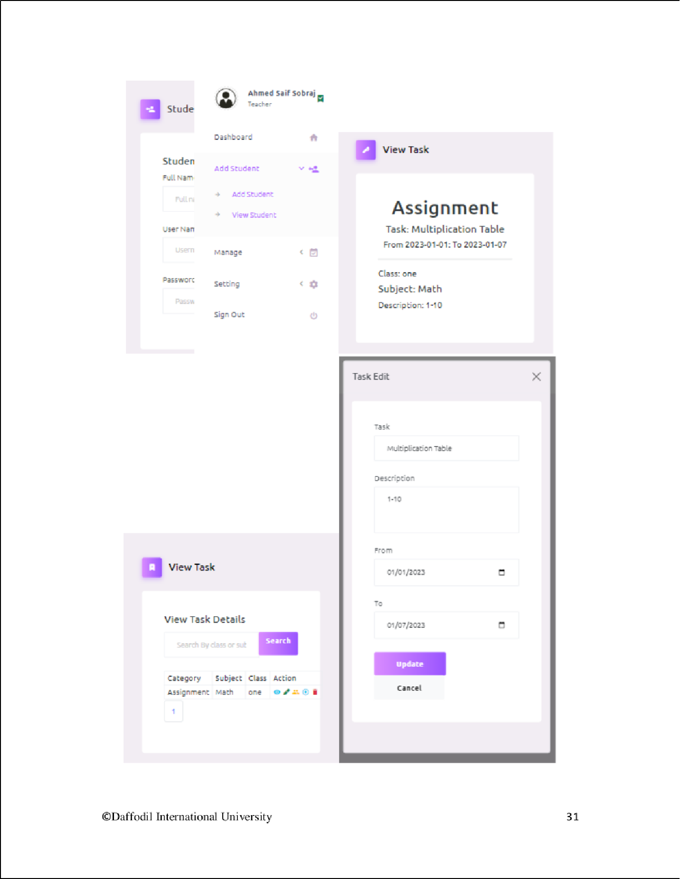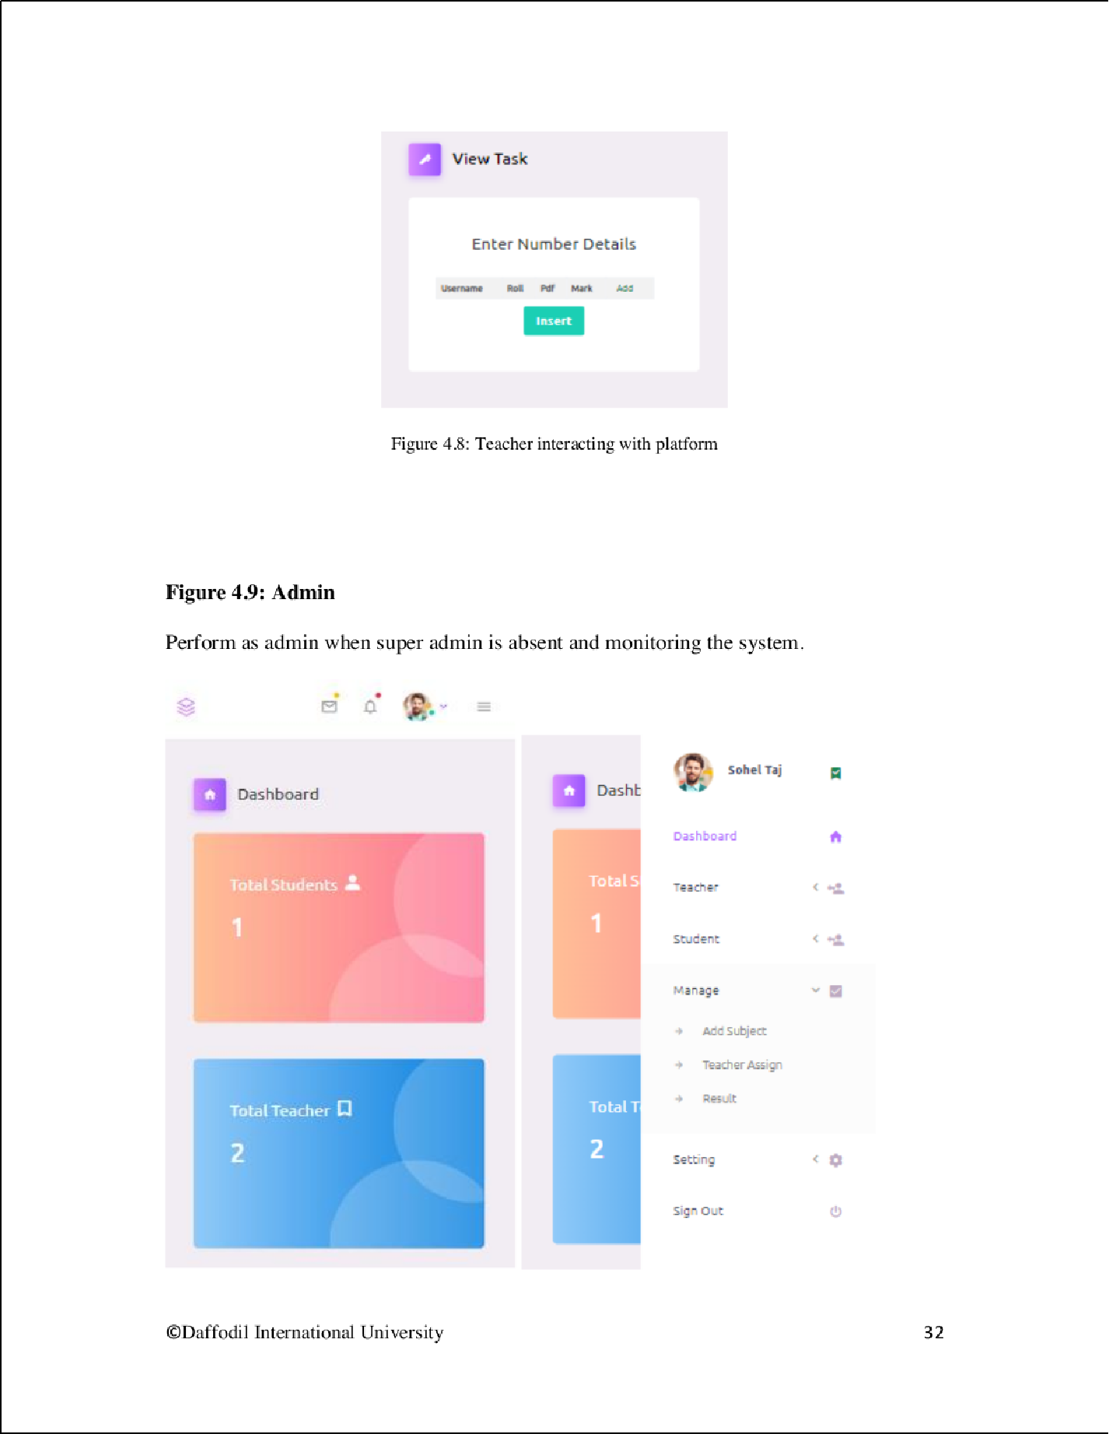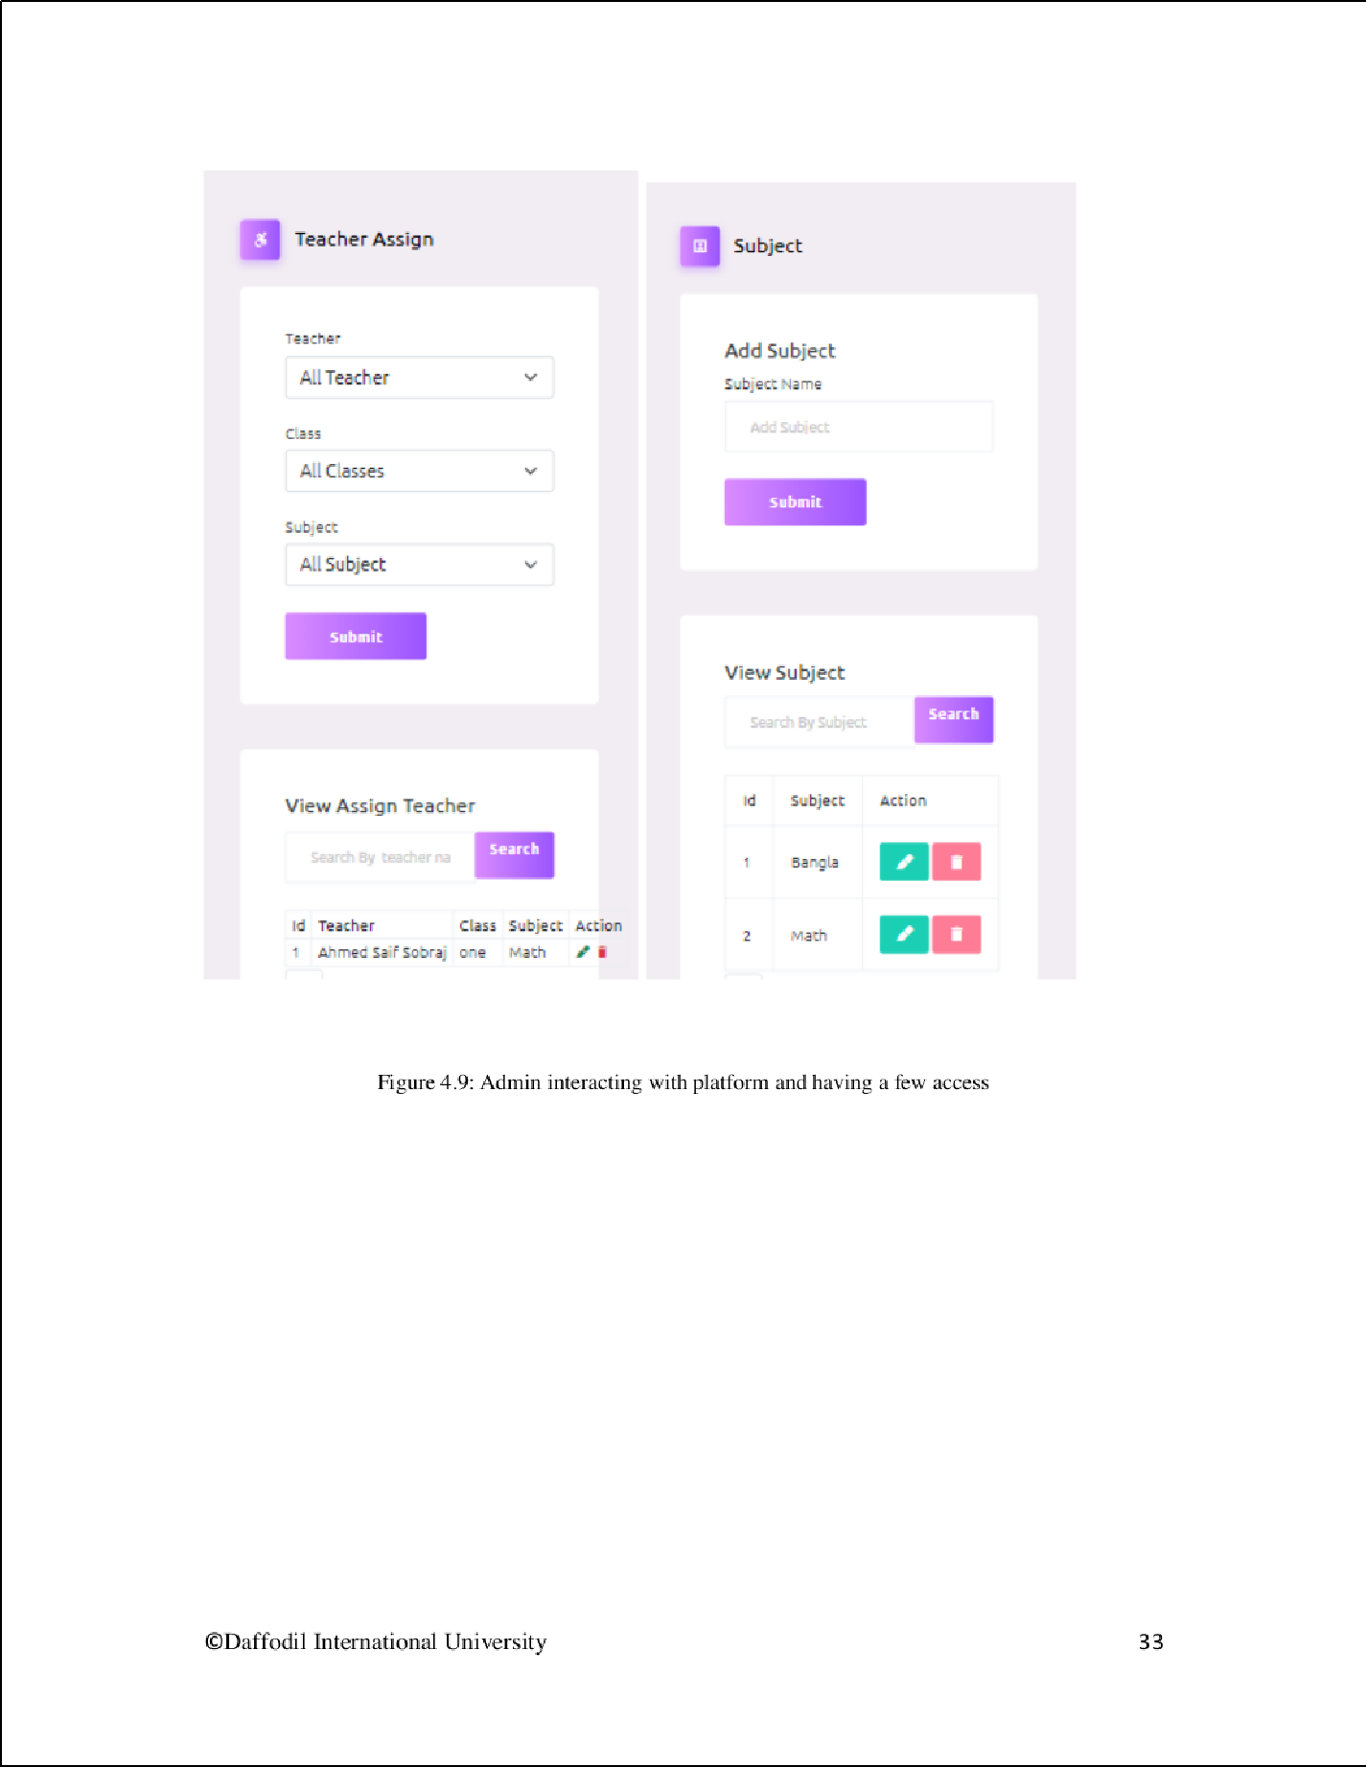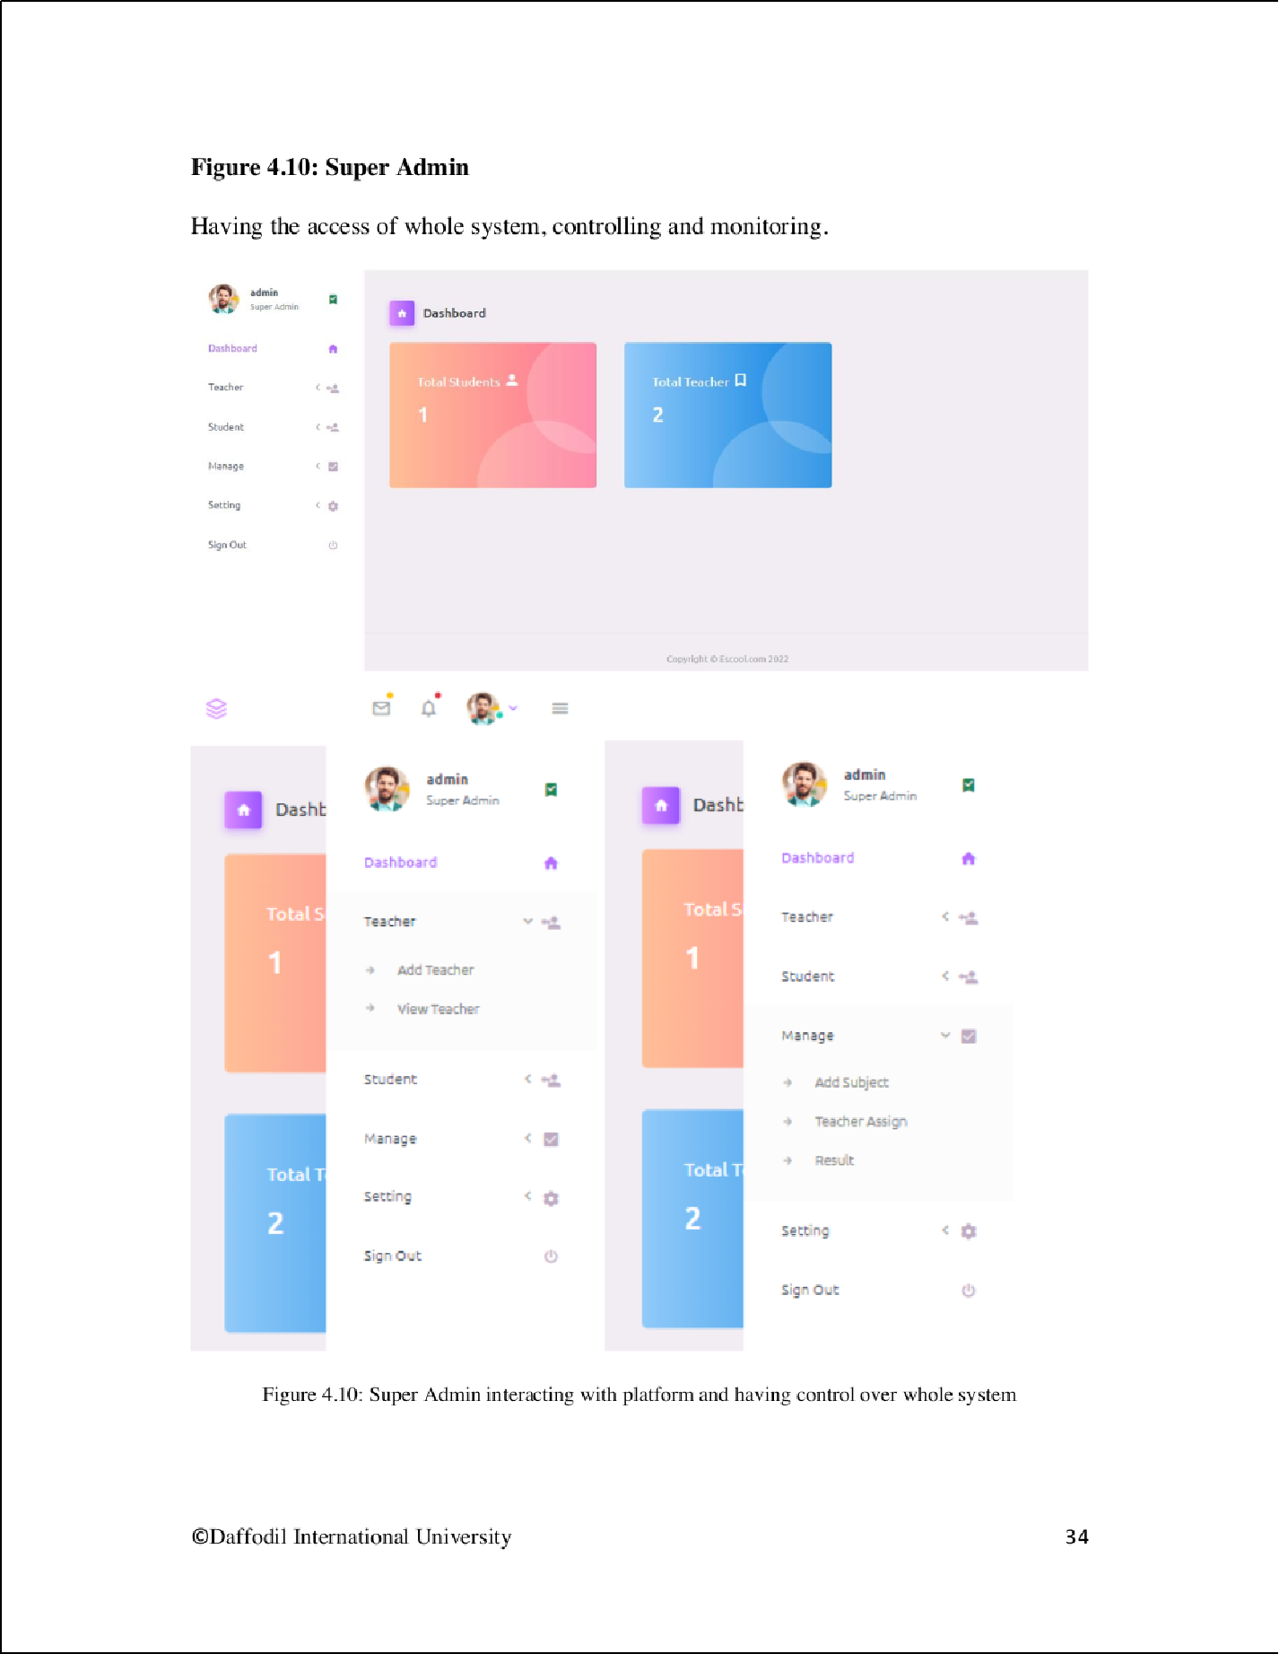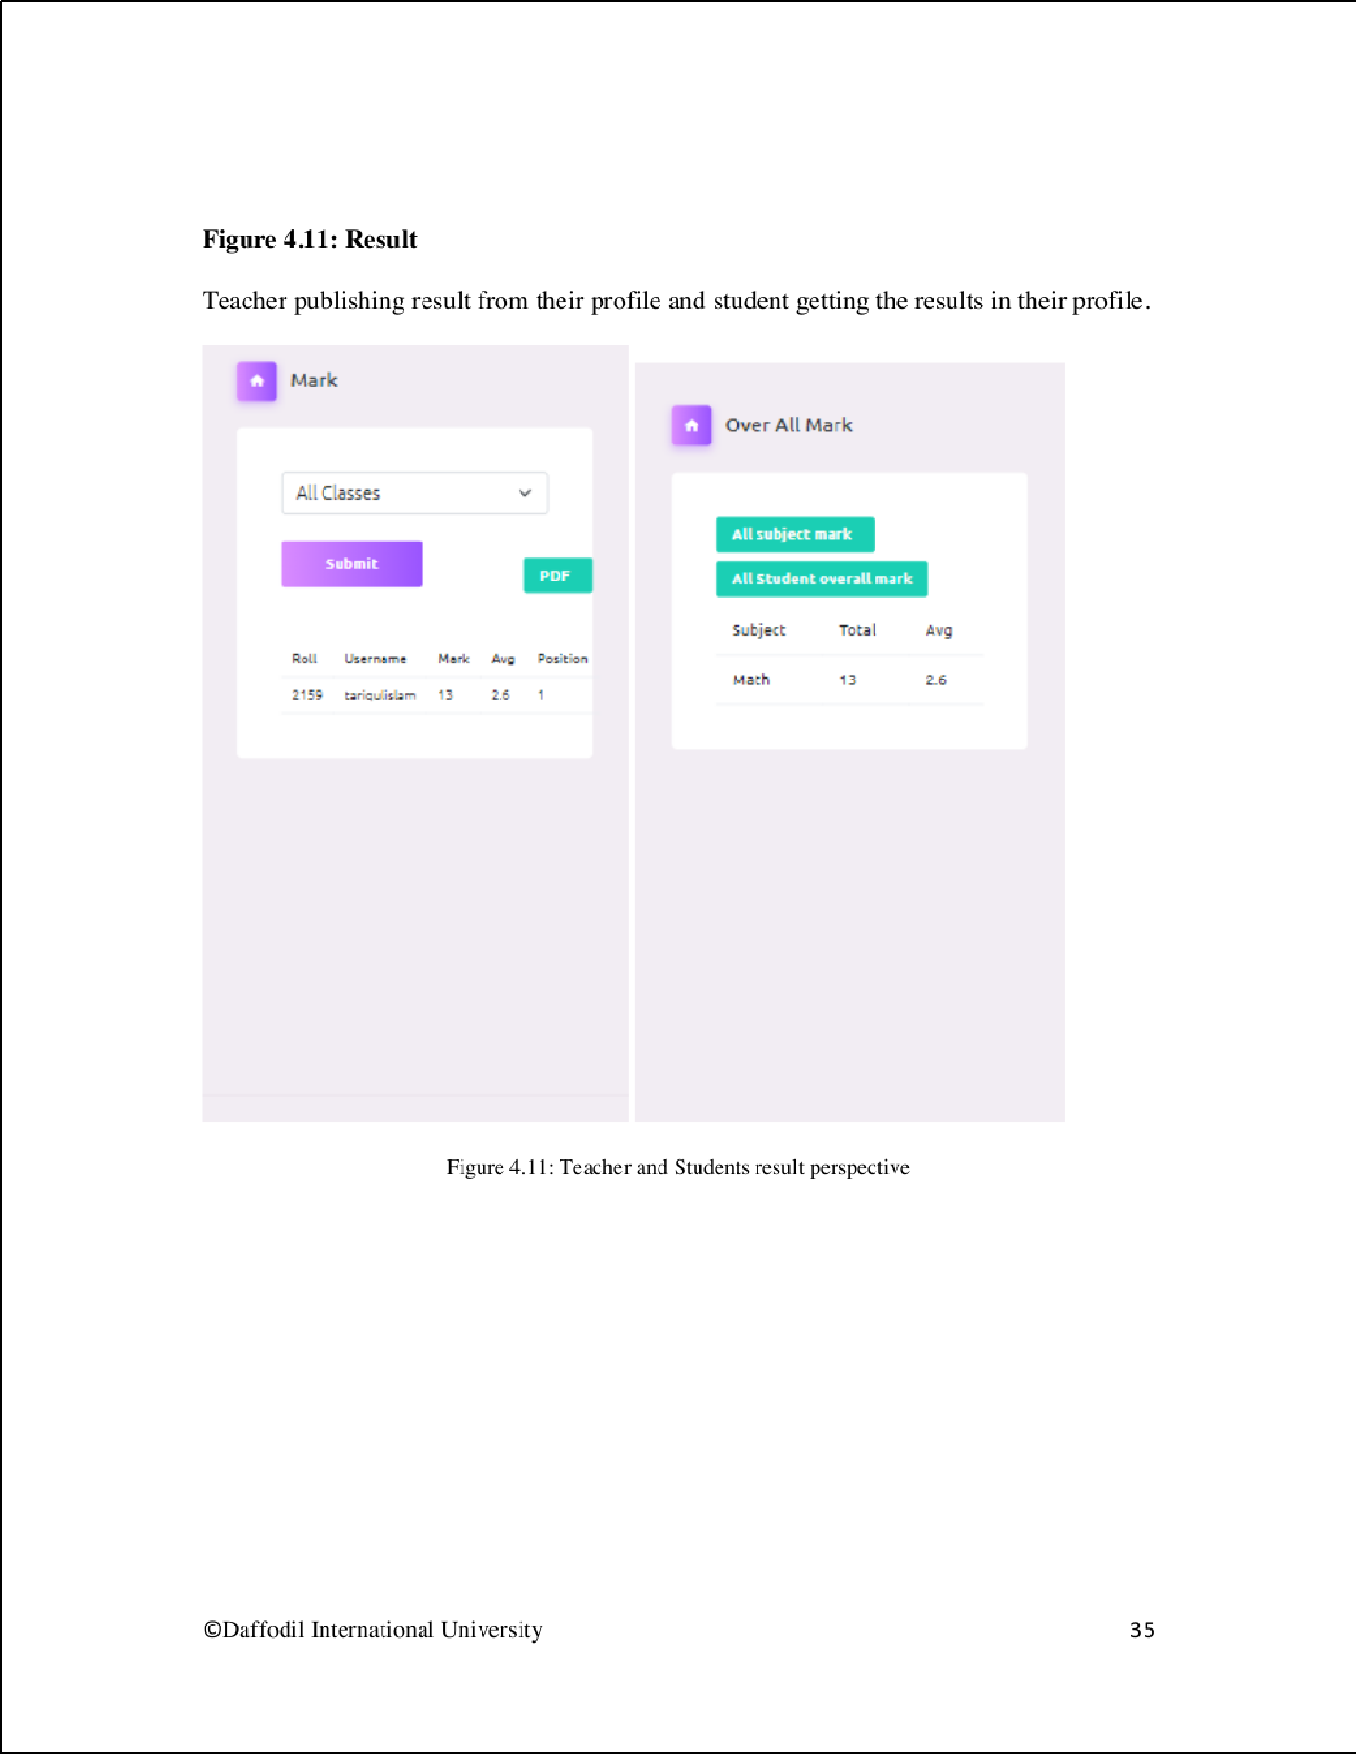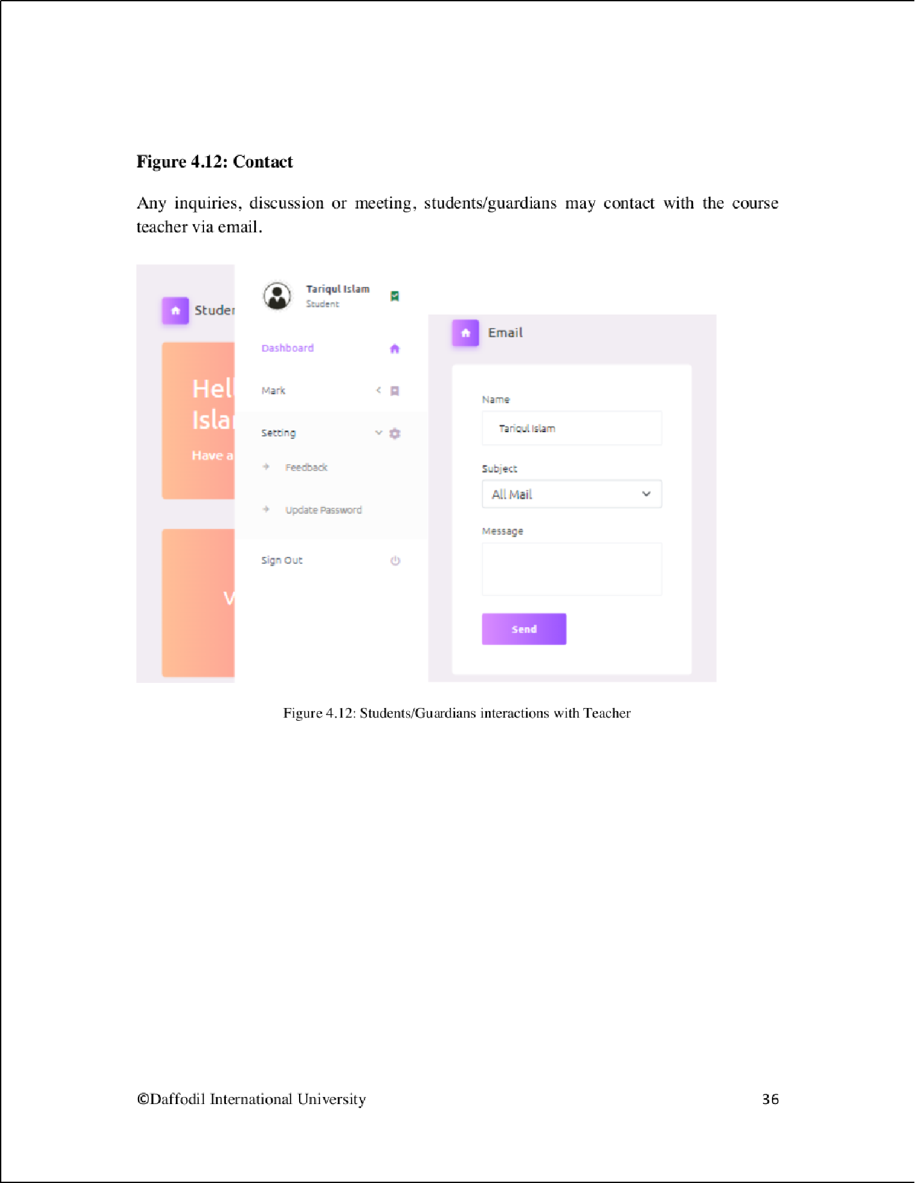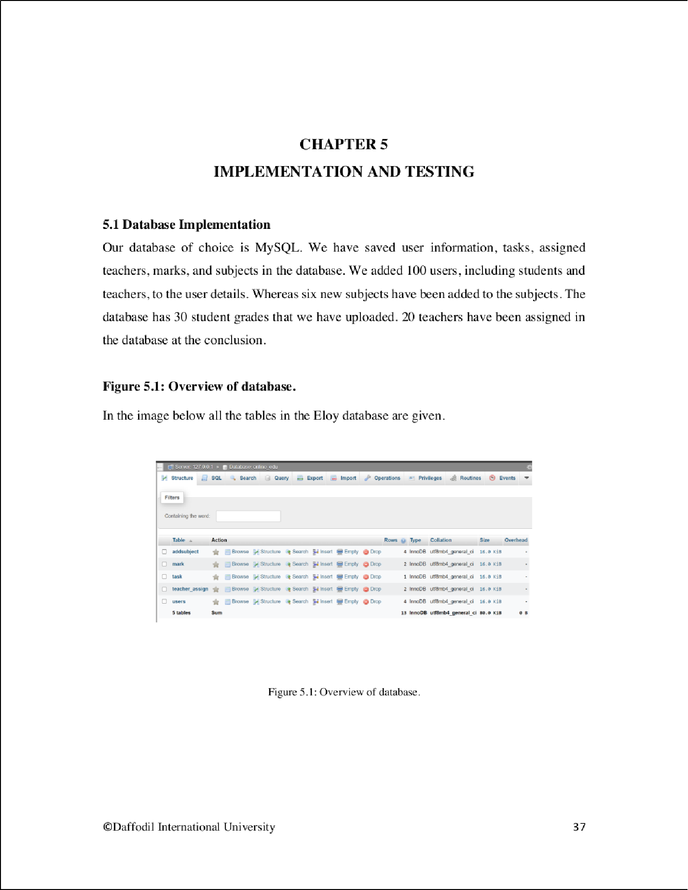

1

2

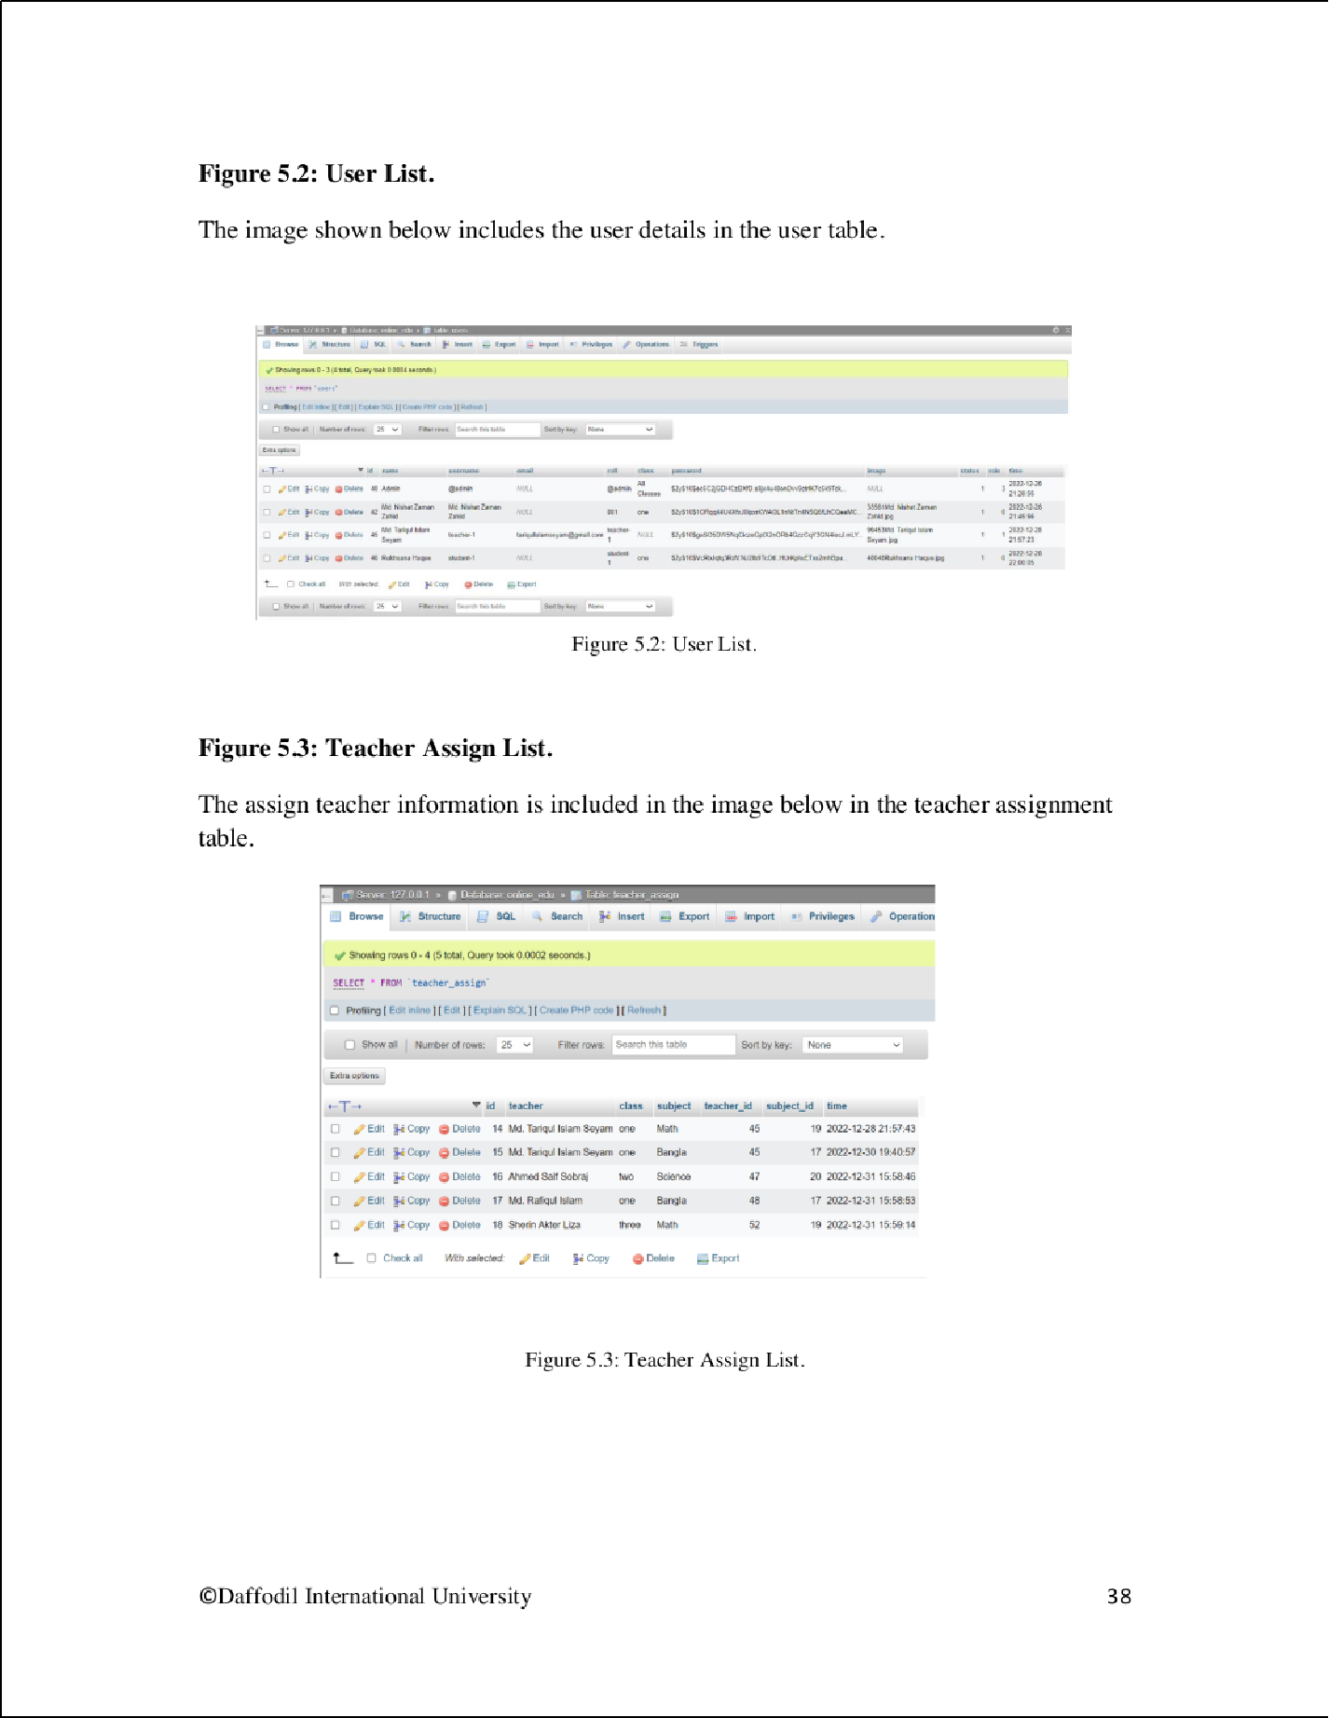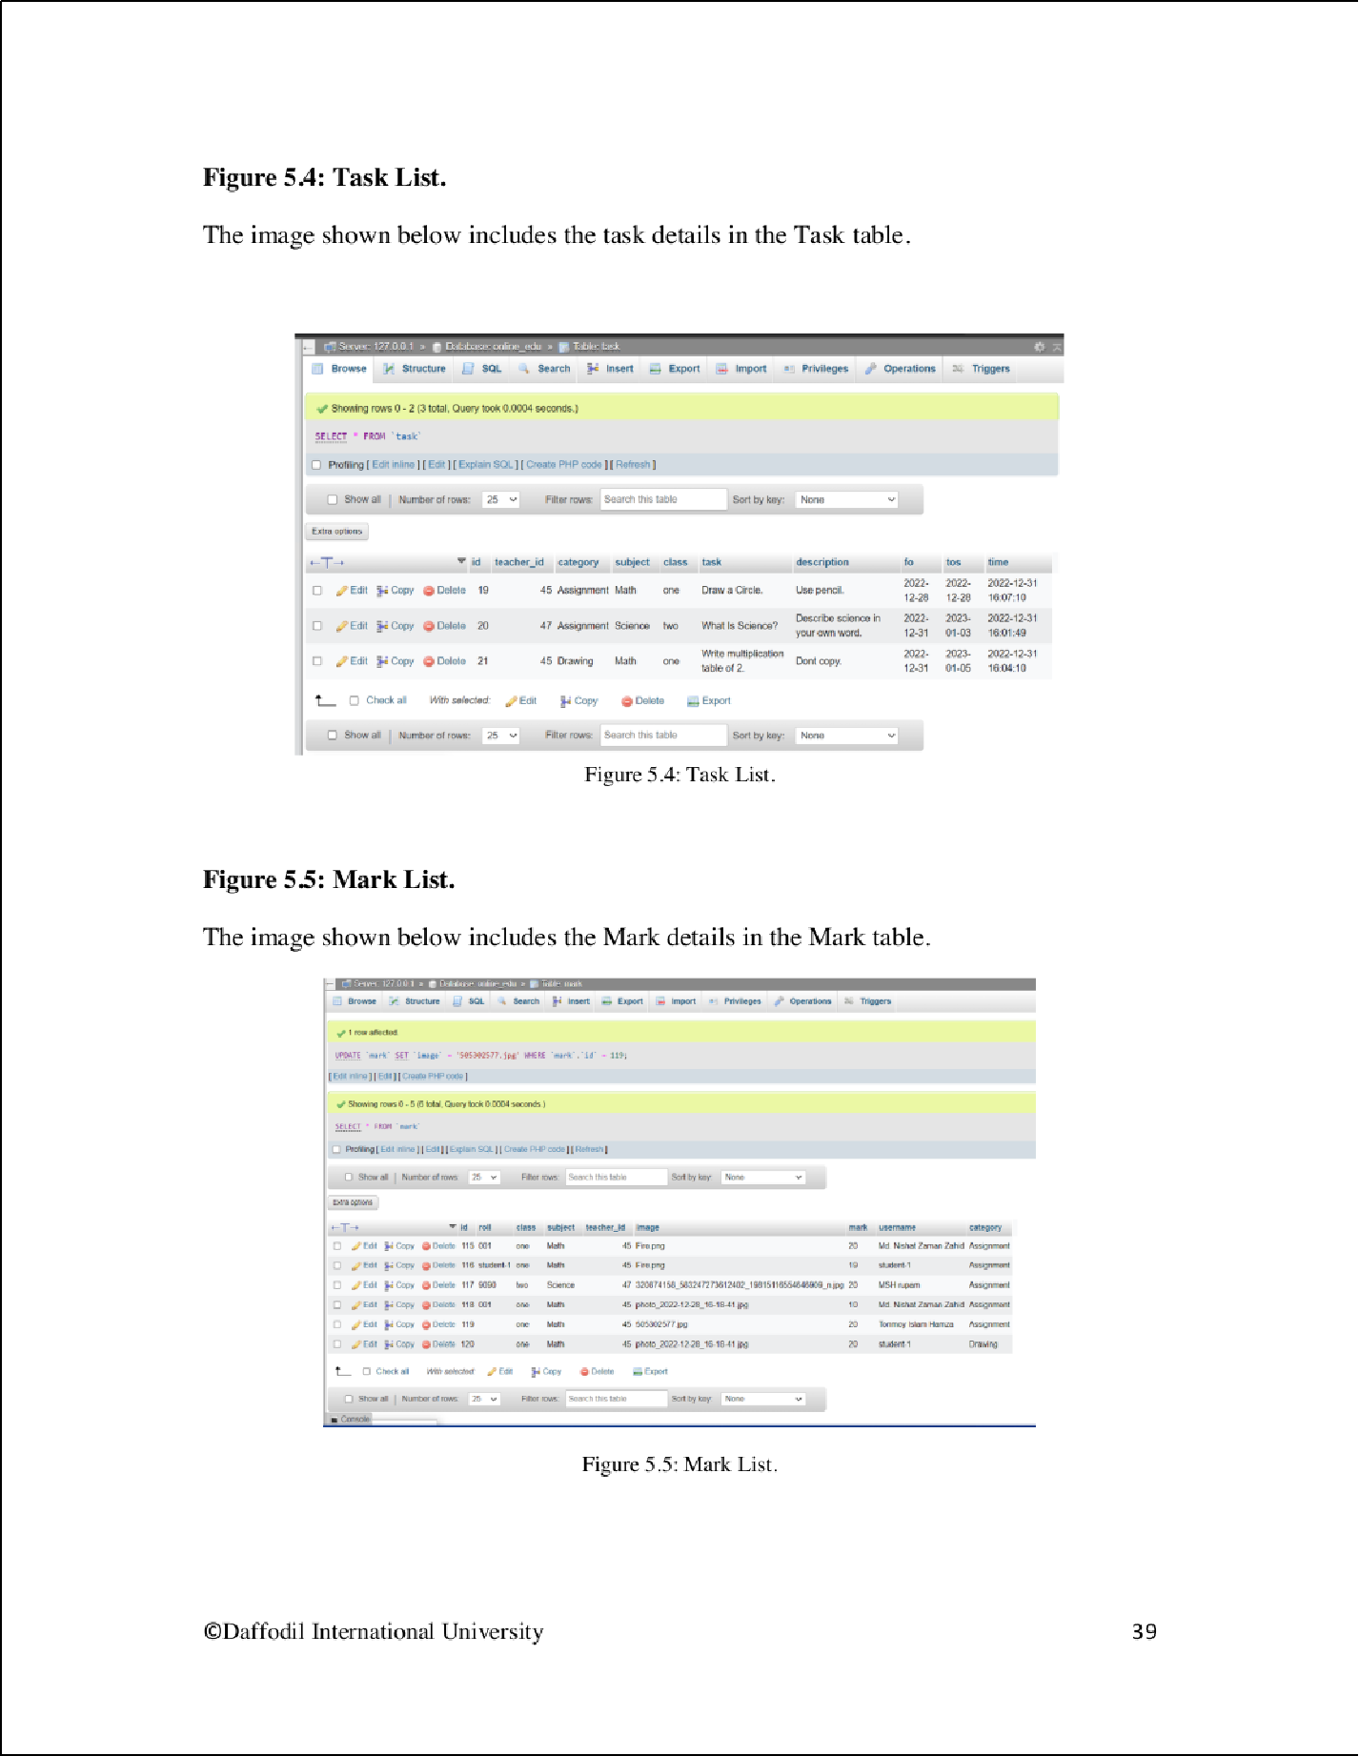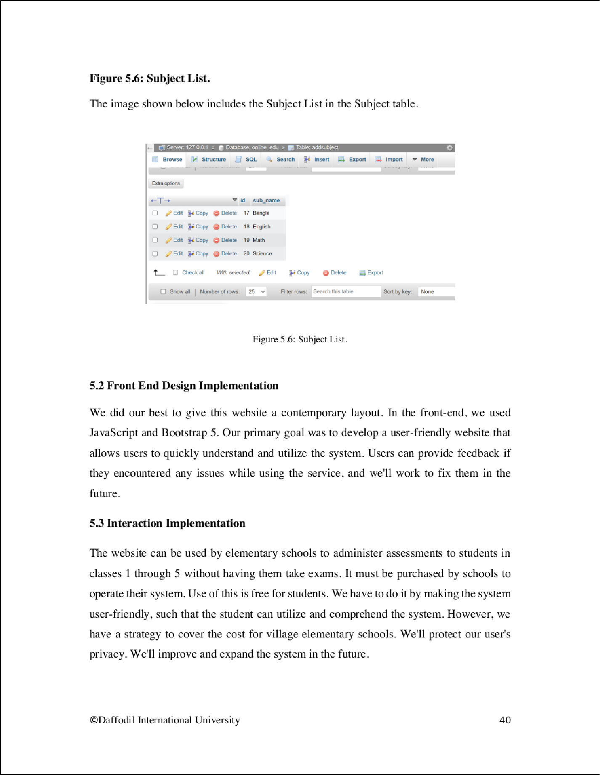

2

2

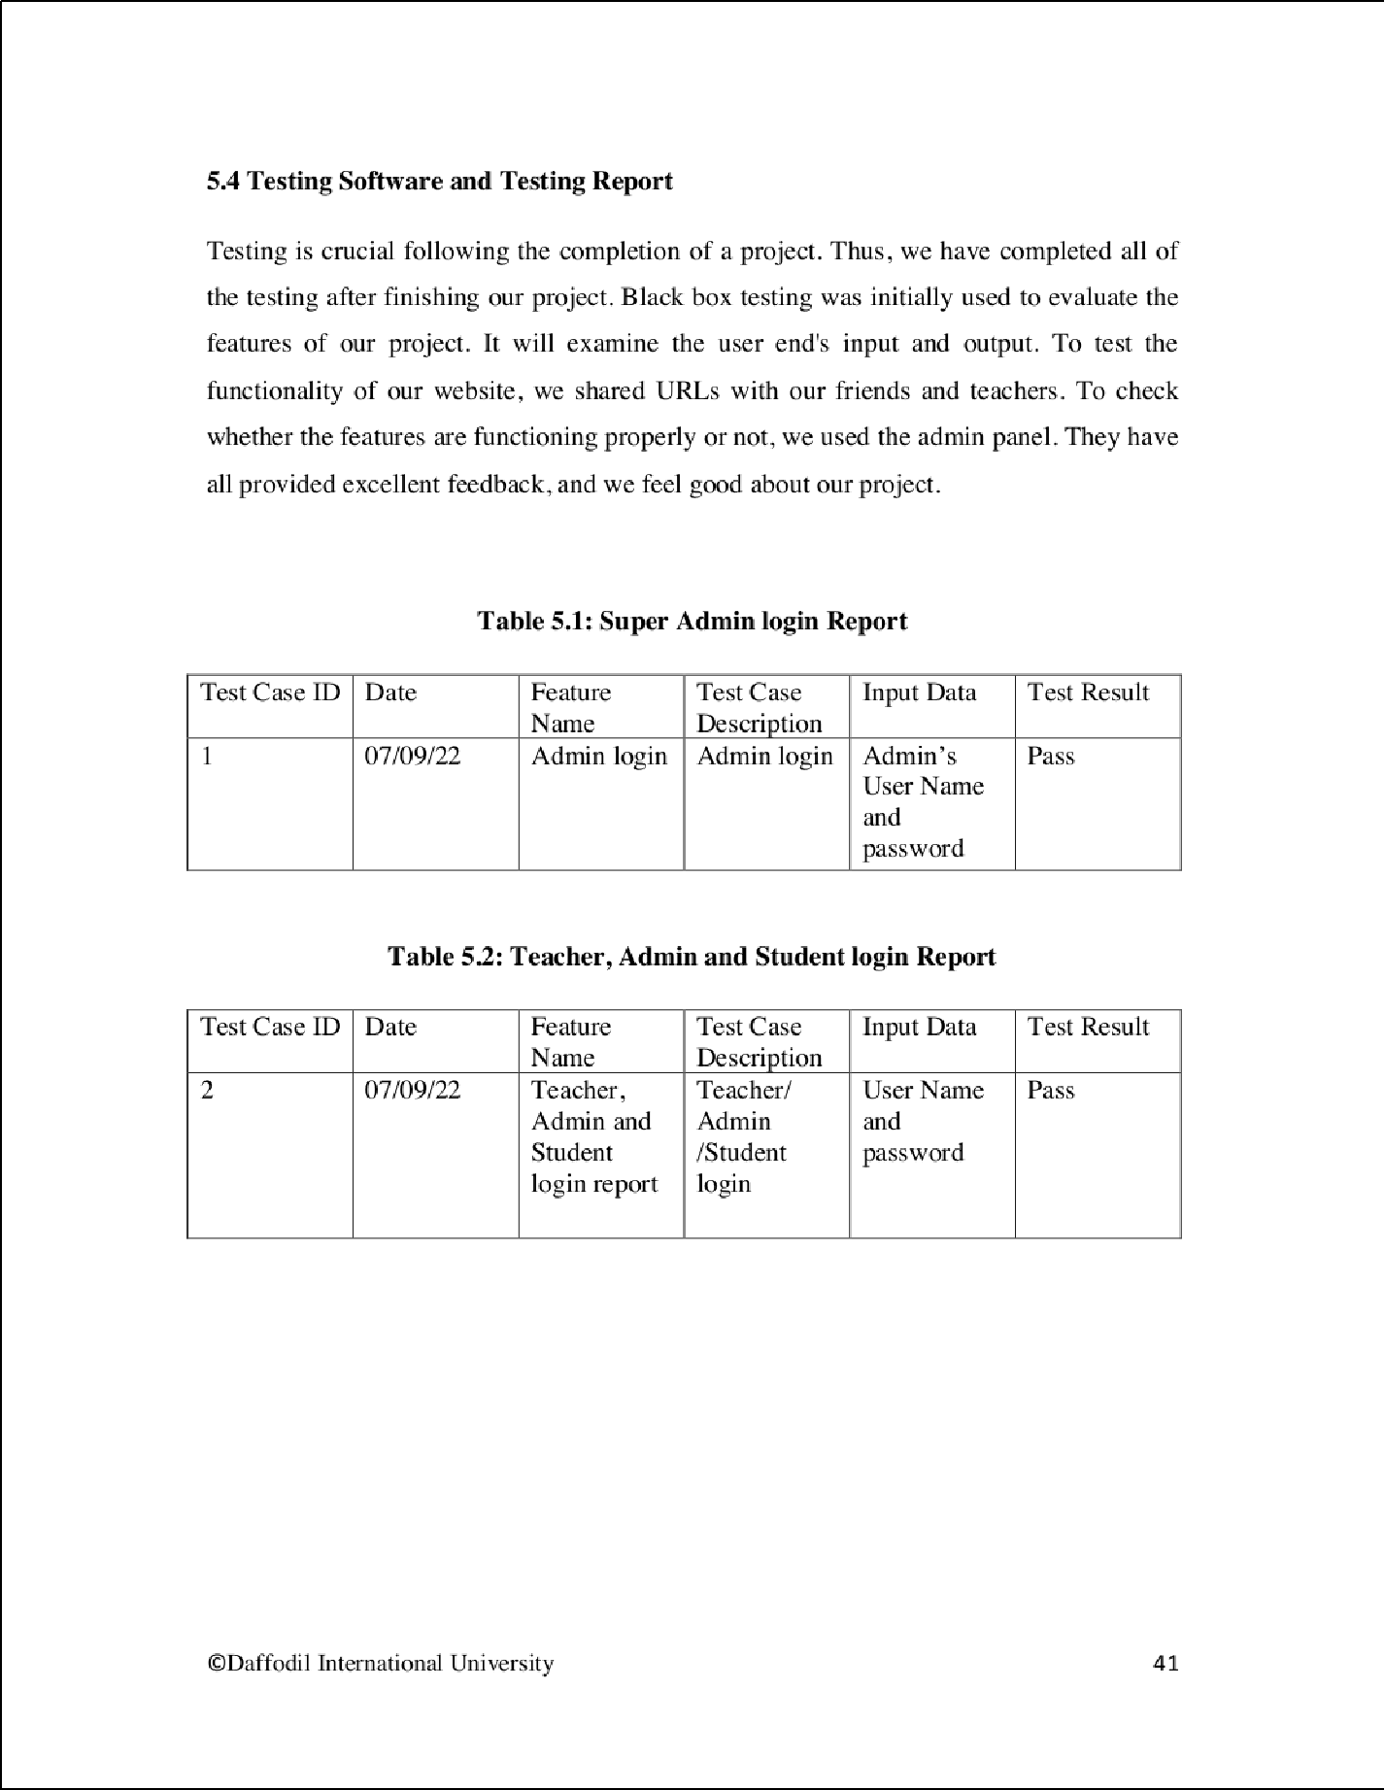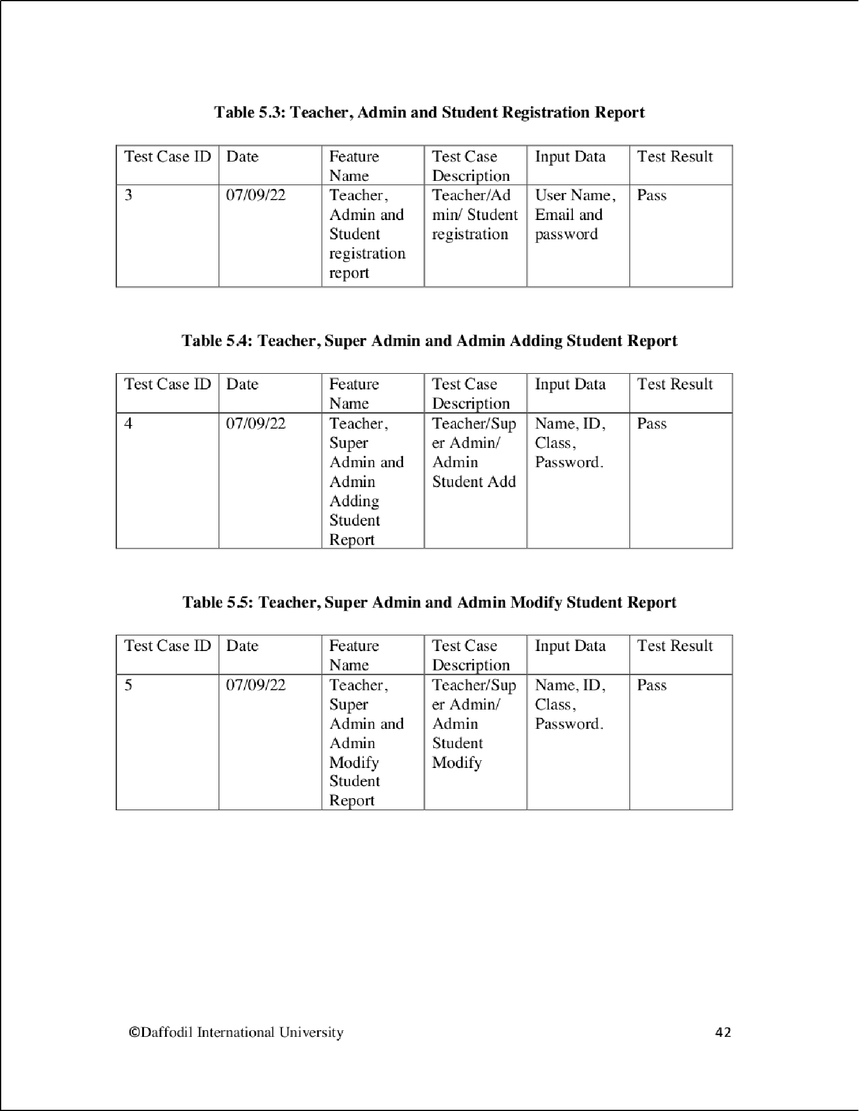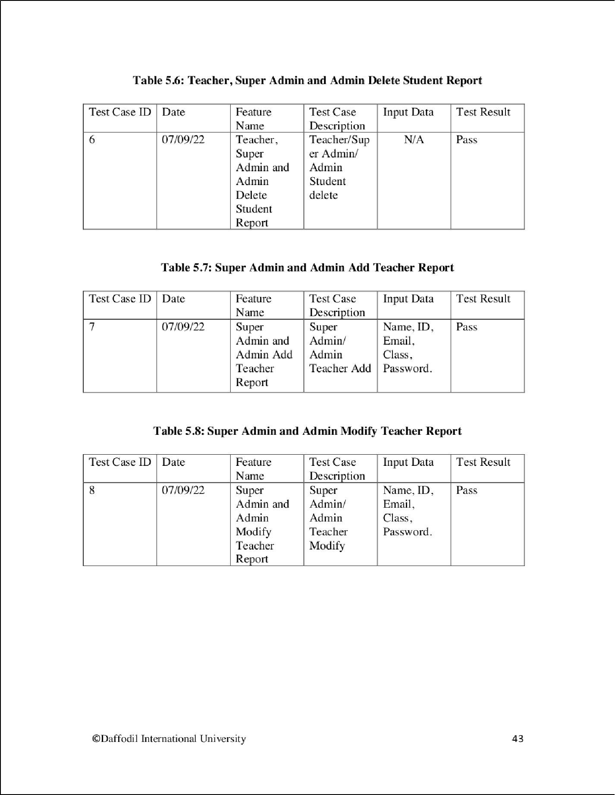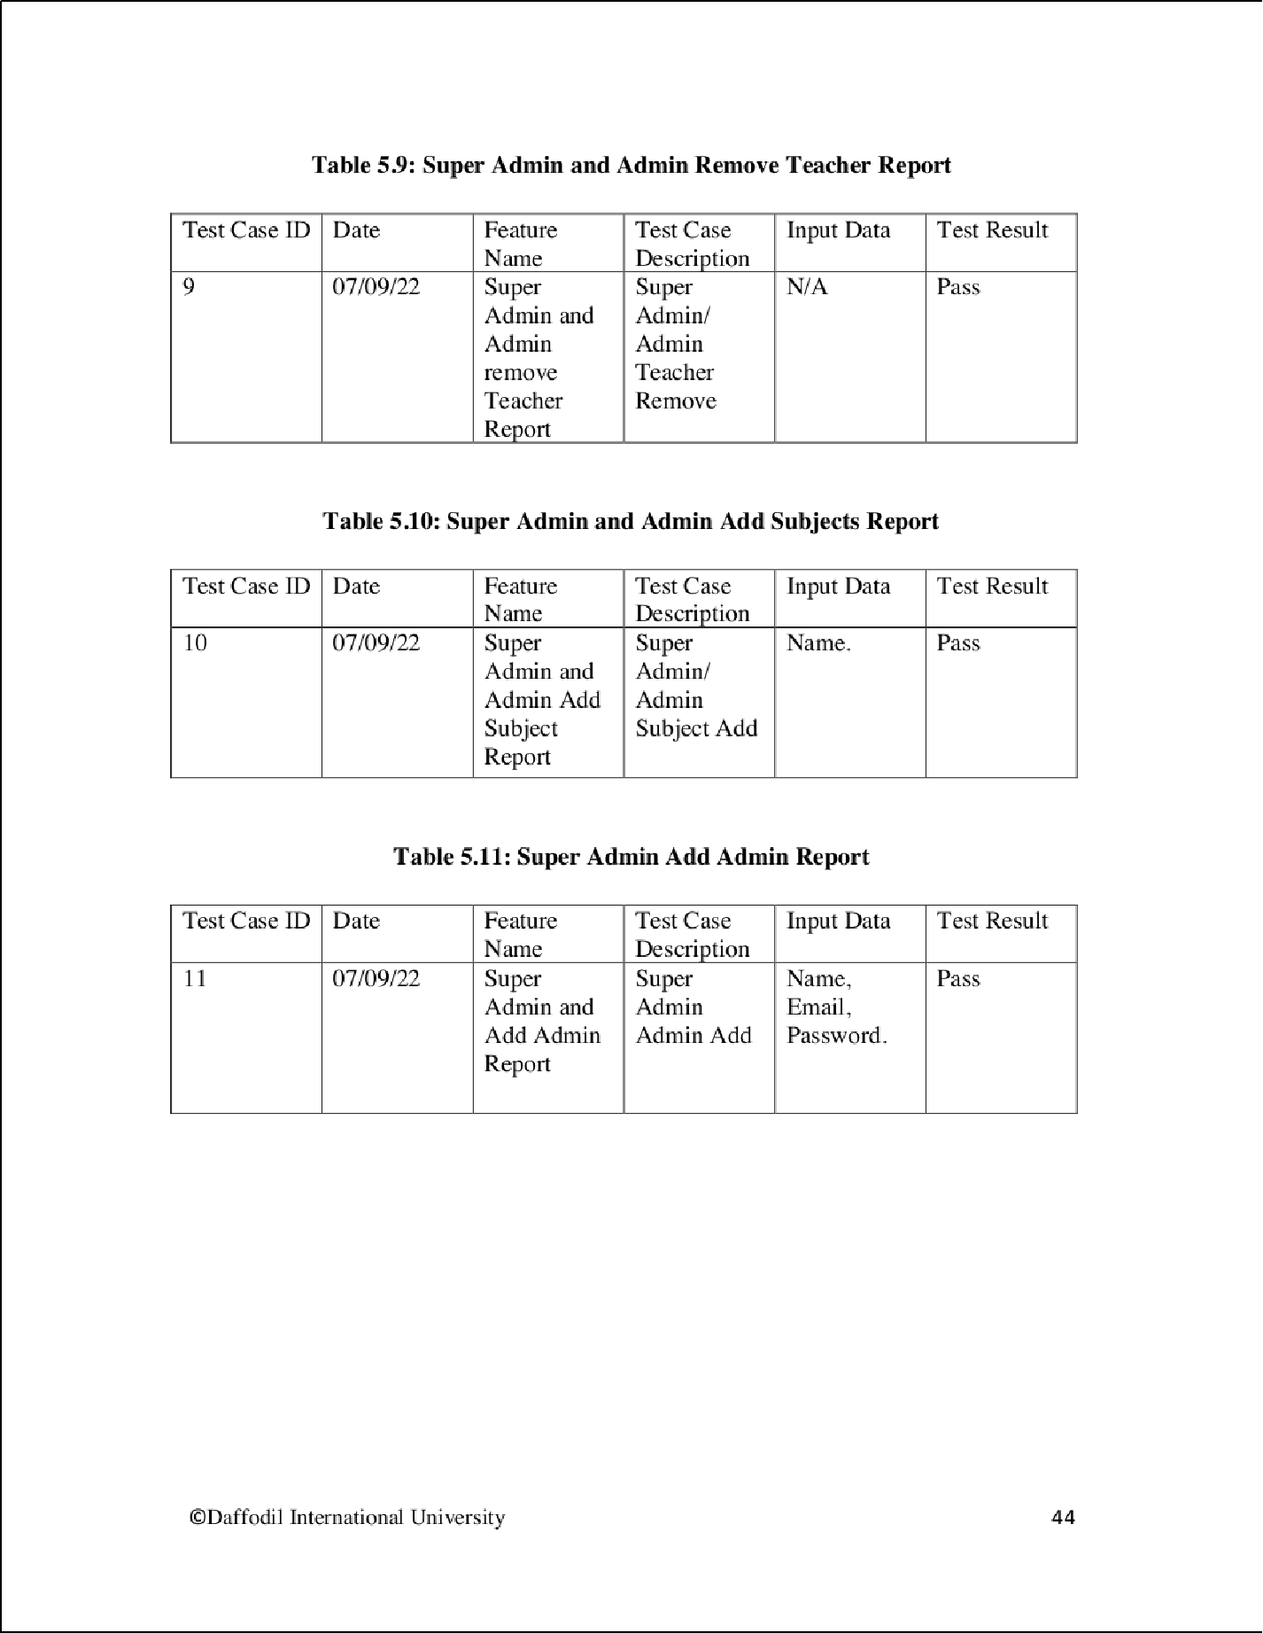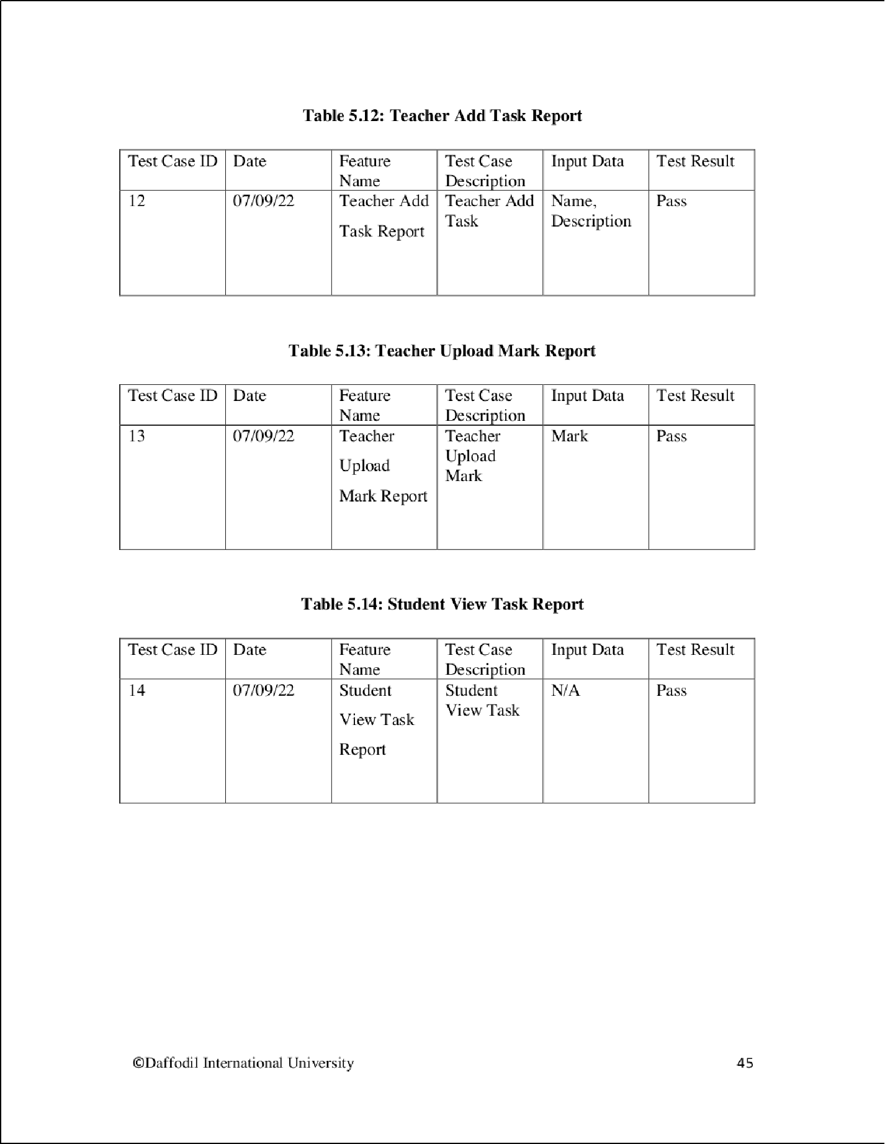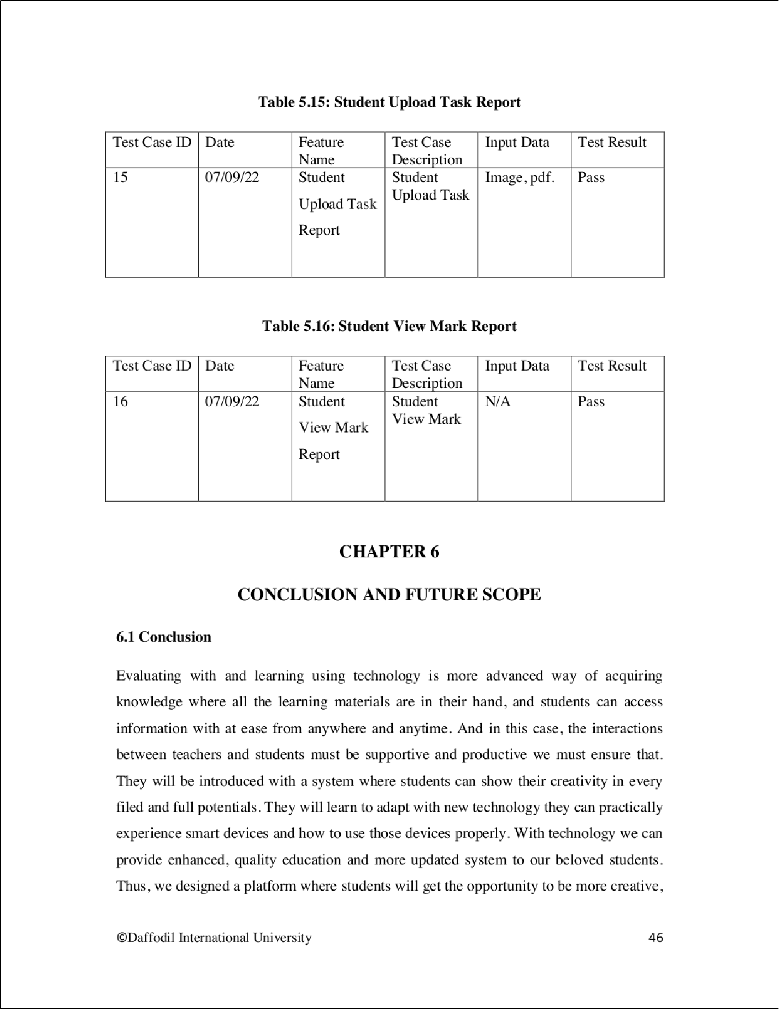

2

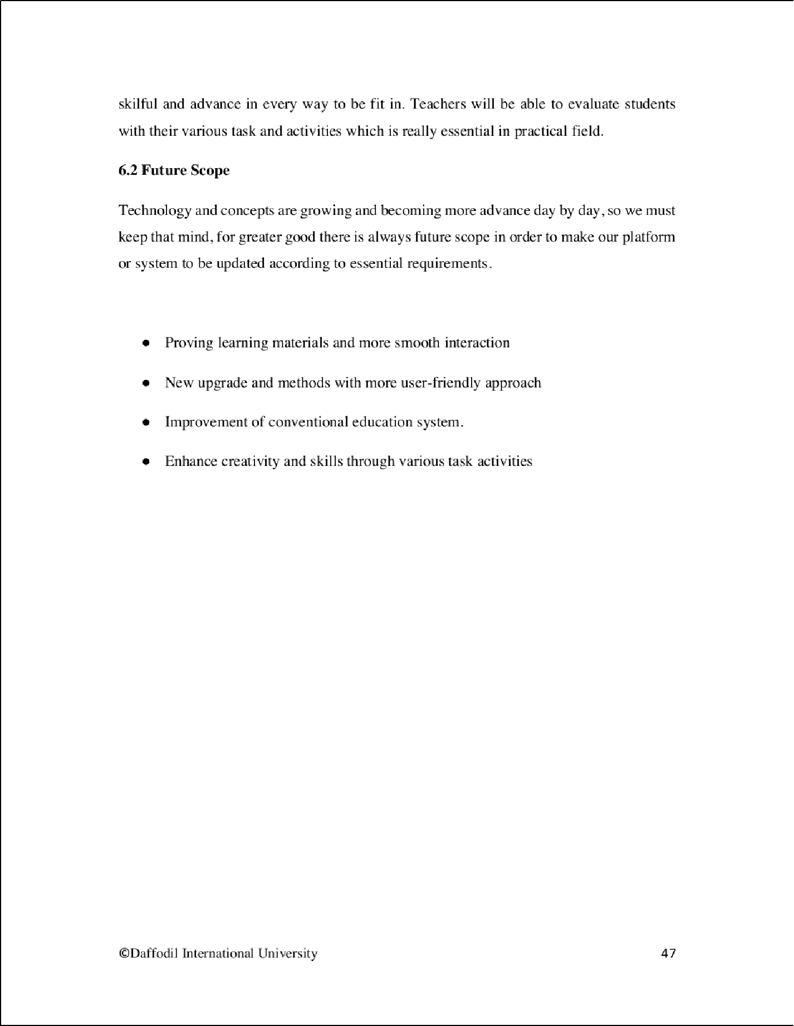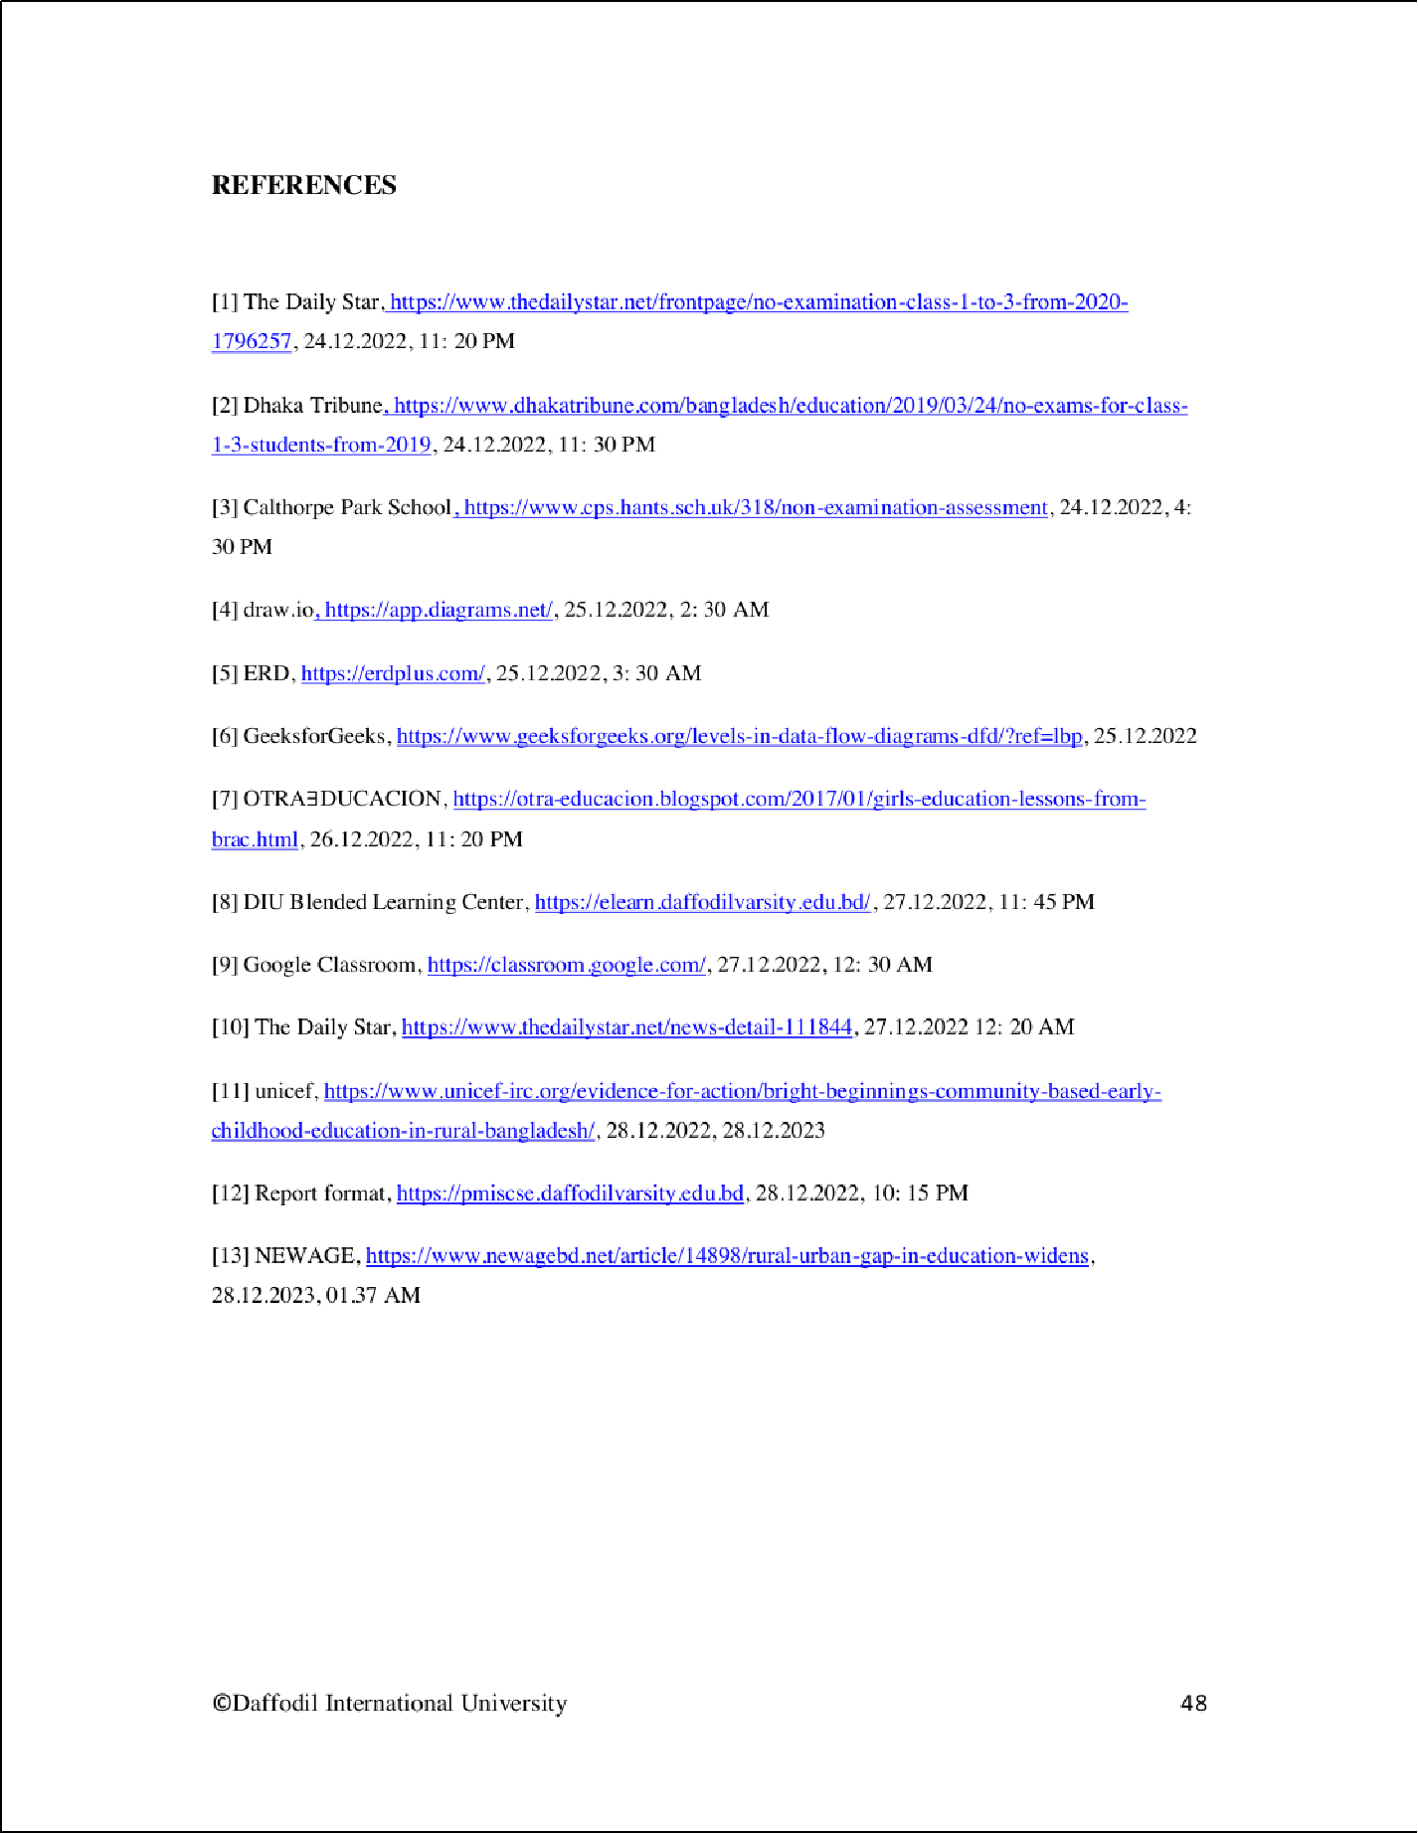

2

18 6

2

10

16

8

13

An Online Based Non-Exam Evaluation System.

21

ORIGINALITY REPORT

%

SIMILARITY INDEX

20%

INTERNET SOURCES

2%

PUBLICATIONS

15%

STUDENT PAPERS

PRIMARY SOURCES

Submitted to Daﬀodil International University

1

Student Paper

dspace.daﬀodilvarsity.edu.bd:8080

2

Internet Source

myﬁk.unisza.edu.my

3

Internet Source

[www.thedailystar.net](http://www.thedailystar.net/)

4

Internet Source

Submitted to Columbia High School

5

Student Paper

[www.dhakatribune.com](http://www.dhakatribune.com/)

6

Internet Source

Submitted to Green Hope High School

7

Student Paper

reliefweb.int

8

Internet Source

Submitted to University of Hull

9

Student Paper

11%

4%

1%

1%

1%

<1%

<1%

<1%

<1%

10

11

12

13

14

15

16

17

18

otra-educacion.blogspot.com

Internet Source

Submitted to BRAC University

Student Paper

Babu Kumar, Ajay Vikram Singh, Parul Agarwal. "Trust in Banking Management System using Firebase in Python using AI", 2021 9th International Conference on Reliability, Infocom Technologies and Optimization (Trends and Future Directions) (ICRITO), 2021

Publication

ir.canterbury.ac.nz

Internet Source

vdocuments.mx

Internet Source

docplayer.net

Internet Source

mro.massey.ac.nz

Internet Source

nanopdf.com

Internet Source

oldweb.lged.gov.bd

Internet Source

<1%

<1%

<1%

<1%

<1%

<1%

<1%

<1%

<1%

19

20

Submitted to University of Central England in Birmingham

Student Paper

text-id.123dok.com

Internet Source

<1%

<1%

Exclude quotes Oﬀ Exclude bibliography Oﬀ

Exclude matches Oﬀ